Computer Architecture  
1999-2000 Fall  
MW 11:55-1:10  
Ciww 109

Allan Gottlieb   
gottlieb@nyu.edu   
http://allan.ultra.nyu.edu/gottlieb   
715 Broadway, Room 1001   
212-998-3344   
609-951-2707   
email is best

**Administrivia**

**Web Pages**

There is a web page for the course. You can find it from my home page.

* Can find these notes there. Let me know if you can't find it.
* They will be updated as bugs are found.
* Will also have each lecture available as a separate page. I will produce the page after the lecture is given. These individual pages might not get updated.

**Textbook**

Text is Hennessy and Patterson ``Computer Orgaiization and Design The Hardware/Software Interface''.

* Available in bookstore.
* The main body of the book assumes you know logic design.
* I do NOT make that assumption.
* We will start with appendix B, which is logic design review.
* A more extensive treatment of logic design is M. Morris Mano ``Computer System Architecture'', Prentice Hall.
* We will not need as much as mano covers and it is not a cheap book so I am not requiring you to get it. I will have it put into the library.
* My treatment will follow H&P not mano.
* Most of the figures in these notes are based on figures from the course textbook. The following copyright notice applies.   
  ``All figures from Computer Organization and Design: The Hardware/Software Approach, Second Edition, by David Patterson and John Hennessy, are copyrighted material (COPYRIGHT 1998 MORGAN KAUFMANN PUBLISHERS, INC. ALL RIGHTS RESERVED). Figures may be reproduced only for classroom or personal educational use in conjunction with the book and only when the above copyright line is included. They may not be otherwise reproduced, distributed, or incorporated into other works without the prior written consent of the publisher.''

**Homeworks and Labs**

I make a distinction between homework and labs.

Labs are

* *Required*
* Due several lectures later (date given on assignment)
* Graded and form part of your final grade
* Penalized for lateness

Homeworks are

* Optional
* Due beginning of *Next* lecture
* Not accepted late
* Mostly from the book
* Collected and returned
* Can help, but not hurt, your grade

Upper left board for assignments and announcements.

**Appendix B: Logic Design**

**Homework:** Read B1

**B.2: Gates, Truth Tables and Logic Equations**

**Homework:** Read B2 Digital ==> Discrete

Primarily (but NOT exclusively) binary at the hardware level

Use only two voltages -- high and low

* This hides a great deal of engineering
* Must make sure not to sample the signal when not in one of these two states.
* Sometimes it is just a matter of waiting long enough (determines the clock rate i.e. how many megahertz)
* Other times it is worse and you must avoid glitches.
* Oscilloscope traces shown below
  + Vertical axis is voltage; horizontal axis is time.
  + Square wave--the ideal. How we think of circuits
  + Sine wave
  + Actual wave
    - Non-zero rise times and fall times
    - Overshoots and undershoots
    - Glitches

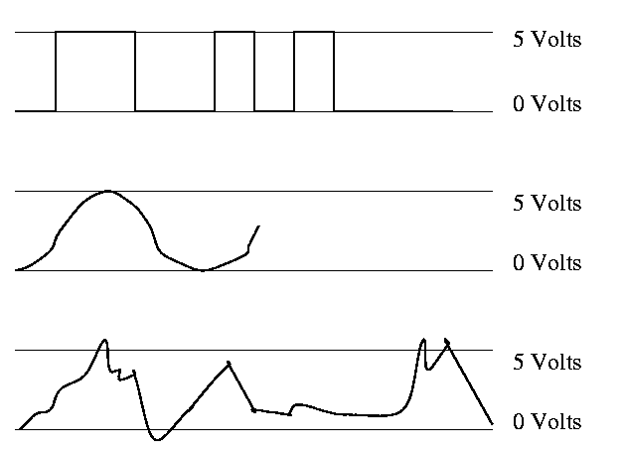

Since this is not an engineering course, we will ignore these issues and assume square waves.

In English digital (think digit, i.e. finger) => 10, but not in computers

Bit = Binary digIT

Instead of saying high voltage and low voltage, we say true and false or 1 and 0 or asserted and deasserted.

0 and 1 are called complements of each other.

A logic block can be thought of as a black box that takes signals in and produces signals out. There are two kinds of blocks

* Combinational (or combinatorial)
  + Does *NOT* have memory elements
  + Is simpler than circuits with memory since it is a function from the inputs to the outputs
* Sequential
  + Contains memory
  + The current value in the memory is called the state of the block.
  + The output depends on the input AND the state

We are doing combinational now. Will do sequential later (few lectures).

**TRUTH TABLES**

Since combinatorial logic has no memory, it is simply a function from its inputs to its outputs. A **Truth Table** has as columns all inputs and all outputs. It has one row for each possible set of input values and the output columns have the output for that input. Let's start with a really simple case a logic block with one input and one output.

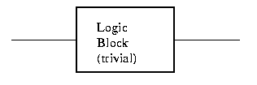

There are two columns (1 + 1) and two rows (2**1).

In Out

0 ?

1 ?

**How many are there?**

How many different truth tables are there for one in and one out?

Just 4: the constant functions 1 and 0, the identity, and an inverter (pictures in a few minutes). There were two `?'s in the above table each can be a 0 or 1 so 2**2 possibilities.

OK. Now how about two inputs and 1 output.

Three columns (2+1) and 4 rows (2**2).

In1 In2 Out

0 0 ?

0 1 ?

1 0 ?

1 1 ?

How many are there? It is just how many ways can you fill in the output entries. There are 4 output entries so answer is 2**4=16.

How about 2 in and 8 out?

* 10 cols
* 4 rows
* 2**(4*8)=4 billion possible

3 in and 8 out?

* 11 cols
* 8 rows
* 2**(8**8)=2**64 possible

n in and k out?

* n+k cols
* 2**n rows
* 2**([2**n]*k) possible

Gets big fast!

**Boolean algebra**

Certain logic functions (i.e. truth tables) are quite common and familiar.

We use a notation that looks like algebra to express logic functions and expressions involving them.

The notation is called **Boolean algebra** in honor of George Boole.

A **Boolean value** is a 1 or a 0.  
A **Boolean variable** takes on Boolean values.   
A Boolean function takes in boolean variables and produces boolean values.

1. The (inclusive) OR Boolean function of two variables. Draw its truth table. This is written + (e.g. X+Y where X and Y are Boolean variables) and often called the logical sum. (Three out of four output values in the truth table look right!)
2. AND. Draw TT. Called log product and written as a centered dot (like product in regular algebra). All four values look right.
3. NOT. Draw TT. This is a unary operator (One argument, not two like above; the two above are called binary). Written A with a bar over it (I will use ' instead of a bar as it is easier for my to type).
4. Exclusive OR (XOR). Written as + with circle around. True if exactly one input is true (i.e. true XOR true = false). Draw TT.

**Homework:** Consider the Boolean function of 3 boolean vars that is true if and only if exactly 1 of the three variables is true. Draw the TT.

Some manipulation laws. Remember this is Boolean *ALGEBRA*.

Identity:

* A+0 = 0+A = A
* A.1 = 1.A = A
* (using . for and)

Inverse:

* A+A' = A'+A = 1
* A.A' = A'.A = 0
* (using ' for not)

Both + and . are commutative so don't need as much as I wrote

The name inverse law is somewhat funny since you *Add* the inverse and get the identity for *Product* or *Multiply* by the inverse and get the identity for *Sum*.

Associative:

* A+(B+C) = (A+B)+C
* A.(B.C)=(A.B).C

Due to associative law we can write A.B.C since either order of evaluation gives the same answer.

Often elide the . so the product associative law is A(BC)=(AB)C.

Distributive:

* A(B+C)=AB+AC
* A+(BC)=(A+B)(A+C)
* Note that BOTH distributive laws hold UNLIKE ordinary arithmetic.

How does one prove these laws??

* Simple (but long) write the TTs for each and see that the outputs are the same.
* Do the first dist laws on the board.

**Homework:** Do the second distributive law.

Let's do (on the board) the examples on pages B-5 and B-6. Consider a logic function with three inputs A, B, and C; and three outputs D, E, and F defined as follows: D is true if at least one input is true, E if exactly two are true, and F if all three are true. (Note that by if we mean if and only if.

Draw the truth table.

Show the logic equations

* For E first use the obvious method of writing one condition for each 1-value in the E column i.e.  
  (A'BC) + (AB'C) + (ABC')
* Observe that E is true if two (but not three) inputs are true, i.e.,  
  (AB+AC+BC) (ABC)' (using . higher precedence than +)

================ Start Lecture 2 ================

The first way we solved part E shows that *any* logic function can be written using just AND, OR, and NOT. Indeed, it is in a nice form. Called two levels of logic, i.e. it is a sum of products of just inputs and their compliments.

DeMorgan's laws:

* (A+B)' = A'B'
* (AB)' = A'+B'

You prove DM laws with TTs. Indeed that is ...

**Homework:** B.6 on page B-45

Do beginning of HW on the board.

With DM we can do quite a bit without resorting to TTs. For example one can show that the two expressions for E on example above (page B-6) are equal. Indeed that is

**Homework:** B.7 on page B-45

Do beginning of HW on board.

**GATES**

Gates implement basic logic functions: AND OR NOT XOR Equivalence 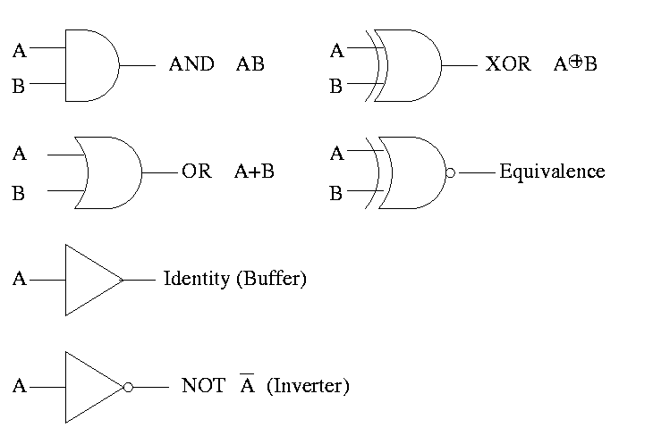

Show why the picture is equivalence, i.e (A XOR B)' is AB + A'B'

(A XOR B)' =

(A'B+AB')' =

(A'B)' (AB')' =

(A''+B') (A'+B'') =

(A + B') (A' + B) =

AA' + AB + B'A' + B'B =

0 + AB + B'A' + 0 =

AB + A'B'

Often omit the inverters and draw the little circles at the input or output of the other gates (AND OR). These little circles are sometimes called bubbles.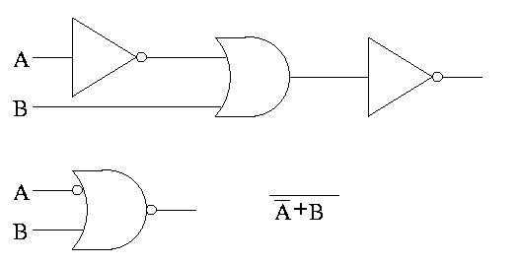

This explains why inverter is drawn as a buffer with a bubble.

**Homework:** B.2 on page B-45 (I previously did the first part of this homework).

**Homework:** Consider the Boolean function of 3 boolean vars (i.e. a three input function) that is true if and only if exactly 1 of the three variables is true. Draw the TT. Draw the logic diagram with AND OR NOT. Draw the logic diagram with AND OR and bubbles.

We have seen that any logic function can be constructed from AND OR NOT. So this triple is called *universal*.

Are there any pairs that are universal? Could it be that there is a single function that is universal? YES!

NOR (NOT OR) is true when OR is false. Do TT.

NAND (NOT AND) is true when AND is false. Do TT.

Draw two logic diagrams for each, one from definition and equivalent one with bubbles.

**Theorem** A 2-input NOR is universal and A 2-input NAND is universal.

**Proof**

We must show that you can get A', A+B, and AB using just a two input NOR.

* A' = A NOR A
* A+B = (A NOR B)' (we can use ' by above)
* AB = (A' OR B')'

**Homework:** Show that a 2-input NAND is universal.

Can draw NAND and NOR each two ways (because (AB)' = A' + B')

We have seen how to get a logic function from a TT. Indeed we can get one that is just two levels of logic. But it might not be the simplest possible. That is we may have more gates than necessary.

Trying to minimize the number of gates is NOT trivial. Mano covers this in detail. We will not cover it in this course. It is not in H&P. I actually like it but must admit that it takes a few lectures to cover well and it not used so much since it is algorithmic and is done automatically by CAD tools.

Minimization is not unique, i.e. there can be two or more minimal forms.

Given A'BC + ABC + ABC'   
Combine first two to get BC + ABC'  
Combine last two to get A'BC + AB

Sometimes when building a circuit, you don't care what the output is for certain input values. For example, that input combination is cannot occur. Another example occurs when, for this combination of input values, a later part of the circuit will ignore the output of this part. These are called **don't care outputs** situations. Making use of don't cares can reduce the number of gates needed.

Can also have **don't care inputs** when , for certain values of a subset of the inputs, the output is already determined and you don't have to look at the remaining inputs. We will see a case of this in the very next topic, multiplexors.

**An aside on theory**

Putting a circuit in disjunctive normal form (i.e. two levels of logic) means that every path from the input to the output goes through very few gates. In fact only two, an OR and an AND. Maybe we should say three since the AND can have a NOT (bubble). Theorticians call this number (2 or 3 in our case) the *depth* of the circuit. Se we see that every logic function can be implemented with small depth. But what about the *width*, i.e., the number of gates.

The news is bad. The **parity** function takes n inputs and gives TRUE if and only if the number of input TRUEs is odd. If the depth is fixed (say limited to 3), the number of gates needed for parity is exponential in n.

**B.3 COMBINATIONAL LOGIC**

**Homework:** Read B.3.

**Generic Homework:** Read sections in book corresponding to the lectures.

**Multiplexor**

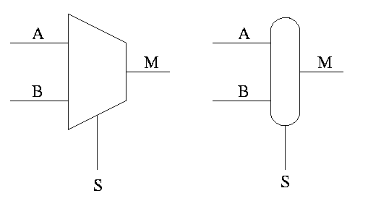

Often called a **mux** or a **selector**

Show equiv circuit with AND OR

Hardware if-then-else

if S=0

M=A

else

M=B

endif

Can have 4 way mux (2 selector lines)

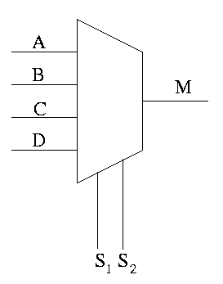

This is an if-then-elif-elif-else

if S1=0 and S2=0

M=A

elif S1=0 and S2=1

M=B

elif S1=1 and S2=0

M=C

else -- S1=1 and S2=1

M=D

endif

Do a TT for 2 way mux. Redo it with don't care values.  
Do a TT for 4 way mux with don't care values.

================ Start Lecture 3 ================

**Homework:** B-12. Assume you have constant signals 1 and 0 as well.

**Decoder**

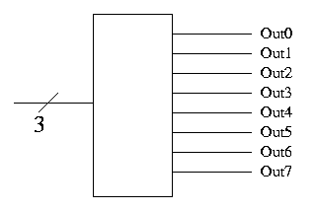

* Note the ``3'' with a slash, which signifies a three bit input. This notation represents three (1-bit) wires.
* Takes n signals in produces 2^n signals out
* View input as ``binary n'', the output has n'th bit set
* Implement on board with AND/OR

**Encoder**

* Reverse "function" of encoder
* Not defined for all inputs (exactly one must be 1)

Sneaky way to see that NAND is universal.

* First show that you can get NOT from NAND. Hence we can build inverters.
* Now imagine that you are asked to do a circuit for some function with N inputs. Assume you have only one output.
* Using inverters you can get 2N signals the N original and N complemented.  
  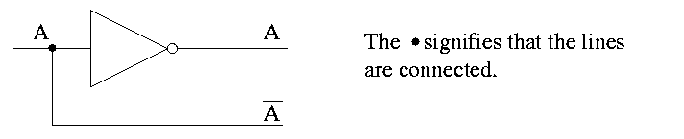
* Recall that the natural sum of products form is a bunch of ORs feeding into one AND.  
  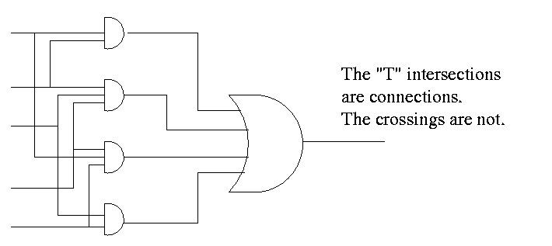
* Naturally you can add pairs of bubbles since they ``cancel''  
  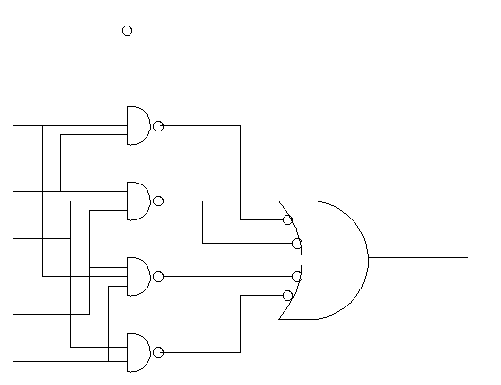
* But these are all NANDS!!

**Half Adder**

* Inputs X and Y
* Outputs S and Co (carry out)
* No CarryIn
* Draw TT

**Homework:** Draw logic diagram

**Full Adder**

* Inputs X, Y and Ci
* Output S and Co
* S = #1s in X, Y, Ci is odd
* Co = #1s is at least 2

**Homework:**

* Draw TT (8 rows)
* show S = X XOR Y XOR Ci
* show Co = XY + (X XOR Y)Ci

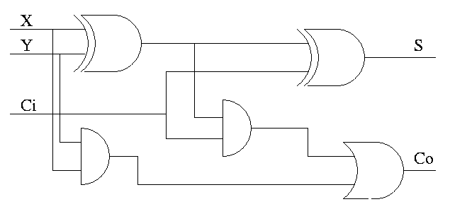

How about 4 bit adder ?

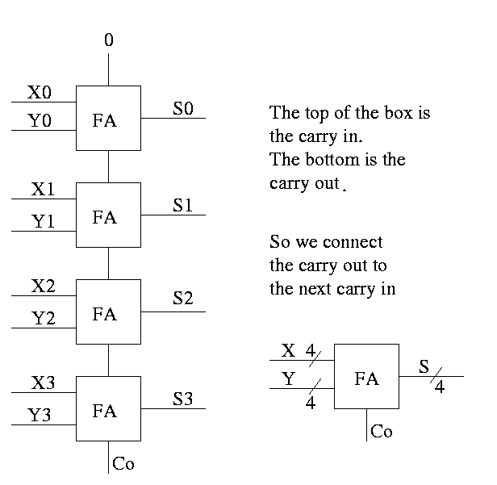

How about n bit adder ?

* Linear complexity
* Called ripple carry
* Faster methods exist

================ Start Lecture 4 ================

**PLAs--Programmable Logic Arrays**

Idea is to make use of the algorithmic way you can look at a TT and produce a circuit diagram in the sums of product form.

Consider the following TT from the book (page B-13)

A | B | C || D | E | F

--+---+---++---+---+--

O | 0 | 0 || 0 | 0 | 0

0 | 0 | 1 || 1 | 0 | 0

0 | 1 | 0 || 1 | 0 | 0

0 | 1 | 1 || 1 | 1 | 0

1 | 0 | 0 || 1 | 0 | 0

1 | 0 | 1 || 1 | 1 | 0

1 | 1 | 0 || 1 | 1 | 0

1 | 1 | 1 || 1 | 0 | 1

* Recall that there is a big OR for each output
* We can see that there are 7 product terms that will be used in one or more of the ORs (in fact all seven will be used in D, but that is special to this example)
* Each of these product terms is called a **Minterm**
* So we need a bunch of ANDs taking A, B, C as inputs (and their complements A', B', and C')
* This is called an **AND plane** and the collection of ORs mentioned above is called a **OR plane**.
* Convert to sum of product forms (only NOTs on vbles)

Here is the [circuit diagram](http://hp-figs-B06.pdf) for this truth table.

Here it is redrawn

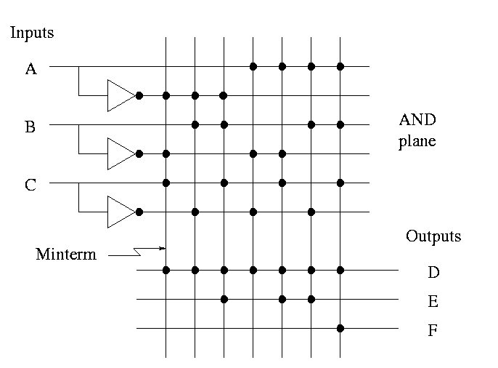

* This figure shows more clearly the AND plane, the OR plane, and the minterms.
* Rather than having bubbles (i.e., custom and gates that invert), we simply invert each input once and send the inverted signal all the way accross.
* AND gates are shown as vertical lines; ORs as horizontal.
* Note the dots to represent connections

Finally, it can be [redrawn](http://hp-figs-B05.pdf) in a more abstract form.

When a PLA is manufactured all the connections have been specified. That is, a PLA is specific for a given circuit. It is somewhat of a misnomer since it is *not*programmable by the user

**Homework:** B.10 and B.11

Can also have a PAL or **Programmable array logic** in which the final dots are specified by the user. The manufacturer produces a ``sea of gates''; the user programs it to the desired logic function.

**Homework:** Read B-5

**ROMs**

One way to implement a mathematical (or C) function (without side effects) is to perform a table lookup.

A ROM (Read Only Memory) is the analogous way to implement a logic function.

* For a math function f we start with x and get f(x).
* For a ROM with start with the address and get the value stored at that address.
* Normally math functions are defined for an infinite number of values, for example f(x) = 3x for all real numbers x
* We can't build an infinite ROM (sorry), so we are only interested in functions defined for a finite number of values. Today a million is OK a billion is too big.
* To create the ROM for the function f(3)=4, f(6)=20 all other values undefined just have the ROM store 4 in address 3 and 20 in address 6
* Consider a function defined for all n-bit numbers (say n=20) and having a k-bit output for each input.
  + View each n-bit input as n 1-bit inputs.
  + View each k-bit output as k 1-bit outputs.
  + Since there are 2^n inputs and each requires a k 1-bit output, there are a total of (2^n)k bits of output, i.e. the ROM must hold (2^n)k bits.
  + Imagine a truth table with n inputs and k outputs. The total number of output bits is again (2^n)k (2^n rows and k output columns).
* Thus the ROM implements a truth table, i.e. is a logic function.

**Important**: The ROM is does not have state. It is still a combinational circuit. That is, it does not represent ``memory''. The reason is that once a ROM is manufactured, the output depends only on the input.

A **PROM** is a *programmable* ROM. That is you buy the ROM with ``nothing'' in its memory and then *before* it is placed in the circuit you load the memory, and never change it.

An **EPROM** is an *erasable* PROM. It costs more but if you decide to change its memory this is possible (but is slow).

``Normal'' EPROMs are erased by some ultraviolet light process. But **EEPROMs** (electrically erasable PROMS) are faster and are done electronically.

All these EPROMS are erasable not writable, i.e. you can't just change one bit.

A ROM is similar to PLA

* Both can implement any truth table, in principle.
* A 2Mx8 ROM can really implment any truth table with 21 inputs (2^21=2M) and 8 outputs.
  + It stores 2M bytes
  + In ROM-speak, it has 21 address pins and 8 data pins
* A PLA with 21 inputs and 8 outputs might need to have 2M minterms (AND gates).
  + The number of minterms depends on the truth table itself.
  + For normal TTs with 21 inputs the number of minterms is MUCH less than 2^21.
  + The PLA is manufactured with the number of minterms needed
* Compare a PAL with a PROM
  + Both can in principle implement any TT
  + Both are user programmable
  + A PROM with n inputs and k outputs can implement any TT with n inputs and k outputs.
  + A PAL does not have enough gates for all possibilities since most TTs with n inputs and k outputs don't require nearly (2^n)k gates.

**Don't Cares**

* Sometimes not all the input and output entries in a TT are needed. We indicate this with an X and it can result in a smaller truth table.
* Input don't cares.
  + The output doesn't depend on all inputs, i.e. the output has the same value no matter what value this input has.
  + We saw this when we did muxes
* Output don't cares
  + For some input values, either output is OK.
    - This input combination is impossible.
    - For this input combination, the given output is not used (perhaps it is ``muxed out'' downstream)

Example

* If A or C is true, then D is true (independent of B).
* If A or B is true, the output E is true.
* F is true if exactly one of the inputs is true, but we don't care about the value of F if both D and E are true

Full truth table

A B C || D E F

----------++----------

0 0 0 || 0 0 0

0 0 1 || 1 0 1

0 1 0 || 0 1 1

0 1 1 || 1 1 0

1 0 0 || 1 1 1

1 0 1 || 1 1 0

1 1 0 || 1 1 0

1 1 1 || 1 1 1

Put in the output don't cares

A B C || D E F

----------++----------

0 0 0 || 0 0 0

0 0 1 || 1 0 1

0 1 0 || 0 1 1

0 1 1 || 1 1 X

1 0 0 || 1 1 X

1 0 1 || 1 1 X

1 1 0 || 1 1 X

1 1 1 || 1 1 X

Now do the input don't cares

* B=C=1 ==> D=E=11 ==> F=X ==> A=X
* A=1 ==> D=E=11 ==> F=X ==> B=C=X

A B C || D E F

----------++----------

0 0 0 || 0 0 0

0 0 1 || 1 0 1

0 1 0 || 0 1 1

X 1 1 || 1 1 X

1 X X || 1 1 X

These don't cares are important for logic minimization. Compare the number of gates needed for the full TT and the reduced TT. There are techniques for minimizing logic, but we will not cover them.

**Arrays of Logic Elements**

* Do the same thing to many signals
* Draw thicker lines and use the "by n" notation.
* Diagram below shows 32- bit 2-way mux and implementation with 32 muxes
* A **Bus** is a collection of data lines treated as a single logical (n-bit) value.
* Use an array of logic elements to process a bus. For example, the above mux switches between 2 32-bit buses.

[32-bit mux](http://hp-figs-B08.pdf)

*********** Big Change Coming ***********

**Sequential Circuits, Memory, and State**

Why do we want to have state?

* Memory (i.e. ram not just rom or prom)
* Counters
* Reducing gate count
  + Multiplier would be quadradic in comb logic.
  + With sequential logic (state) can do in linear.
    - What follows is unofficial (i.e. too fast to understand)
    - Shift register holds partial sum
    - Real slick is to share this shift reg with multiplier
    - We will do this circuit later in the course

Assume you have a real OR gate. Assume the two inputs are both zero for an hour. At time t one input becomes 1. The output will OSCILLATE for a while before settling on exactly 1. We want to be sure we don't look at the answer before its ready.

**start lecture #5**

**B.4: Clocks**

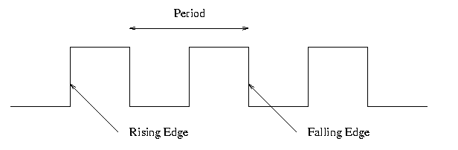

Frequency and period

* Hertz (Hz), Megahertz, Gigahertz vs. Seconds, Microseconds, Nanoseconds
* Old (descriptive) name for Hz is cycles per second (CPS)
* Rate vs. Time

Edges

* Rising Edge; falling edge
* We use edge-triggered logic
* State changes occur only on a clock edge
* Will explain later what this really means
* One edge is called the *Active* edge
  + The edge (rising or falling) on which changes occur
  + Choice is technology dependent
  + Sometimes trigger on both edges (e.g., RAMBUS memory)

**Synchronous system**

Now we are going to add *state elements* to the combinational circuits we have been using previously.

Remember that a combinational/combinatorial circuits has its outpus determined by its input, i.e. combinatorial circuits do not contain *state*.

[Reading and writing State Elements.](http://hp-figs-B10.pdf)

State elements include *state* (naturally).

* i.e., memory
* state-elements have clock as an input
* can change state only at active edge
* produce output *Always*; based on current state
* all signals that are written to state elements must be valid at the time of the active edge.
* For example, if cycle time is 10ns make sure combinational circuit used to compute new state values completes in 10ns
* So state elements change on active edge, comb circuit stablizes between active edges.
* Can have loops like [this](http://hp-figs-B11.pdf).
* Think of registers or memory as state elements.
* A loop like the above is a cycle of the computer

**B.5: Memory Elements**

We want *edge-triggered clocked* memory and will only use *edge-triggered clocked* memory in our designs. However we get there by stages. We first show how to build *unclocked* memory; then using*unclocked* memory we build *level-sensitive clocked* memory; finally from *level-sensitive clocked* memory we build *edge-triggered clocked* memory.

**Unclocked Memory**

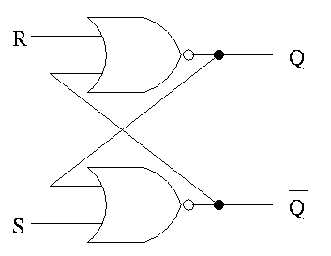

S-R latch (set-reset)

* ``Cross-coupled'' nor gates
* *Don't* assert both S and R at once
* When S is asserted (i.e., S=1 and R=0)
  + the latch is **Set** (that's why it is called S)
  + Q becomes true (Q is the output of the latch)
  + Q' becomes false (Q' is the complemented output)
* When R is asserted
  + the latch is **Reset**
  + Q becomes false
  + Q' becomes true
* When neither one is asserted
  + The latch remains the same, i.e. Q and Q' stay as they were
  + This is the *memory* aspect

**Clocked Memory: Flip-flops and latches**

**The S-R latch defined above is not clocked memory. Unfortunately the terminology is not perfect.**

**For both flip-flops and latches the output equals the value stored in the structure. Both have an input and an output (and the complemented output) and a clock input as well. The clock determines when the internal value is set to the current input. For a latch, the change occurs whenever the clock is asserted (level sensitive). For a flip-flop, the change only occurs during the active edge.**

**D latch**

The D is for data

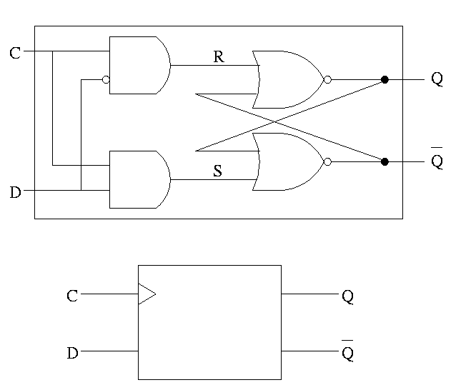

* The left part uses the clock.
  + When the clock is low, both R and S are forced low
  + When the clock is high, S=D and R=D' so the value store is D
* Output changes when input changes and the clock is asserted
* *Level sensitive* rather than *edge triggered*
* Sometimes called a *transparent* latch
* We won't use these in designs
* The right part is the S-R (unclocked) latch we just did

In the traces below notice how the output follows the input when the clock is high and remains constant when the clock is low. We assume the stored value is initially low.

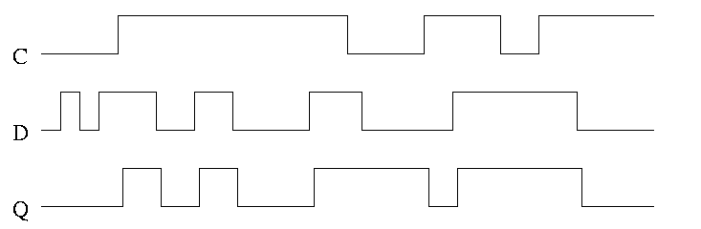

**D or Master-Slave Flip-flop**

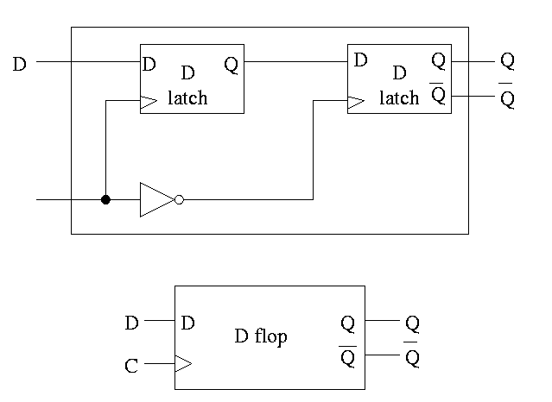

This was our goal. We now have an edge-triggered, clocked memory.

* Built from D latches, which are transparent
* The result is *Not* transparent
* Changes on the active edge
* This one has the falling edge as active edge
* Sometimes called a master-slave flip-flop
* Note substructures with letters reused having different meaning (block structure a la algol)
* Master latch (the left one) is set during the time clock is asserted. Remember that the latch is transparent, i.e. follows its input when its clock is asserted. But the second latch is ignoring its input at this time. When the clock falls, the 2nd latch pays attention and the first latch keeps producing whatever D was at fall-time.
* Actually D must remain constant for some time around the active edge.
  + The *set-up* time *before* the edge
  + The *hold* time *after* the edge
  + See diagram below

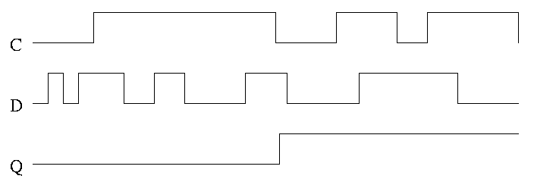

Note how much less wiggly the output is with the master-slave flop than before with the transparent latch. As before we are assuming the output is initially low.

**Homework:** Try moving the inverter to the other latch What has changed?

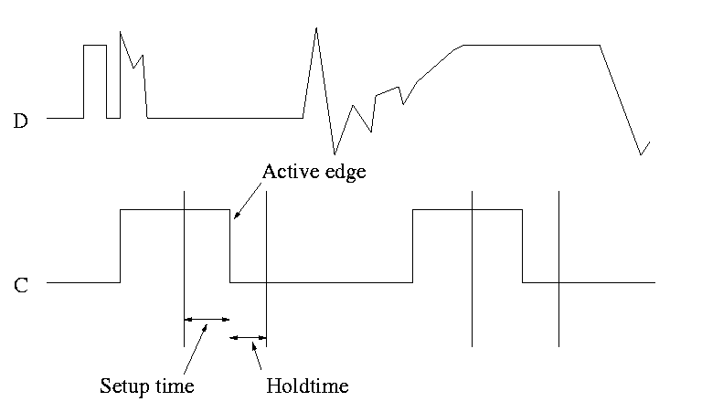

This picture shows the setup and hold times discussed above. It is crucial when building circuits with flip flops that D is stable during the interval between the setup and hold times. Note that D is wild outside the critical interval, but that is OK.

**Homework:** B.18

**start lecture #6**

**Registers**

* Basically just an array of D flip-flops
* But what if you don't want to change the register during a particular cycle?
* Introduce another input, the *write line*

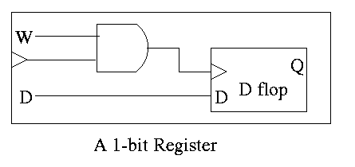

* The write line is used to ``gate the clock''
  + The book forgot the write line.
  + Clearly if the write line is high forever, the clock input to the register is passed right along to the D flop and hence the input to the register is stored in the D flop when the active edge occurs (for us the falling edge).
  + Also clear is that if the write line is low forever, the clock to the D flop is always low so has no edges and no writing occurs.
  + But what about changing the write line?
  + Assert or deassert the write line while the clock is low and keep it at this value until the clock is low again.
  + Not so good! Must have the write line correct quite a while before the active edge. That is you must know whether you are writing quite a while in advance.
  + Better to do things so the write line must be correct when the clock is high (i.e., just before the active edge

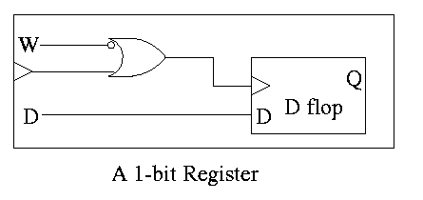

* + An alternative is to use an *active low* write line, i.e. have a W' input.

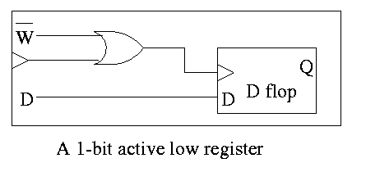

* Must have write line and data line valid during setup and hold times
* To do a multibit register, just use multiple D flopss.

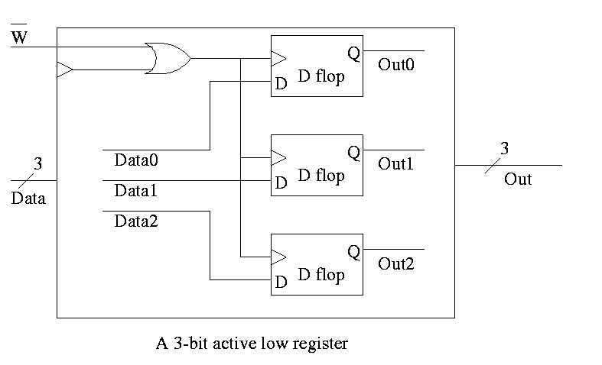

**Register File**

Set of registers each numbered

* Supply reg#, write line, and data (if a write)
* Can read and write same reg same cycle. You read the old value and then the written value replaces this old value for subsequent cycles.
* Often have several read and write ports so that several registers can be read and written during one cycle.
* We will do 2 read ports and one write port since that is needed for ALU ops. This is *Not* adequate for superscalar (or EPIC) or any other system where more than one operation is to be calculated each cycle.

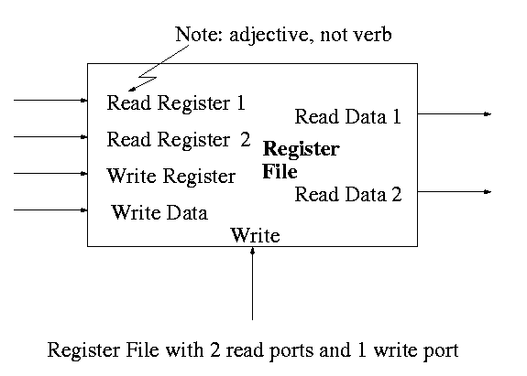

To read just need mux from register file to select correct register.

* Have one of these for each read port
* Each is an n to 1 mux, b bits wide; where
  + n is the number of registers (32 for MIPS)
  + b is the width of each register (32 for MIPS)

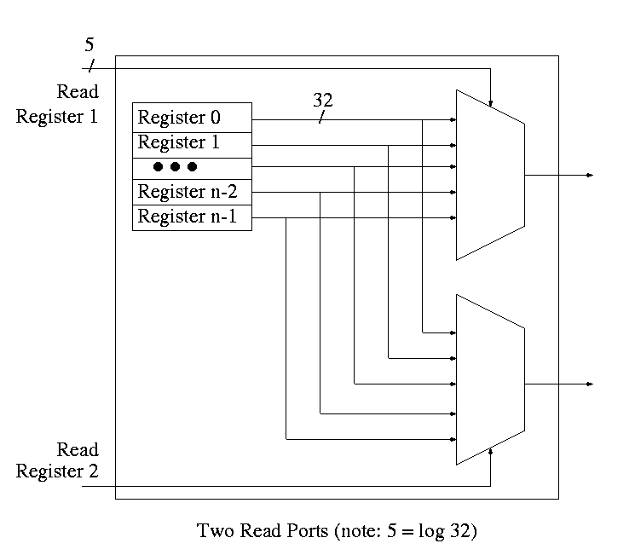

**start lecture #7**

For writes use a decoder on register number to determine which register to write. Note that 3 errors in the book's figure were fixed

* decoder is log n to n
* decoder outputs numbered 0 to n-1 (NOT n)
* clock is needed

The idea is to gate the write line with the output of the decoder. In particular, we should perform a write to register r this cycle providing

* Recall that the inputs to a register are W, the write line, D the data to write (if the write line is asserted) and the clock.
* The clock to each register is simply the clock input to the register file.
* The data to each register is simply the write data to the register file.
* The write line to each register is unique
  + The register number is fed to a decoder.
  + The rth output of the decoder is asserted if r is the specified register.
  + Hence we wish to write register r if
    - The write line to the register file is asserted
    - The rth output of the decoder is asserted
    - Bingo! We just need an and gate.

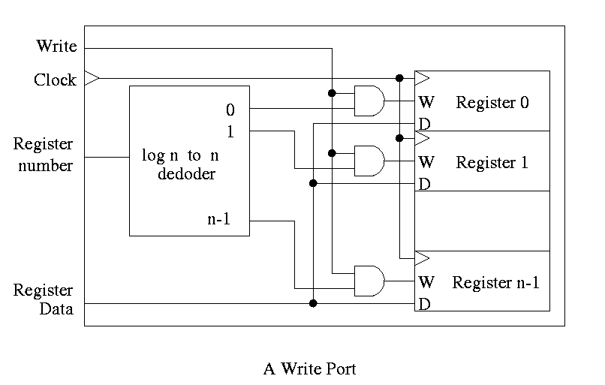

**Homework:** 20

**SRAMS and DRAMS**

* External interface is below
* (Sadly) we will not look inside. Following is unofficial
  + Conceptually like a register file but can't use the implementation above for a large memory because there would be too many wires and the muxes would be too big.
  + Two stage decode
  + Tri-state buffers instead of mux for SRAM. Hence I was fibbing when I said that signals always have a 1 or 0. However, we will not use tristate logic (will use muxes the way we build them
  + DRAM latches whole row but outputs only one (or a few) column(s)
    - So can speed up access to elts in same Row
    - Merged DRAM + CPU a modern hot topic
* Error Correction (Omitted)

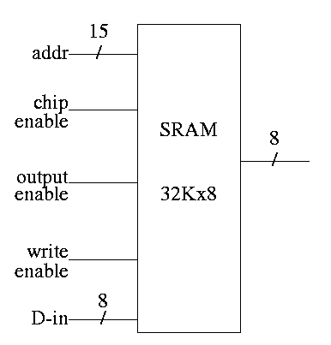

Note: There are other kinds of flip-flops T, J-K. Also one could learn about excitation tables for each. We will *not* cover this material (H&P doesn't either). If interested, see Mano

**Counters**

A **counter** counts (naturally). The counting is done in binary.

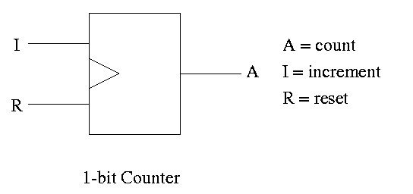

Let's look at the state transition diagram for A, the output of a 1-bit counter.

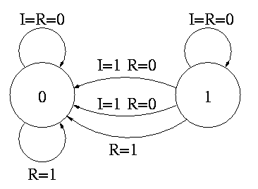

We need one flop and a combinatorial circuit.

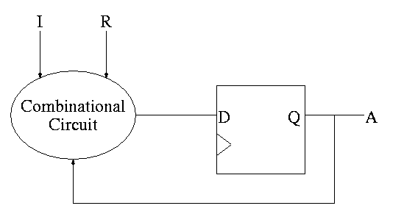

The flop producing A is often itself called A and the D input to this flop is called DA (really D sub A).

Current Next ||

A I R A || DA <-- i.e. to what must I set DA

------------------++-- in order to

0 0 0 0 || 0 get the desired Next A for

1 0 0 1 || 1 the next cycle

0 1 0 1 || 1

1 1 0 0 || 0

x x 1 0 || 0

But this table (without Next A) is the truth table for the combinatorial circuit.

A I R || DA

-------++--

0 0 0 || 0

1 0 0 || 1

0 1 0 || 1

1 1 0 || 0

x x 1 || 0

DA = R' (A XOR I)

**start lecture #8**

How about a two bit counter.

* State diagram has 4 states 00, 01, 10, 11 and transitions from one to another
* The circuit diagram has 2 D flops

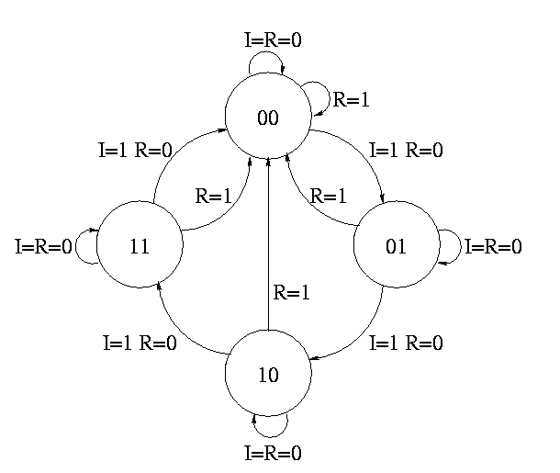

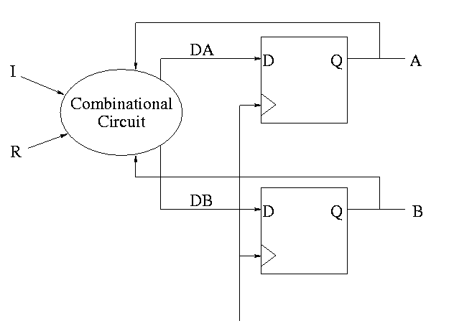

To determine the combinationatorial circuit we could preceed as before

Current Next ||

A B I R A B || DA DB

------------------++------

This would work but we can instead think about how a counter works and see that.

DA = R'(A XOR I)

DB = R'(B XOR AI)

**Homework:** 23

**B.6: Finite State Machines**

Skipped

**B.7 Timing Methodologies**

Skipped

**Chapter 1**

**Homework:** READ chapter 1. Do 1.1 -- 1.26 (really one matching question)  
Do 1.27 to 1.44 (another matching question),  
1.45 (and do 7200 RPM and 10,000 RPM), 1.46, 1.50

**Chapter 3**

**Homework:** Read sections 3.1 3.2 3.3

**3.4 Representing instructions in the Computer (MIPS)**

Register file

* We just learned how to build this
* 32 Registers each 32 bits
* Register 0 is always 0 when read and stores to register 0 are ignored

**Homework:** 3.2

**R-type instruction (R for register)**

op rs rt rd shamt funct

6 5 5 5 5 6

The fields are quite consistent

* op is the opcode
* rs,rt are source operands
* rd is destination
* shamt is the shift amount
* funct is used for op=0 to distinguish alu ops
  + alu is *arithmetic and logic unit*
  + add/sub/and/or/not etc.

Example: add $1,$2,$3

* Machine format: 0--2--3--1--0--21
* op=0, alu op
* funct=21 specifies add
* reg1 <-- reg2 + reg3
* the regs can be the same (doubles the value in the reg)
* Do sub by just changing the funct
* If regs are the same, clears the register

**I-type (why I?)**

op rs rt address

6 5 5 16

* rs is a source reg
* rt is the destination reg
* Transfers to/from memory, normally in words (32-bits)
  + But the machine is byte addressible!
  + Then how come have load/store word instead of byte?
  + Ans: It has load/store byte as well, but we don't cover it.
  + What if the address is not a multiple of 4:
  + Ans: An error (MIPS requires aligned accesses).

lw/sw $1,addr($2)

* machine format is: op 2 1 addr
* $1 <-- Mem[$2+addr]  
  $1 --> Mem[$2+addr]

RISC-like properties of the MIPS architecture

* Instructions of the same length
* Field sizes of R-type and I-type correspond.
* The type (R-type, I-type, etc.) is determined by the opcode
* Note that rs is the ref to memory for both load and store
* These properties will prove helpful when we construct a MIPS processor.

**Branching instruction**

**slt (set less-then)**

* R-type
* Slt $3,$8,$2
* reg3 <-- (if reg8 < reg2 then 1 else 0)
* Like other R-types: read 2nd and 3rd reg, write 1st

**beq and bne (branch (not) equal)**

* I-type
* beq $1,$2,L
* if reg1=reg2 then goto L
* bne $1,$2,L
* if reg1!=reg2 then goto L

**blt (branch if less than)**

* I-type
* blt $5,$8,L
* if reg5 < reg8 then goto L
* **\*\*\* WRONG \*\*\***
* There is no blt instruction.
* Instead use
* stl $1,$5,$8
* bne $1,$0,L

**ble (branch if less than or equal)**

* There is no ``ble $5,$8,L'' instruction.
* Note that $5<=$8 <==> NOT ($8<$5)
* Hence we test for $8<$5 and branch if false
* stl $1,$8,$5
* beq $1,$0,L

**bgt (branch if greater than>**

* There is no ``bgt $5,$8,L'' instruction.
* Note that $5>$8 <==> $8<$5
* Hence we test for $8<$5 and branch if true
* stl $1,$8,$5
* bne $1,$0,L

**bge (branch if greater than or equal>**

* There is no ``bge $5,$8,L'' instruction.
* Note that $5>=$8 <==> NOT ($5<$8)
* Hence we test for $5<$8 and branch if
* stl $1,$5,$8
* beq $1,$0,L

**Note:** Please do not make the mistake of thinking that

stl $1,$5,$8

beq $1,$0,L

is the same as

stl $1,$8,$5

bne $1,$0,L

The negation of X < Y is *not* Y < X

**Homework:** 3.12-3.17

**J-type instructions (J for jump)**

op address

6 26

**j (jump)**

* J type
* Range is 2^26 *words* = 1/4 GB

**jr (jump register)**

* R type, but only one register
* Will it be one of the source registers or the destination register?
* Ans: This will be obvious when we construct the processor

**jal (jump and link)**

* Used for subroutine calls
* J type
* return address is stored in register 31

**I type instructions (revisited)**

* The I is for *immediate*
* These instructions have an *immediate* third operand, i.e., the third operand is contained in the instruction itself.
* This means the operand itself and not just its address or register number are contained in the instruction

**addi (add immediate)**

addi $1,$2,100

Why is there no subi?  
Ans: Make the immediate operand negative.

**slti (set less-than immediate)**

slti $1,$2,50

**\*\*\*\* START LECTURE #9 \*\*\*\***

**Handout Lab #1 and supporting sheets**

* Due in two weeks

**lui (load upper immediate)**

* How can we get a 32-bit constant into reg since we can't have a 32 bit immediate?
  1. Load the word
     + Have the constant placed in the program text (via some assembler directive).
     + Issue lw to load the register
     + But memory accesses are slow and this uses a cache entry
  2. Load shift add
     + Load immediate the high order 16 bits (into the low order of the register).
     + Shift the register left 16 bits (filling low order with zero)
     + Add immediate the low order 16 bits
     + Three instructions, three words of memory
  3. load-upper add
     + Use lui to load immediate the high order 16 bits into the high order bits and clear the low order
     + Add immediate the low order 16 bits.
     + lui $4,123 -- puts 123 into top half of reg4  
       addi $4,$4,456 -- puts 456 into bottom half of reg4

**Homework:** 3.1, 3.3-3.7, 3.9, 3.18, 3.37 (for fun)

**Chapter 4**

**Homework:** Read 4.1-4.4

**Homework:** 4.1-4.9

**4.2: Signed and Unsigned Numbers**

MIPS uses 2s complement (just like 8086)

To form the 2s complement (of 0000 1111 0000 1010 0000 0000 1111 1100)

* take the 1s complement
* That is complement each bit (1111 0000 1111 0101 1111 1111 0000 0011)
* Then add 1 (1111 0000 1111 0101 1111 1111 0000 0100)

Need comparisons for signed and unsigned.

* For signed a leading 1 is smaller (negative) than a leading 0
* For unsigned a leading 1 is larger than a leading 0

**sltu and sltiu**

Just like slt and slti but the comparison is unsigned.

**4.3: Addition and subtraction**

To add two (signed) numbers just add them. That is don't treat the sign bit special.

To subtract A-B, just take the 2s complement of B and add.

**Overflows**

An overflow occurs when the result of an operatoin cannot be represented with the available hardware. For MIPS this means when the result does not fit in a 32-bit word.

* We have 31 bits plus a sign bit.
* The result would definitely fit in 33 bits (32 plus sign)
* The hardware simply discards the carry out of the top (sign) bit
* This is *not* wrong--consider -1 + -1
* 11111111111111111111111111111111 (32 ones is -1)
* + 11111111111111111111111111111111
* ----------------------------------
* 111111111111111111111111111111110 Now discard the carry out
* 11111111111111111111111111111110 this is -2
* The bottom 31 bits are always correct.  
  Overflow occurs when the 32 (sign) bit is set to a value and not the sign.
* Here are the conditions for overflow
* Operation Operand A Operand B Result
* A+B >= 0 >= 0 < 0
* A+B < 0 < 0 >= 0
* A-B >= 0 < 0 < 0
* A-B < 0 >= 0 >= 0
* These conditions are the same as  
  CarryIn to sign position != CarryOut

**\*\*\* START LECTURE #10 \*\*\*\***

> I have a question about the first lab; I'm not sure how we

> would implement a mux, would a series of if-else

> statements be an acceptable option?

No. But that is a good question. if-then-elif...-else

would be a FUNCTIONAL simulation. That is you are

simulating what the mux does but not HOW it does it. For a

gate level simulation, you need to implement the mux in

terms of AND, NOT, OR, XOR and then write code link

Fulladder.c

The implementation of a two way mux in terms of AND OR NOT

is figure B.4 on page B-9 of the text. You need to do a 3

way mux.

**Homework:** (for fun) prove this last statement (4.29)

**addu, subu, addiu**

These add and subtract the same the same was as add and sub, but do not signal overflow

**4.4: Logical Operations**

**Shifts: sll, srl**

* R type, with shamt used and rs *not* used
* sll $1,$2,5  
  reg2 gets reg1 shifted left 5 bits
* Why do we need both sll and srl, i.e, why not just have one of them and use a negative shift amt for the other?  
  Ans: The shift amt is only 5 bits and need shifts from 0 to 31 bits. Hence not enough bits for negative shifts.
* Op is 0 (these are ALU ops, will understand why in a few weeks).

**Bitwise AND and OR: and, or, andi, ori**

No surprises.

* and $r1,$r2,$r3  
  or $r1,$r2,$r3
* standard R-type instruction
* andi $r1,$r2,100  
  ori $r1,$r2,100
* standard I-type

**4.5: Constructing an ALU--the fun begins**

First goal is 32-bit AND, OR, and addition

Recall we know how to build a full adder. Will draw it as

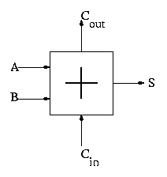

With this adder, the ALU is easy.

* Just choose the correct operation (ADD, AND, OR)
* Note the principle that if you want a logic box that sometimes computes X and sometimes computes Y, what you do is
  1. Compute X and also compute Y
  2. Put both X and Y into a mux
  3. Use the ``sometimes'' condition as the select line to the mux

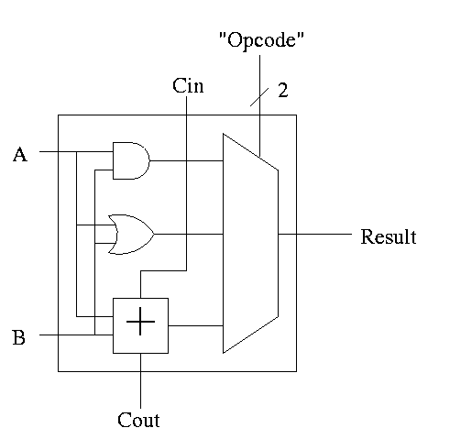

32-bit version is simple.

1. Use an array of logic elements for the logic. The logic element is the 1-bit ALU
2. Use buses for A, B, and Result.
3. ``Broadcast'' Opcode to all of the internal 1-bit ALUs. This means wire the external Opcode to the Opcode input of each of the internal 1-bit ALUs

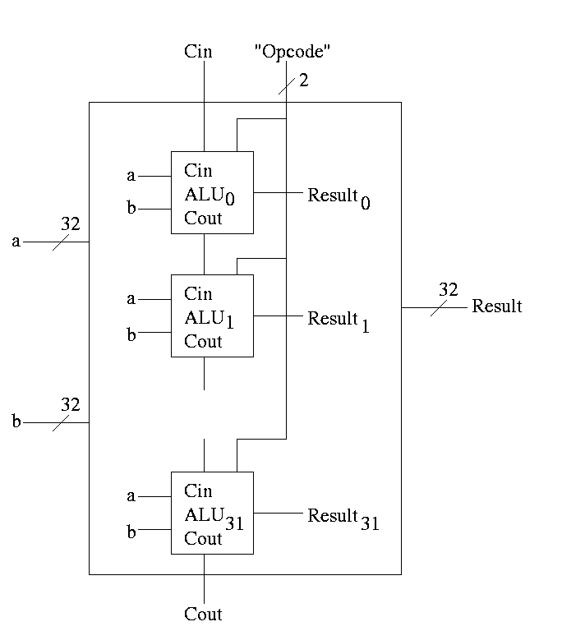

First goal accomplished.

How about subtraction?

* Big deal about 2's compliment is that  
  A - B = A + (2's comp B) = A + (B' + 1)
* Get B' from an inverter (naturally)
* Get +1 from the CarryIn

1-bit ALU with ADD, SUB, AND, OR is

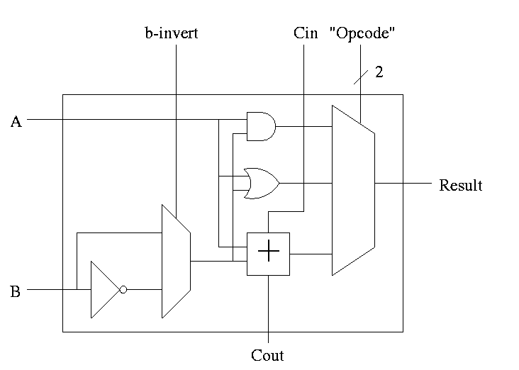

For subtraction set Binvert and Cin.

32-bit version is simply a bunch of these.

* For subtraction assert both B-invert and Cin.
* For addition de-assert both B-invert and Cin.
* For AND and OR d-assert B-invert. Cin is a don't care

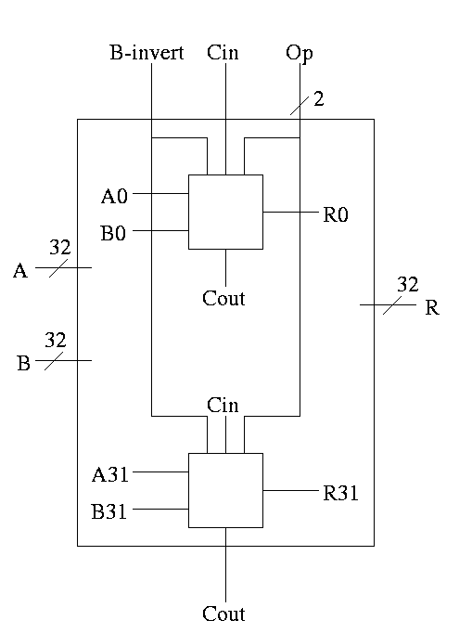

**Simulating Combinatorial Circuits at the Gate Level**

Write a procedure for each logic box with the following properties.

* Parameters for each input and output
* (Local) variable for each (internal) wire
* Can only do AND OR XOR NOT
  + In the C language & | ^ ~
  + Other languages similar
* No conditional assignment; the output is a FUNCTION of the input
* Single assignment to each variable.  
  Multiple assignments would correspond to a cycle
* Bus (set of signals) represented by array
* Testing
  + Exhaustive possible for 1-bit cases
  + Cleverness for n-bit cases (n=32, say)

Handout: [FullAdder.c](http://FullAdder.c) and [FourBitAdder.c](http://FourBitAdder.c).

Lab 1: Do the equivalent for 1-bit-alu (without subtraction). This is easy. Lab 2 will be similar but for a more sophisticated ALU.

Extra requirements for MIPS alu:

1. slt set-less-than
   * Result reg is 1 if a < b  
     Result reg is 0 if a >= b
   * So need to set the LOB (low order bit, aka least significant bit) of the result equal to the sign bit of a subtraction, and set the rest of the result bits to zero.
   * Idea #1. Give the mux another input, called LESS. This input is brought in from outside the bit cell. That is, if the opcode is slt we make the select line to the mux equal to 11 (three) so that the the output is the this new input. For all the bits except the LOB, the LESS input is zero. For the LOB we must figure out how to set LESS.

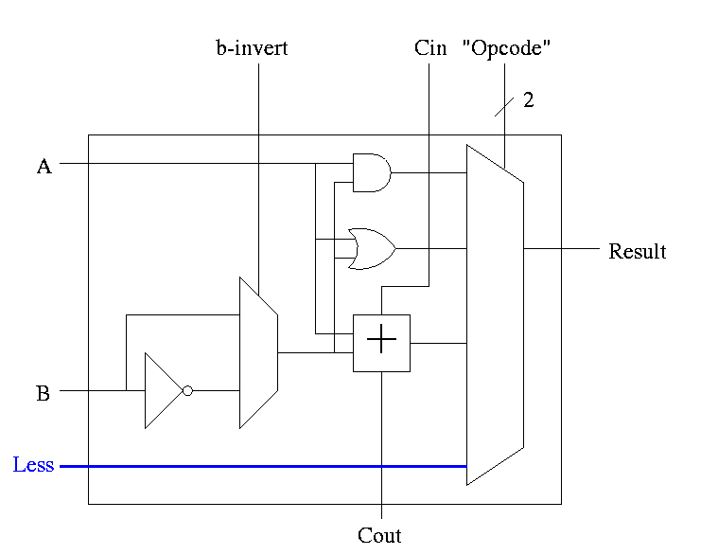

* + Idea #2. Bring out the result of the adder (BEFORE the mux)  
      
    Only needed for the HOB (high order bit, i.e. sign) Take this new output from the HOB, call it SET and connect it to the LESS input in idea #1 for the LOB. The LESS input for other bits are set to zero.

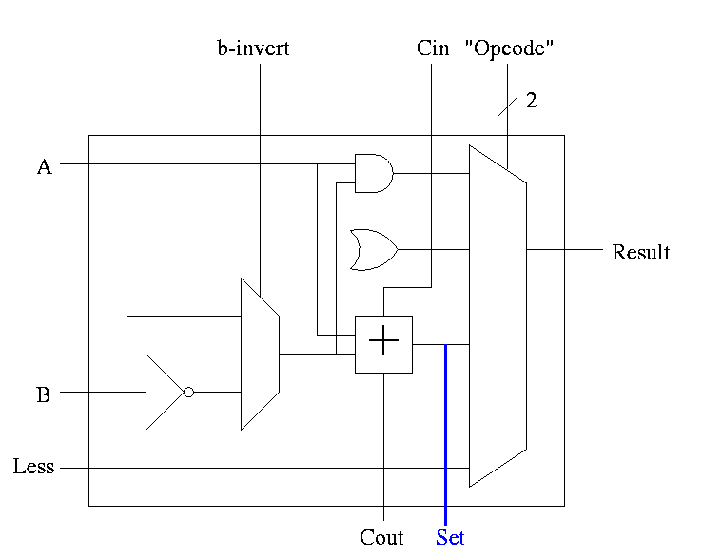

1. Why isn't this method used?
2. Ans: It is wrong!
3. Example using 3 bit numbers (i.e. -4 .. 3). Try slt on -3 and +2. True subtraction (-3 - +2) give -5. The negative sign in -5 indicates (correctly) that -3 < +2. But three bit subtraction -3 - +2 gives +3 ! Hence we will incorrectly conclude that -3 is NOT less than +2. (Really, it signals an *overflow.* unless doing unsigned)
4. Solution: Need the correct rule for less than (not just sign of subtraction)  
     
   **Homework:** figure out correct rule, i.e. prob 4.23. Hint: when an overflow occurs the sign bit is definitely wrong (so the complement of the sign bit is right).
   1. Overflows
      * The HOB is already unique (outputs SET)
      * Need to enhance it some more to produce the overflow output
      * Recall that we gave the rule for overflow: you need to examine
        + Whether add or sub (binvert)
        + The sign of A
        + The sign of B
        + The sign of the result
        + Since this is the HOB we have all the sign bits.
        + The book also uses Cout, but this appears to be an error

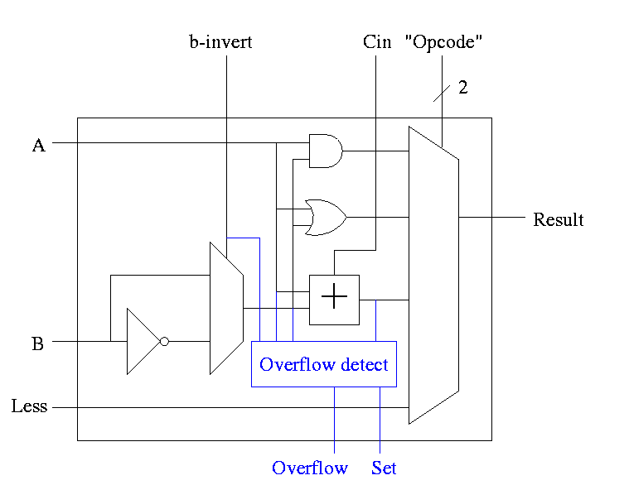

* 1. Simpler overflow detection
     + An overflow occurs if and only if the carry in to the HOB differs from the carry of of the HOB

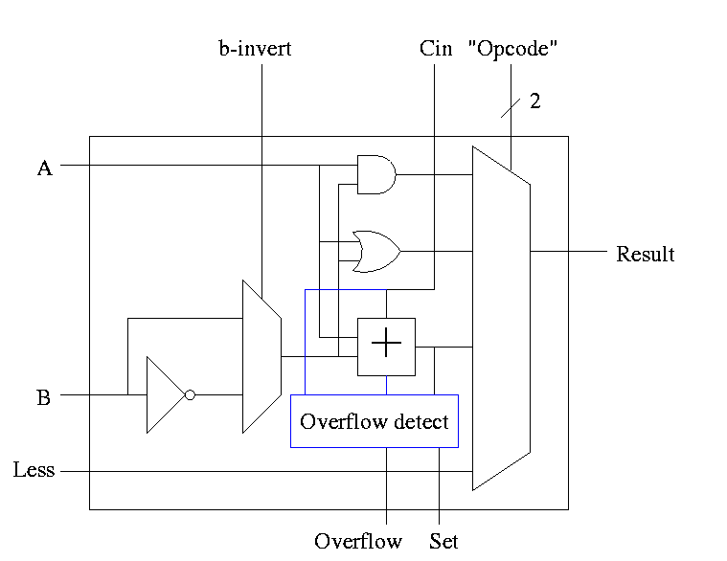

* 1. Zero Detect
     + To see if all bits are zero just need NOR of all the bits
     + Conceptually trivially but does require some wiring
  2. **Observation:** The initial Cin and Binvert are always the same. So just use one input called Bnegate.

The Final Result is

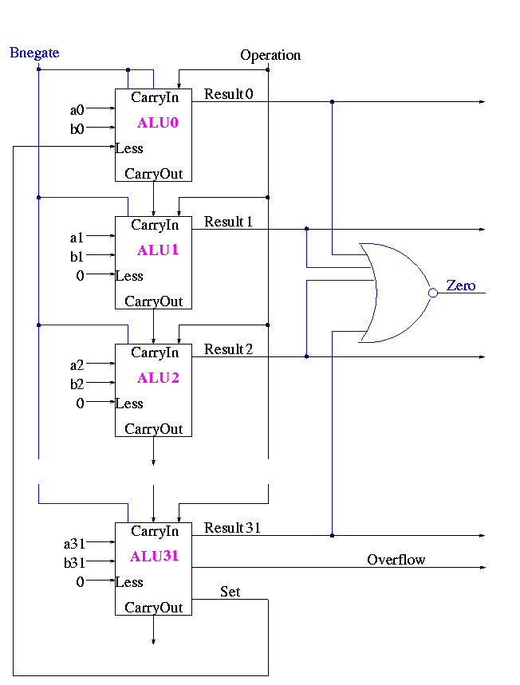

Symbol for the alu is

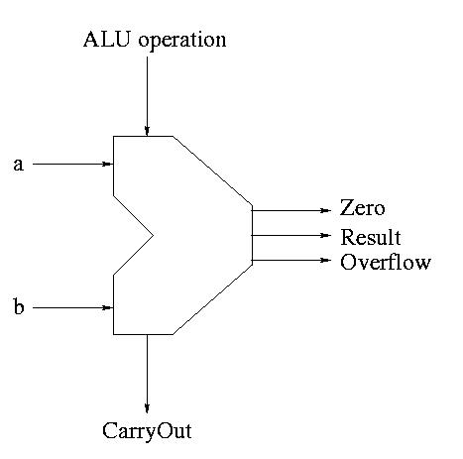

What are the control lines?

* + Bnegate (1 bit)
  + OP (2 bits)

What functions can we perform?

* + and
  + or
  + add
  + sub
  + set on less than

What (3-bit) values for the control lines do we need for each function?

|  |  |  |
| --- | --- | --- |
| and | 0 | 00 |
| or | 0 | 01 |
| add | 0 | 10 |
| sub | 1 | 10 |
| slt | 1 | 11 |

**\*\*\* START LECTURE #11 \*\*\*\***

Adders

* 1. We have done what is called a ripple carry adder.  
     The carry "ripples" from one bit to the next (LOB to HOB).  
     So the time required is proportional to the wordlength.  
     Each carry can be computed with two levels of logic (any function can be so computed) hence the number of gate delays is 2*wordsize.
  2. What about doing the entire 32 (or 64) bit adder with 2 levels of logic?
     + Such a circuit clearly exists. Why?
     + Ans: A two levels of logic circuit exists for *any* function.
     + But it would be very expensive: many gates and wires.
     + The big problem: The AND and OR gates have high fan-in, i.e., they have a large number of inputs. It is *not* true that a 64-input AND takes the same time as a 2-input AND.
     + Unless you are doing full custom VLSI, you get a toolbox of primative functions (say 4 input NAND) and must build from that
  3. There are faster adders, e.g. carry lookahead and carry save. We will study the carry lookahead.

**Carry Lookahead adders**

We did a ripple adder

* 1. The delay proportional to # bits.
  2. In detail, each bit the CarryOut uses two levels of logic after the CarryIn is stable.
  3. So the delay for calculating an n-bit sum is 2n gate delays.
  4. For 4 bits the delay is 8
  5. For 16, delay is 32
  6. For 32, delay is 64
  7. For 64, delay is 128

We will now do the carry lookahead adder, which is much faster, especially for many bit (e.g. 64 bit) addition.

For each bit we can in one gate delay calculate

generate a carry gi = ai bi

propogate a carry pi = ai+bi

H&P give a [plumbing analogue](http://hp-figs-4.22.pdf) for generate and propogate.

Given the generates and propogates, we can calculate all the carries for a 4-bit addition (recall that c0=Cin is an input) as follows

c1 = g0 + p0 c0

c2 = g1 + p1 c1 = g1 + p1 g0 + p1 p0 c0

c3 = g2 + p2 c2 = g2 + p2 g1 + p2 p1 g0 + p2 p1 p0 c0

c4 = g3 + p3 c3 = g3 + p3 g2 + p3 p2 g1 + p3 p2 p1 g0 + p3 p2 p1 p0 c0

Thus we can calculate c1 ... c4 in just two additional gate delays (where we assume one gate can accept upto 5 inputs). Since we get gi and pi after one gate delay, the total delay for calculating all the carries is 3 (this includes c4=CarryOut)

Each bit of the sum si can be calculated in 2 gate delays given ai, bi, and ci. Thus 5 gate delays after we are given a, b and CarryIn, we have calculated s and CarryOut

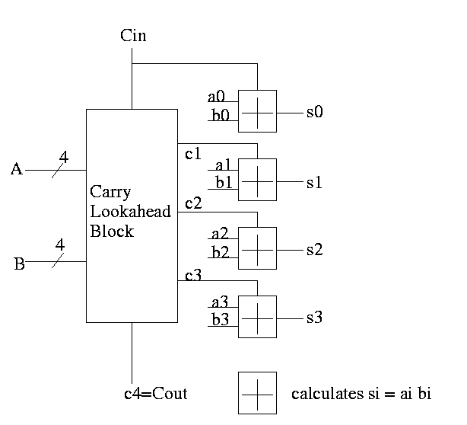

So for 4-bit addition the faster adder takes time 5 and the slower adder time 8.

Now we want to put four of these together to get a fast 16-bit adder. Again we are assuming a gate can accept upto 5 inputs. It is important that the number of inputs per gate does not grow with the size of the numbers to add. If the technology available supplies only 4-input gates, we would use groups of 3 bits rather than four.

We start by determining ``supergenerate'' and ``superpropogate'' bits. The super propogate indicates whether the **4-bit adder** constructed above generates a CarryOut or propogates a CarryIn to a CarryOut

P0 = p3 p2 p1 p0 Does the low order 4-bit adder

propogate a carry?

P1 = p7 p6 p5 p4

P2 = p11 p10 p9 p8

P3 = p15 p14 p13 p12 Does the high order 4-bit adder

propogate a carry?

G0 = g3 + p3 g2 + p3 p2 g1 + p3 p2 p1 g0 Does low order 4-bit

adder generate a carry

G1 = g7 + p7 g6 + p7 p6 g5 + p7 p6 p5 g4

G2 = g11 + p11 g10 + p11 p10 g9 + p11 p10 p9 g8

G3 = g15 + p15 g14 + p15 p14 g13 + p15 p14 p13 g12

C1 = G0 + P0 c0

C2 = G1 + P1 C1 = G1 + P1 G0 + P1 P0 c0

C3 = G2 + P2 C2 = G2 + P2 G1 + P2 P1 G0 + P2 P1 P0 c0

C4 = G3 + P3 C3 = G3 + P3 G2 + P3 P2 G1 + P3 P2 P1 G0 + P3 P2 P1 P0 c0

From these C's you just need to do a 4-bit CLA since the C's are the CarryIns for each group of 4-bits out of the 16-bits.

How long does this take, again assuming 5 input gates?

* 1. We calculate the P's one gate delay after we have the p's. Since the pj's are determined 1 gate delay after we are given the a's and b's. So we have all Pi 2 gate delays after we start.
  2. The G's are determined 2 gate delays after we have the g's and p's. So the G's are done 3 gate delays after we start.
  3. The C's are determined 2 gate delays after the P's and G's. So the C's are done 5 gate delays after we start.
  4. Now the C's are sent back to the 4-bit adders, which have already calculated the p's and g's. Hence the c's are calculated in 2 more gate delays (7 total) and the s's 2 more after that (9 total).
  5. So a 16-bit CLA takes 9 cycles instead of 32 for a ripple carry adder.

Some pictures follow.

Take our original picture of the 4-bit CLA and collapse the details so it looks like.

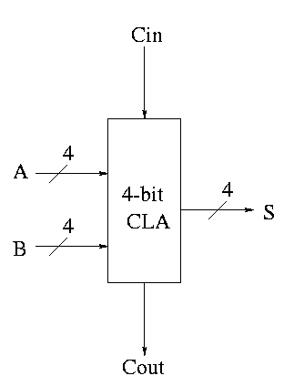

Next include the logic to calculate P and G

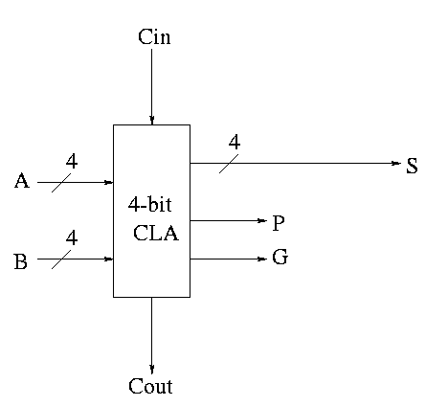

Now put four of these with a CLA block (to calculate C's from P's, G's and Cin) and we get a 16-bit CLA. Note that we do not use the Cout from the 4-bit CLAs.

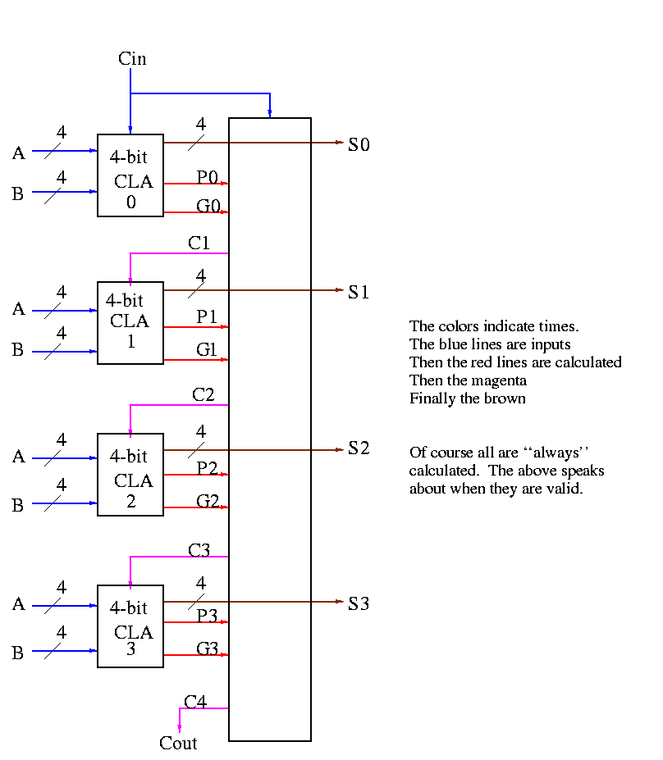

Note that the tall skinny box is general. It takes 4 Ps 4Gs and Cin and calculates 4Cs. The Ps can be propogates, superpropogates, superduperpropogates, etc. That is, you take 4 of these 16-bit CLAs and the same tall skinny box and you get a 64-bit CLA.

**Homework:** 4.44, 4.45

**\*\*\* START LECTURE #12 \*\*\*\***

As noted just above the tall skinny box is useful for all size CLAs. To expand on that point and to review CLAs, let's redo CLAs with the general box.

Since we are doing 4-bits at a time, the box takes 9=2*4+1 input bits and produces 6=4+2 outputs

* 1. Inputs
     + 4 generate bits from the previous size (i.e. if now doing a 64-bit CLA, these are the generate bits from the four 16-bit CLAs). Let's call these bits Gin0, Gin1, Gin2, Gin3.
     + 4 propogate bits from the previous size Pin0, Pin1, Pin2, Pin3.
     + The Carry in Cin
  2. Outputs
     + Four carries C1, C2, C3, and C4 to be used in the previous size
       - Cin is also called C0 and is used in the previous size as well as in this box.
       - C4 is also called Cout. It is the carry out from this size, but is *not* used in the *next* size
     + Gout and Pout, the generate and propogate to be used in the *next* size
  3. Formulas
  4. C1 = G0 + PO Cin
  5. C2 = G1 + P1 G0 + P1 P0 Cin
  6. C3 = G2 + P2 G1 + P2 P1 G0 + P2 P1 P0 Cin
  7. C4 = G3 + P3 G2 + P3 P2 G1 + P3 P2 P1 G0 + P3 P2 P1 P0 Cin
  8. Gout = G3 + P3 G2 + P3 P2 G1 + P3 P2 P1 Go
  9. Pout = P3 P2 P1 P0
  10. Picture

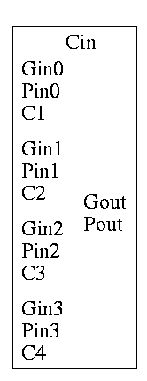

A 4-bit adder is now

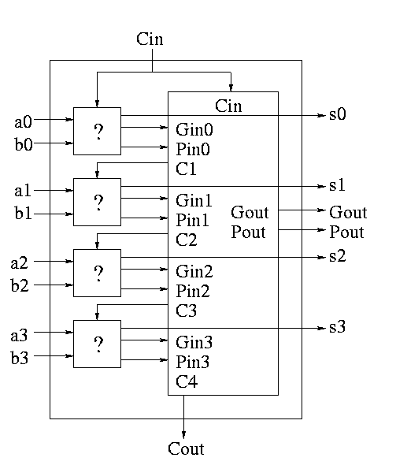

What does the ``?'' box do?

* 1. Calculates Gi and Pi based on ai and bi
     + Gi = ai bi
     + Pi = ai + bi
  2. Calculate s1 based on ai, bi, and Ci=Cin (normal full adder)
  3. Do not bother calculating Cout

Now take four of these 4-bit adders and use the *identical* CLA box to get a 16-bit adder

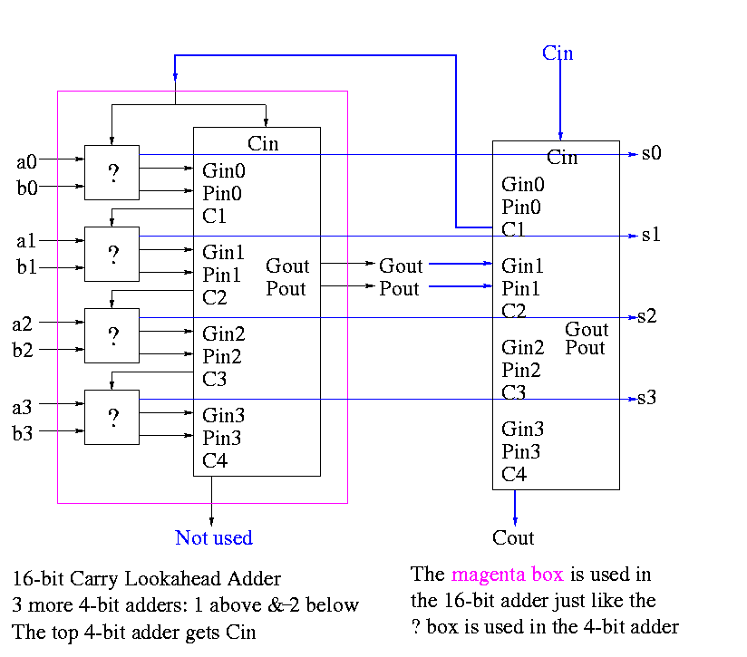

Four of these 16-bit adders with the *identical* CLA box to gives a 64-bit adder.

**Shifter**

* 1. Just a string of D-flops; output of one is input of next
     + Input to first is the *serial input*.
     + Output of last is the *serial output*.

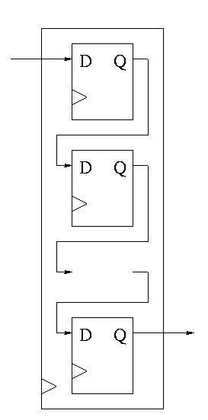

* 1. We want more.
     + Left and right shifting (with serial input/output)
     + Parallel load
     + Parallel Output
     + Don't shift every cycle
  2. Parallel output is just wires.
  3. Shifter has 4 modes (left-shift, right-shift, nop, load) so
     + 4-1 mux inside
     + 2 control lines must come in

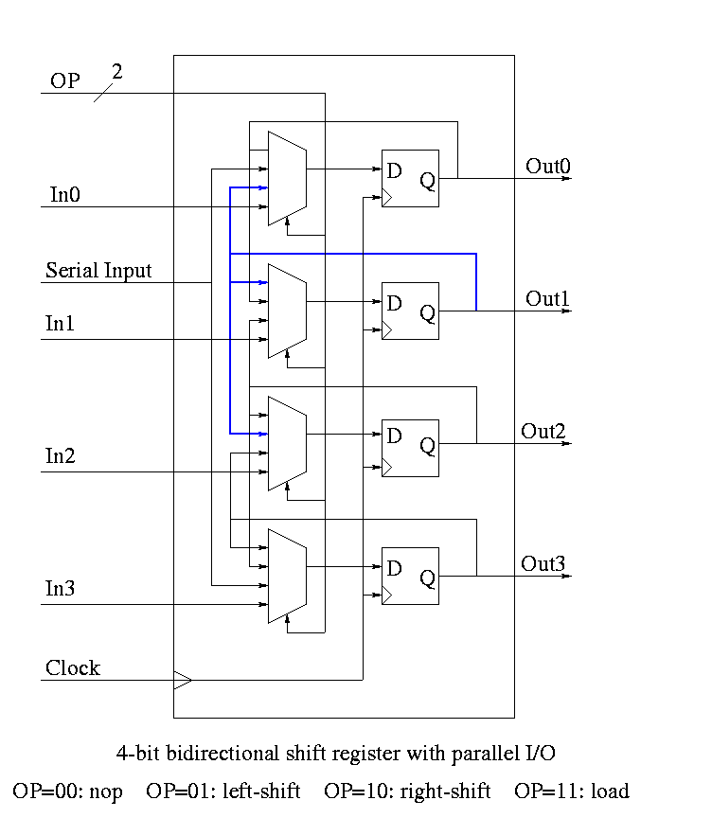

* 1. We could modify our registers to be shifters (bigger mux), but ...
  2. Our shifters are slow for big shifts; ``barrel shifters'' are better

**Homework:** A 4-bit shift register initially contains 1101. It is shifted six times to the right with the serial input being 101101. What is the contents of the register after each shift.

**Homework:** Same register, same init condition. For the first 6 cycles the opcodes are left, left, right, nop, left, right and the serial input is 101101. The next cycle the register is loaded (in parallel) with 1011. The final 6 cycles are the same as the first 6. What is the contents of the register after each cycle?

**Multipliers**

* 1. Recall how to do multiplication.
     + Multiplicand times multiplier gives product
     + Multiply multiplicand by each digit of multiplier
     + Put the result in the correct column
     + Then add the partial products just produced
  2. We will do it the same way ...  
     ... but differently
     + We are doing binary arithmetic so each ``digit'' of the multiplier is 1 or zero.
     + Hence ``multiplying'' the mulitplicand by a digit of the multiplier means either
       - Getting the multiplicand
       - Getting zero
     + Use an ``if appropriate bit of multiplier is 1'' stmt
     + To get the ``appropriate bit''
       - Start with the LOB of the multiplier
       - Shift the multiplier right (so the next bit is the LOB)
     + Putting in the correct column means putting it one column further left that the last time.
     + This is done by shifting the multiplicand left one bit each time (even if the multiplier bit is zero)
     + Instead of adding partial products at end, keep a running sum
       - If the multiplier bit is zero add the (shifted) multiplicand to the running sum
       - If the bit is zero, simply skip the addition.
  3. This results in the following algorithm

product <- 0

for i = 0 to 31

if LOB of multiplier = 1

product = product + multiplicand

shift multiplicand left 1 bit

shift multiplier right 1 bit

Do on board 4-bit addition (8-bit registers) 1100 x 1101

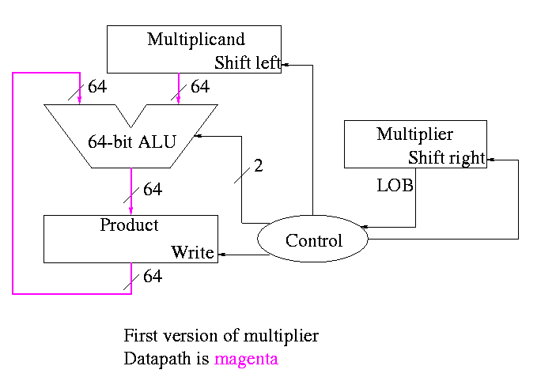

What about the control?

* 1. Always give the ALU the ADD operation
  2. Always send a 1 to the multiplicand to shift left
  3. Always send a 1 to the multiplier to shift right
  4. Pretty boring so far but
     + Send a 1 to write line in product if and only if LOB multiplier is a 1
     + I.e. send LOB to write line
     + I.e. it really is pretty boring

**\*\*\* START LECTURE #13 \*\*\*\***

This works!  
but, when compared to the better solutions to come, is wasteful of resourses and hence is

* 1. slower
  2. hotter
  3. bigger
  4. all these are bad

The product register must be 64 bits since the product is 64 bits

Why is multiplicand register 64 bits?

* 1. So that we can shift it left
  2. I.e., for our convenience.   
     By this I mean it is not required by the problem specification,  
     but only by the solution method chosen.

Why is ALU 64-bits?

* 1. Because the product is 64 bits
  2. But we are only adding a 32-bit quantity to the product at any one step.
  3. Hmmm.
  4. Maybe we can just pull out the correct bits from the product.
  5. Would be tricky to pull out bits in the middle because which bits to pull changes each step

POOF!! ... as the smoke clears we see an idea.

We can solve both problems at once

* 1. DON'T shift the multiplicand left
     + Hence register is 32-bits.
     + Also register need not be a shifter
  2. Instead shift the product right!
  3. Add the high-order (HO) 32-bits of product register to multiplicand and place result back into HO 32-bits
     + Only do this if the current multiplier bit is one.
     + Use the Carry Out of the sum as the new bit to shift in
     + The book forgot the last point but their example used numbers too small to generate a carry

This results in the following algorithm

product <- 0

for i = 0 to 31

if LOB of multiplier = 1

(serial_in, product[32-63]) <- product[32-63] + multiplicand

shift product right 1 bit

shift multiplier right 1 bit

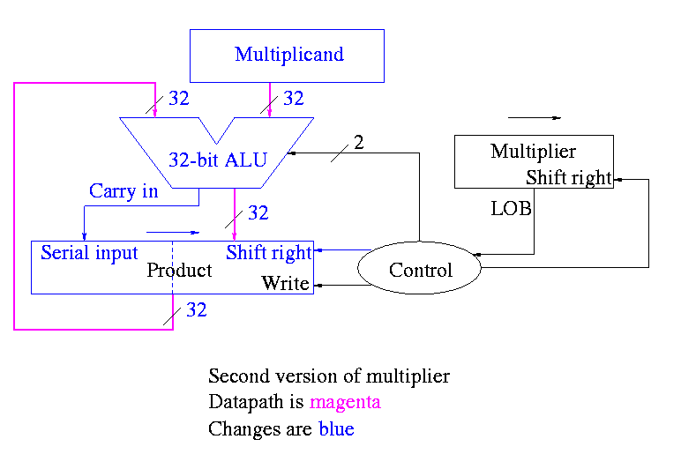

What about control

* 1. Just as boring as before
  2. Send (ADD, 1, 1) to (ALU, multiplier (shift right), Product (shift right))
  3. Send LOB to Product (write)

Redo same example on board

A final trick (``gate bumming'', like code bumming of 60s)

* 1. There is a waste of registers, i.e. not full unilization
     + The multiplicand is fully unilized since we always need all 32 bits
     + But once we use a multiplier bit, we can toss it so we need less and less of the multiplier as we go along
     + And the product is half unused at beginning and only slowly ...
     + POOF!!
  2. ``Timeshare'' the LO half of the ``product register''
     + In the beginning LO half contains the multiplier
     + Each step we shift right and more goes to product less to multiplier
  3. The algorithm changes to

product[0-31] <- multiplier

for i = 0 to 31

if LOB of product = 1

(serial_in, product[32-63]) <- product[32-63] + multiplicand

shift product right 1 bit

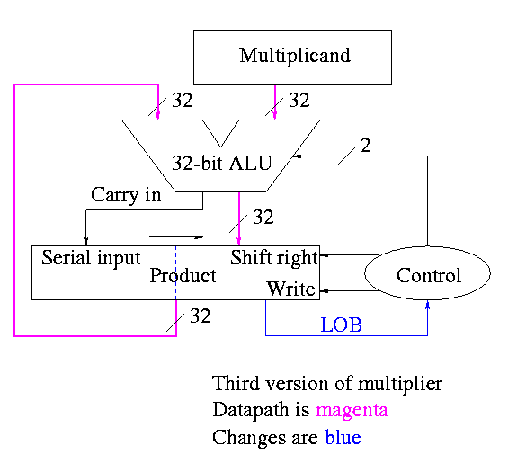

Control again boring

* 1. Send (ADD, 1) to (ALU, Product (shift right))
  2. Send LOB to Product (write)

Redo same example on board

The above was for unsigned 32-bit multiplication

For signed multiplication

* 1. Save the signs of the multiplier and multiplicand
  2. Convert multiplier and multiplicand to non-neg numbers
  3. Use above algorithm
  4. Only use 31 steps not 32 since there are only 31 multiplier bits (the HOB of the multiplier is the sign bit, not a bit used for multiplying)
  5. Compliment product if original signs were different

There are faster multipliers, but we are not covering them.

We are skiping division.

We are skiping floating point.

**Homework:** Read 4.11 ``Historical Perspective''.

**\*\*\* START LECTURE #14 \*\*\*\***

Midterm Exam

**\*\*\* START LECTURE #15 \*\*\*\***

Lab 2. Due in three weeks. Modify lab 1 to deal with sub, slt, zero detect, overflow. Also lab 2 is to be 32 bits. That is, Figure 4.18.

Go over the exam.

**Chapter 5: The processor: datapath and control**

**Homework:** Start Reading Chapter 5.

**5.1: Introduction**

We are going to build the MIPS processor

Figure 5.1 redrawn below shows the main idea

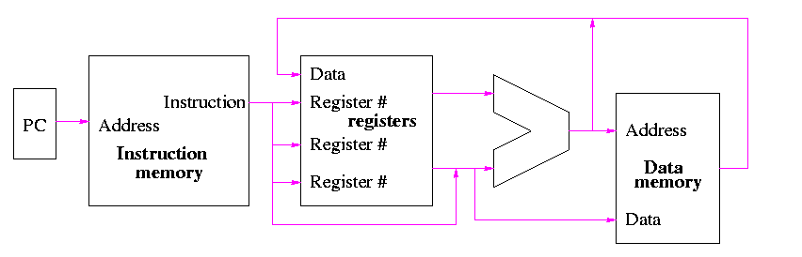

Note that the instruction gives the three register numbers as well as an immediate value to be added.

* 1. No instruction actually does all this
  2. We have datapaths for all possibilities
  3. Will see how we arrange for only certain datapaths to be used for each instruction type
     + For example R type uses all three registers but not the immediate field
     + The I type uses the immediate but not all three registers
  4. The memory address for a load or store is the sum of a register and an immediate
  5. The data value to be stored comes from a register

**5.2: Building a datapath**

Let's begin doing the pieces in more detail.

**Instruction fetch**

We are ignoring branches for now.

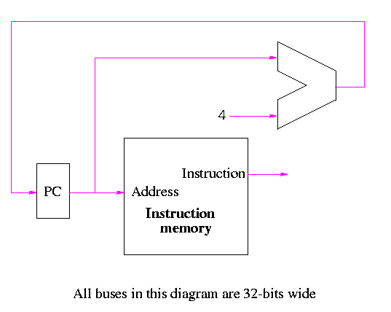

* 1. How come no write line for the PC register?
  2. Ans: We write it every cycle.
  3. How come no control for the ALU
  4. Ans: This one always adds

**R-type instructions**

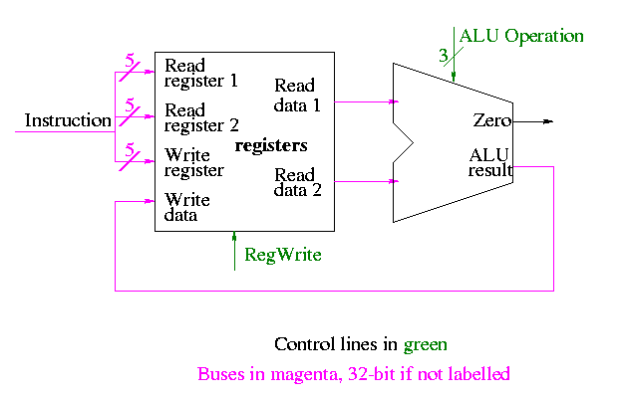

* 1. ``Read'' and ``Write'' in the diagram are adjectives not verbs.
  2. The 32-bit bus with the instruction is divided into three 5-bit buses for each register number (plus other wires not shown).
  3. Two read ports and one write port, just as we learned in chapter 4
  4. The 3-bit control consists of Bnegate and Op from chapter 4

**======== START LECTURE #16 ========**

**Don't forget the mirror site. My main website will be going down for an OS upgrade. Start at http://cs.nyu.edu/**

**load and store**

lw $r,disp($s)

sw $r,disp($s)

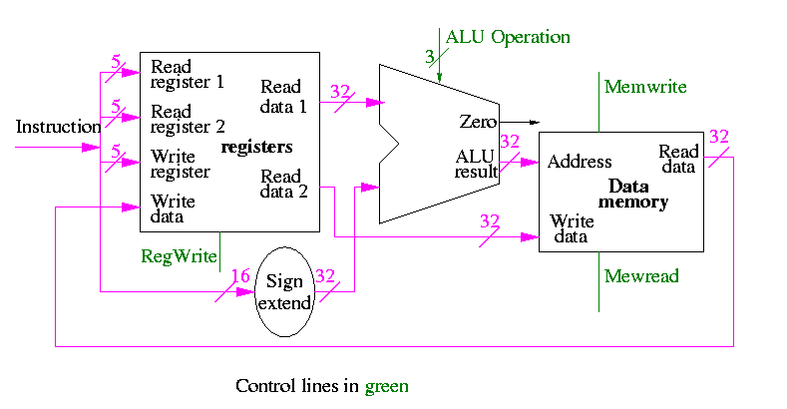

* 1. lw $r,disp($s):
     + Computes the effective address formed by adding the 16-bit immediate constant ``disp'' to the contents of register $s.
     + Fetches the value from this address.
     + Inserts this value into register $r
  2. sw $r,disp($s):
     + Computes the same effective address as lw $r,disp($s)
     + Stores the contents of register $r into this address
  3. We have a 32-bit adder so need to extend the 16-bit immediate constant to 32 bits. Produce an additional 16 HOBs all equal to the sign bit of the 16-bit immediate constant. This is called *sign extending* the constant.
  4. I previously said that the address was a word address and that the hardware shifted the address 2 bits. This is *wrong* and has been [corrected](NULL#byte-addressed).

There is a cheat here.

* 1. For lw we read register r (and read s)
  2. For sw we write register r (and read s)
  3. But we indicate that the same bits in the register always go to the same ports in the register file.
  4. We are ``mux deficient''.
  5. We will put in the mux later

**Branch on equal (beq)**

Compare two registers and branch if equal

* 1. To check for equal we subtract and test for zero (our ALU does this)
  2. If $r=$s, the target of the branch beq $r,$s,disp is the sum of
     + The program counter PC *after* it has been incremented, that is the address of the next sequential instruction
     + The 16-bit immediate constant ``disp'' (treated as a signed number) left shifted 2 bits.
  3. The value of PC after the increment is available. We computed it in the basic instruction fetch datapath.
  4. Since the immediate constant is signed it must be sign extended.

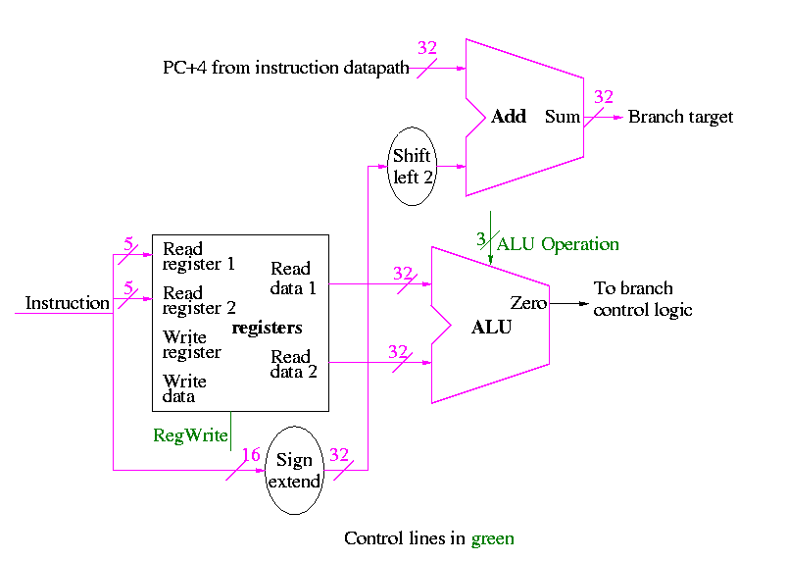

* 1. The top ``alu symbol'' labeled ``add'' is just an adder so does not need any control
  2. The shift left 2 is not a shifter. It simply moves wires and includes two zero wires. We need a 32-bit version. Below is a 5 bit version.

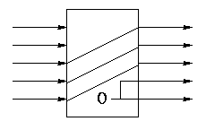

**5.3: A simple implementation scheme**

We will just put the pieces together and then figure out the control lines that are needed and how to set them. We are not now worried about speed.

We are assuming that the instruction memory and data memory are separate. So we are not permitting self modifying code. We are not showing how either memory is connected to the outside world (i.e. we are ignoring I/O).

We have to use the same register file with all the pieces since when a load changes a register a subsequent R-type instruction must see the change, when an R-type instruction makes a change the lw/sw must see it (for loading or calculating the effective address, etc.

We could use separate ALUs for each type but it is easy not to so we will use the same ALU for all. We do have a separate adder for incrementing the PC.

**Combining R-type and lw/sw**

The problem is that some inputs can come from different sources.

* 1. For R-type, both ALU operands are registers. For I-type (lw/sw) the second operand is the (sign extended) immediate field.
  2. For R-type, the write data comes from the ALU. For lw it comes from the memory.
  3. For R-type, the write register comes from field rd, which is bits 15-11. For sw, the write register comes from field rt, which is bits 20-16.

We will deal with the first two now by using a mux for each. We will deal with the third shortly by (surprise) using a mux.

**Combining R-type and lw/sw**

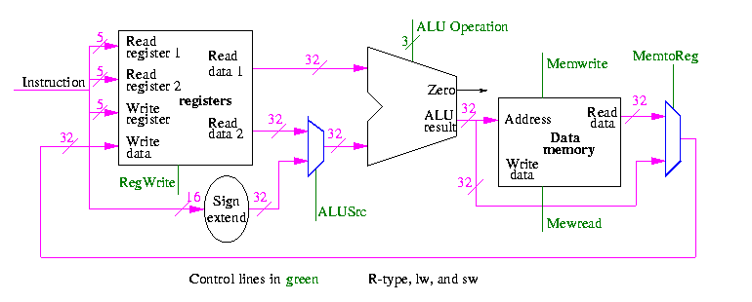

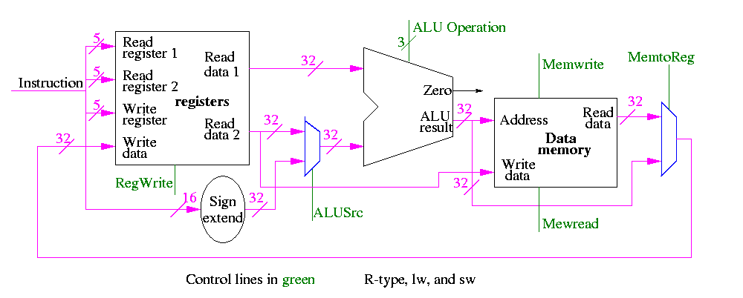

**Including instruction fetch**

This is quite easy

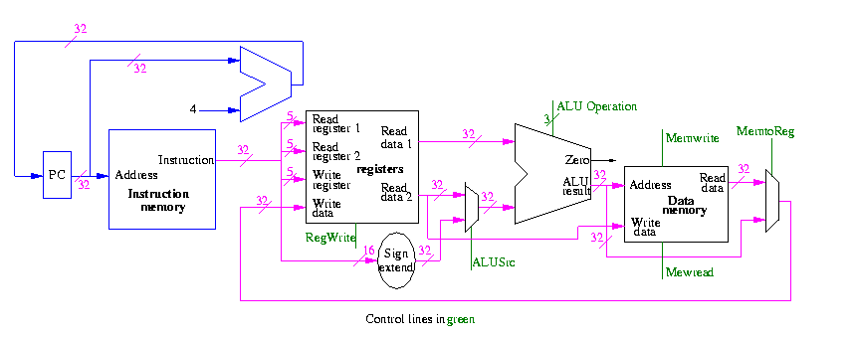

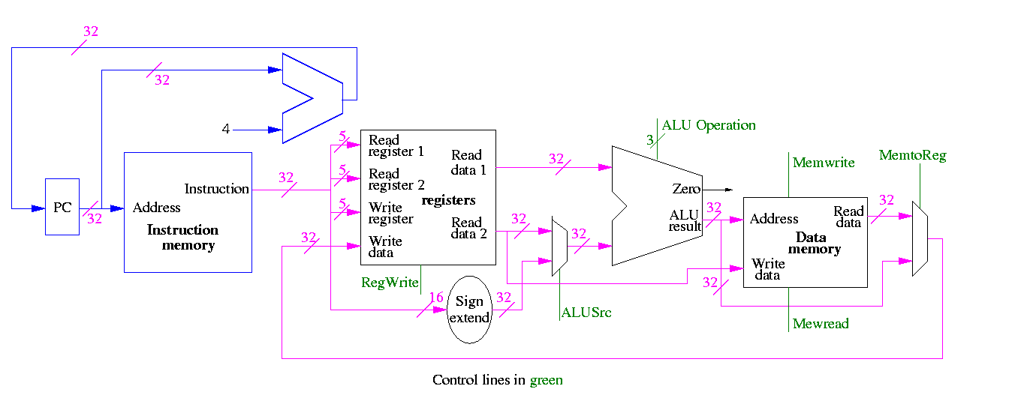

**Finally, beq**

We need to have an ``if stmt'' for PC (i.e., a mux)

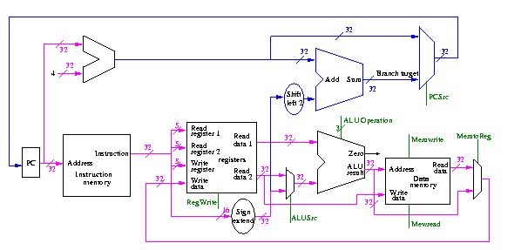

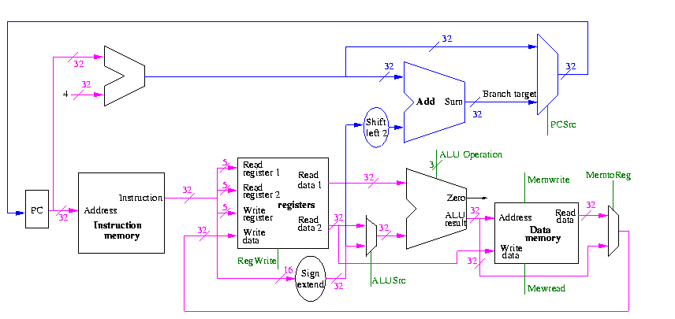

**Homework:**

* 1. 5.5 and 5.8 (just datapaths not control)
  2. 5.9

**======== START LECTURE #17 ========**

**The control for the datapath**

We start with our last figure, which shows the data path and then add the missing mux and show how the instruction is broken down.

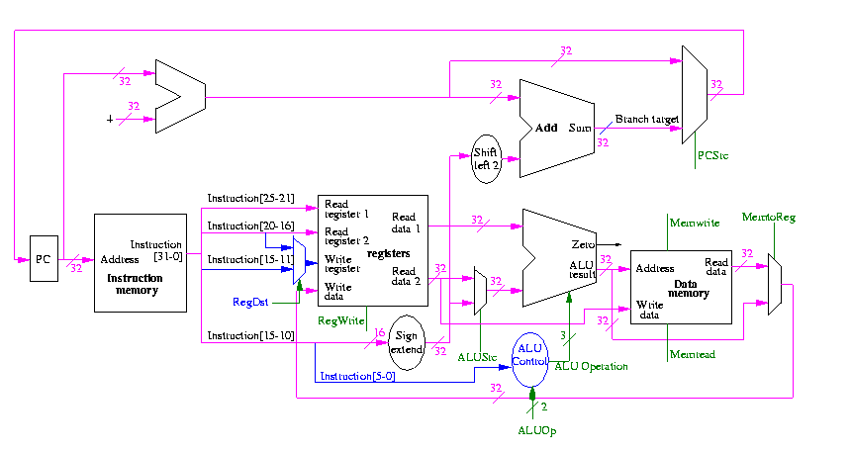

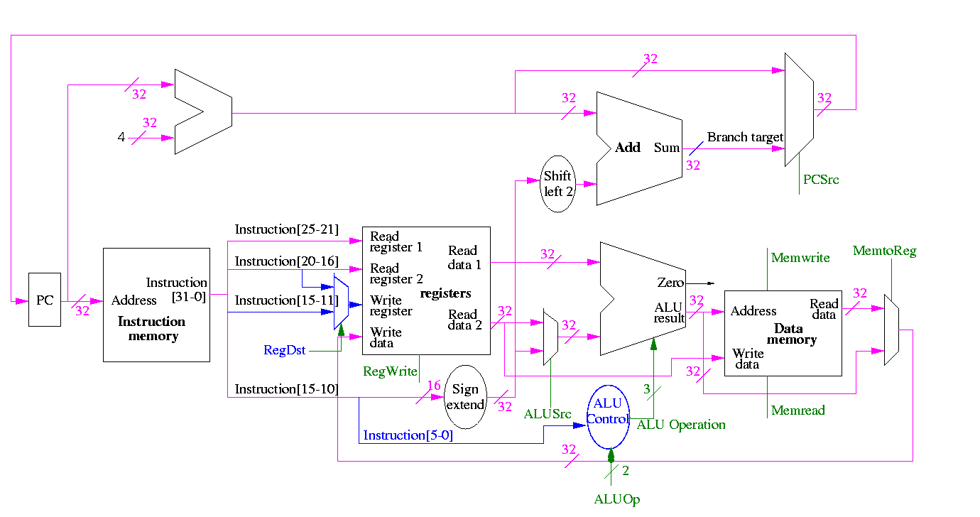

We need to set the muxes.

We need to generate the three ALU cntl lines: 1-bit Bnegate and 2-bit OP

And 0 00

Or 0 01

Add 0 10

Sub 1 10

Set-LT 1 11

**Homework:** What happens if we use 1 00? if we use 1 01? Ignore the funny business in the HOB. The funny business ``ruins'' these ops.

What information can we use to decide on the muxes and alu cntl lines?

The instruction!

* 1. Opcode field (6 bits)
  2. For R-type the funct field (6 bits)

So no problem, just do a truth table.

* 1. 12 inputs, 3 outputs
  2. 4096 rows, 15 columns, > 60K entries
  3. HELP!

We will let the main control (to be done later) ``summarize'' the opcode for us. It will generate a 2-bit field ALUop

ALUop Action needed by ALU

00 Addition (for load and store)

01 Subtraction (for beq)

10 Determined by funct field (R-type instruction)

11 Not used

How many entries do we have now in the truth table

* 1. Instead of a 6-bit opcode we have a 2-bit summary.
  2. We still have a 6-bit function (funct) field
  3. So now we have 8 inputs (2+6) and 3 outputs
  4. 256 rows, 11 columns; ~2800 entries
  5. Certainly easy for automation ... but we will be clever
  6. We only have 8 MIPS instructions that use the ALU (fig 5.15).

|  |  |  |  |  |  |
| --- | --- | --- | --- | --- | --- |
| **opcode** | **ALUop** | **operation** | **funct field** | **ALU action** | **ALU cntl** |
| LW | 00 | load word | xxxxxx | add | 010 |
| SW | 00 | store word | xxxxxx | add | 010 |
| BEQ | 01 | branch equal | xxxxxx | subtract | 110 |
| R-type | 10 | add | 100000 | add | 010 |
| R-type | 10 | subtract | 100010 | subtract | 110 |
| R-type | 10 | AND | 100100 | and | 000 |
| R-type | 10 | OR | 100101 | or | 001 |
| R-type | 10 | SLT | 101010 | set on less than | 111 |

* 1. The first two rows are the same
  2. When funct is used its two HOBs are 10 so are don't care
  3. ALUop=11 impossible ==> 01 = X1 and 10 = 1X
  4. So we get

ALUop | Funct || Bnegate:OP

1 0 | 5 4 3 2 1 0 || B OP

------+--------------++------------

0 0 | x x x x x x || 0 10

x 1 | x x x x x x || 1 10

1 x | x x 0 0 0 0 || 0 10

1 x | x x 0 0 1 0 || 1 10

1 x | x x 0 1 0 0 || 0 00

1 x | x x 0 1 0 1 || 0 01

1 x | x x 1 0 1 0 || 1 11

* 1. How would we implement this?
  2. A circuit for each of the three output bits.
  3. Must decide when each output bit is 1.
  4. We do this one output bit at a time.
     + When is Bnegate (called Op2 in book) asserted?
       - Those rows where its bit is 1, rows 2, 4, and 7.
       - ALUop | Funct
       - 1 0 | 5 4 3 2 1 0
       - ------+------------
       - x 1 | x x x x x x
       - 1 x | x x 0 0 1 0
       - 1 x | x x 1 0 1 0

* + - * Notice that, in the 5 rows with ALUop=1x, F1=1 is enough to distinugish the two rows where Bnegate is asserted.
      * This gives
      * ALUop | Funct
      * 1 0 | 5 4 3 2 1 0
      * ------+-------------
      * x 1 | x x x x x x
      * 1 x | x x x x 1 x

* + - * Hence Bnegate is ALUOp0 + (ALUOp1 F1)
    - When is OP1 asserted?
      * Again we begin with the rows where its bit is one
      * ALUop | Funct
      * 1 0 | 5 4 3 2 1 0
      * ------+------------
      * 0 0 | x x x x x x
      * x 1 | x x x x x x
      * 1 x | x x 0 0 0 0
      * 1 x | x x 0 0 1 0
      * 1 x | x x 1 0 1 0

* + - * Again inspection of the 5 ALUOp rows finds one F bit that distinguishes when OP1 is asserted, namely F2=0
      * ALUop | Funct
      * 1 0 | 5 4 3 2 1 0
      * ------+------------
      * 0 0 | x x x x x x
      * x 1 | x x x x x x
      * 1 x | x x x 0 x x

* + - * Since x 1 in the second row is really 0 1, rows 1 and 2 can be combined to give
      * ALUop | Funct
      * 1 0 | 5 4 3 2 1 0
      * ------+------------
      * 0 x | x x x x x x
      * 1 x | x x x 0 x x

* + - * Now we can use the first row to enlarge the scope of the last row
      * ALUop | Funct
      * 1 0 | 5 4 3 2 1 0
      * ------+------------
      * 0 x | x x x x x x
      * x x | x x x 0 x x

* + - * So OP1 = NOT ALUOp0 + NOT F2
    - When is OP0 asserted?
      * Start with the rows where its bit is set.
      * ALUop | Funct
      * 1 0 | 5 4 3 2 1 0
      * ------+------------
      * 1 x | x x 0 1 0 1
      * 1 x | x x 1 0 1 0

* + - * But looking at all the rows ALUOp is 1 x we see that these two are characterized by simply two Function bits
      * ALUop | Funct
      * 1 0 | 5 4 3 2 1 0
      * ------+------------
      * 1 x | x x x x x 1
      * 1 x | x x 1 x x x

* + - * So OP0 is ALUop1 F0 + ALUop1 F3

The circuit is then easy.

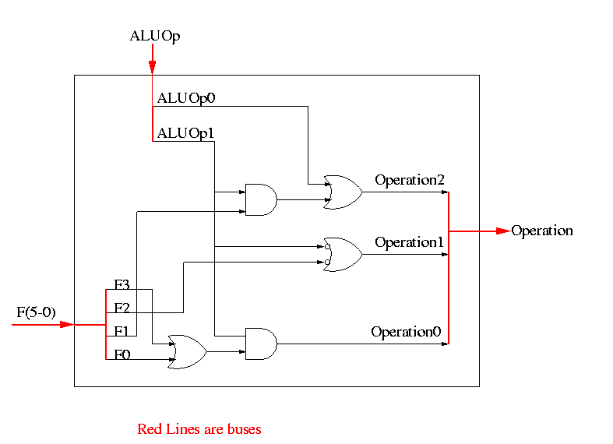

**======== START LECTURE #18 ========**

**I cleaned up the discussion about OP[2-0] from the end of last time**

Now we need the main control

* 1. setting the four muxes
  2. Writing the registers
  3. Writing the memory
  4. Reading the memory ??? (for technical reasons)
  5. Calculating ALUop

So 9 bits

The following figure shows where these occur.

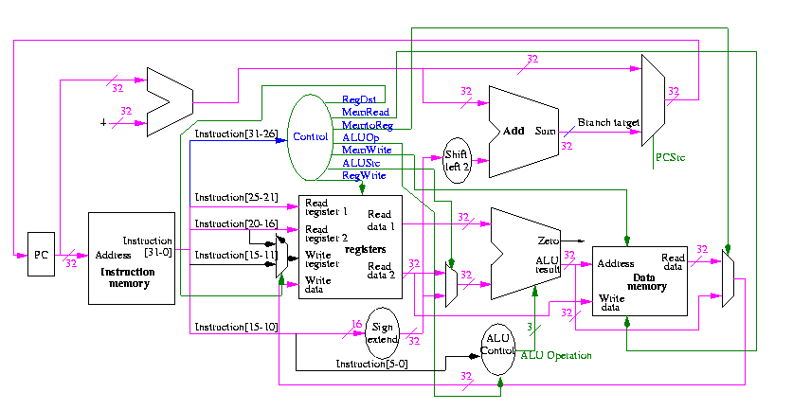

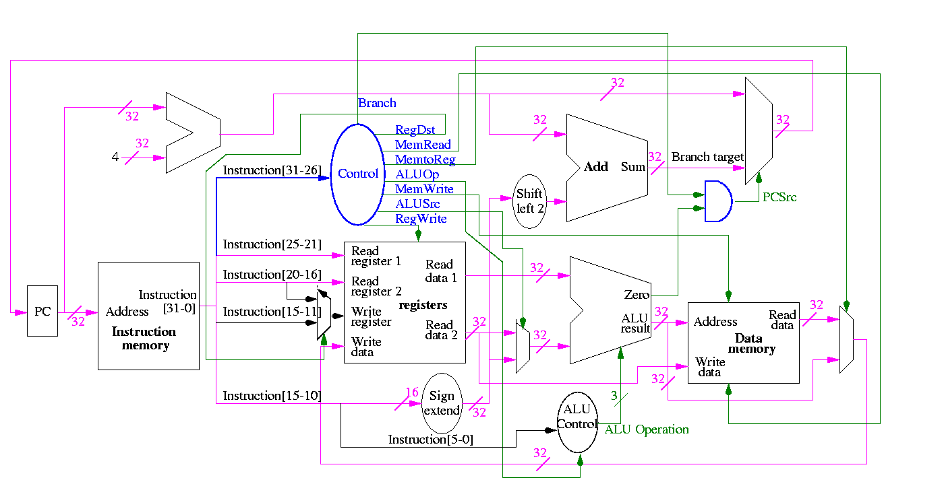

They all are determined by the opcode

The MIPS instruction set is fairly regular. Most fields we need are always in the same place in the instruction.

* 1. Opcode (called Op[5-0]) always in 31-26
  2. Regs to be read always 25-21 and 20-16 (R-type, beq, store)
  3. Base reg for effective address always 25-21 (load store)
  4. Offset always 15-0
  5. Oops: Reg to be written EITHER 20-16 (load) OR 15-11 (R-type) MUX!!

|  |  |
| --- | --- |
| MemRead: | Memory delivers the value stored at the specified addr |
| MemWrite: | Memory stores the specified value at the specified addr |
| ALUSrc: | Second ALU operand comes from (reg-file / sign-ext-immediate) |
| RegDst: | Number of reg to write comes from the (rt / rd) field |
| RegWrite: | Reg-file stores the specified value in the specified register |
| PCSrc: | New PC is Old PC+4 / Branch target |
| MemtoReg: | Value written in reg-file comes from (alu / mem) |

We have seen the wiring before (and given a hardcopy handout)

We are interested in four opcodes

* 1. R-type
  2. load
  3. store
  4. BEQ

Do a stage play

* 1. Need ``volunteers''
     + One for each of 4 muxes
     + One for PC reg
     + One for the register file
     + One for the instruction memory
     + One for the data memory
  2. I will play the control
  3. Let the PC initially be zero
  4. Let each register initially contain its number (e.g. R2=2)
  5. Let each data memory word initially contain 100 times its address
  6. Let the instruction memory contain (starting at zero)
  7. add r9,r5,r1 r9=r5+r1 0 5 1 9 0 32
  8. sub r9,r9,r6 0 9 6 9 0 34
  9. beq r9,r0,-8 4 9 0 < -2 >
  10. slt r1,r9,r0 0 9 0 1 0 42
  11. lw r1,102(r2) 35 2 1 < 100 >
  12. sw r9,102(r2)
  13. Go!

The following figures illustrate the play.

We start with R-type instructions

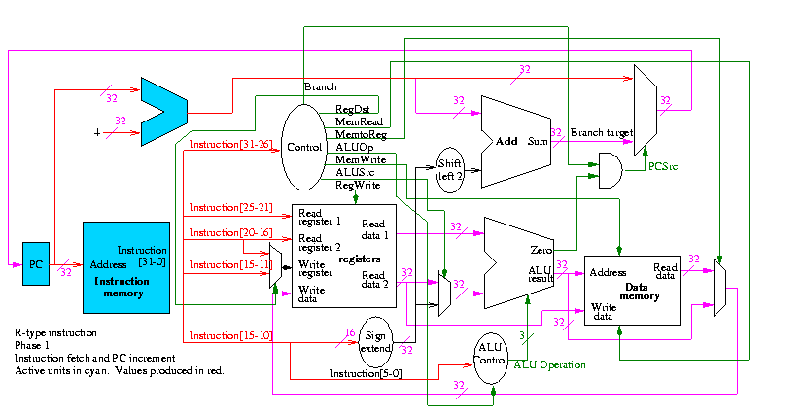

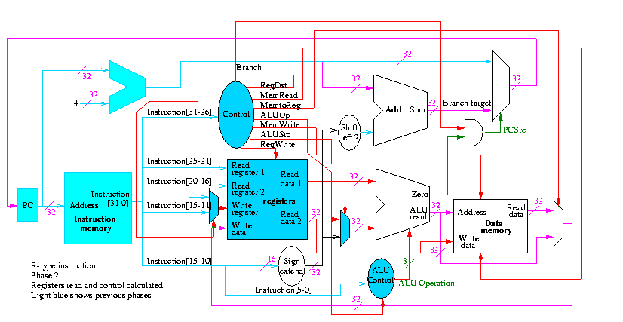

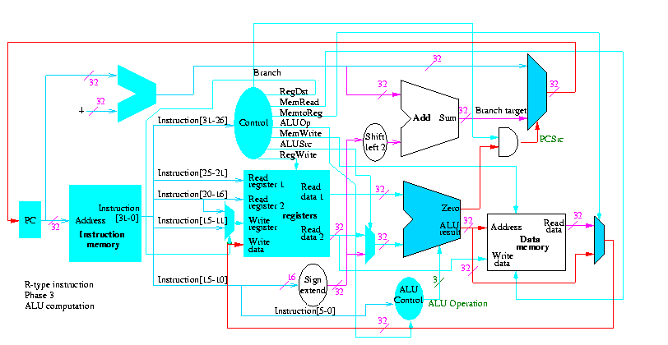

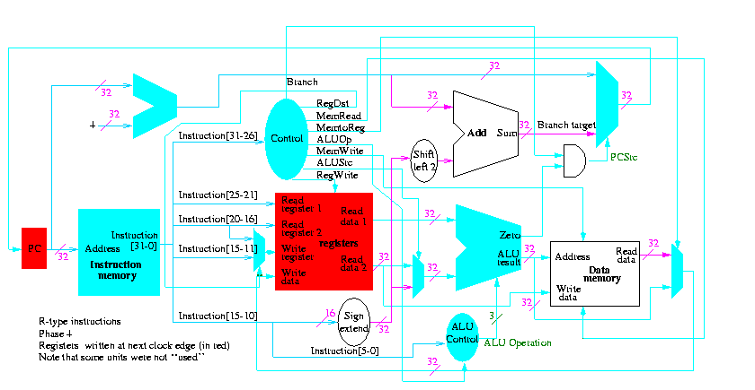

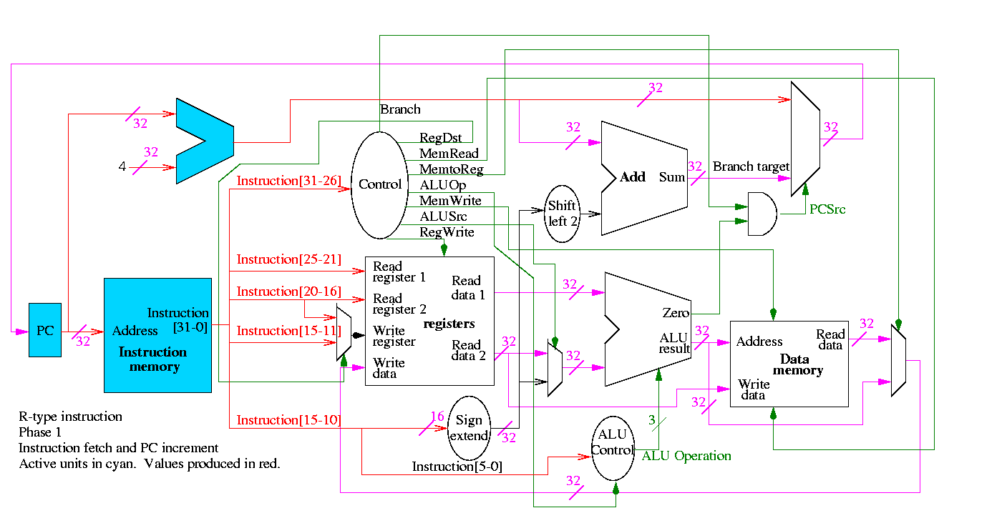

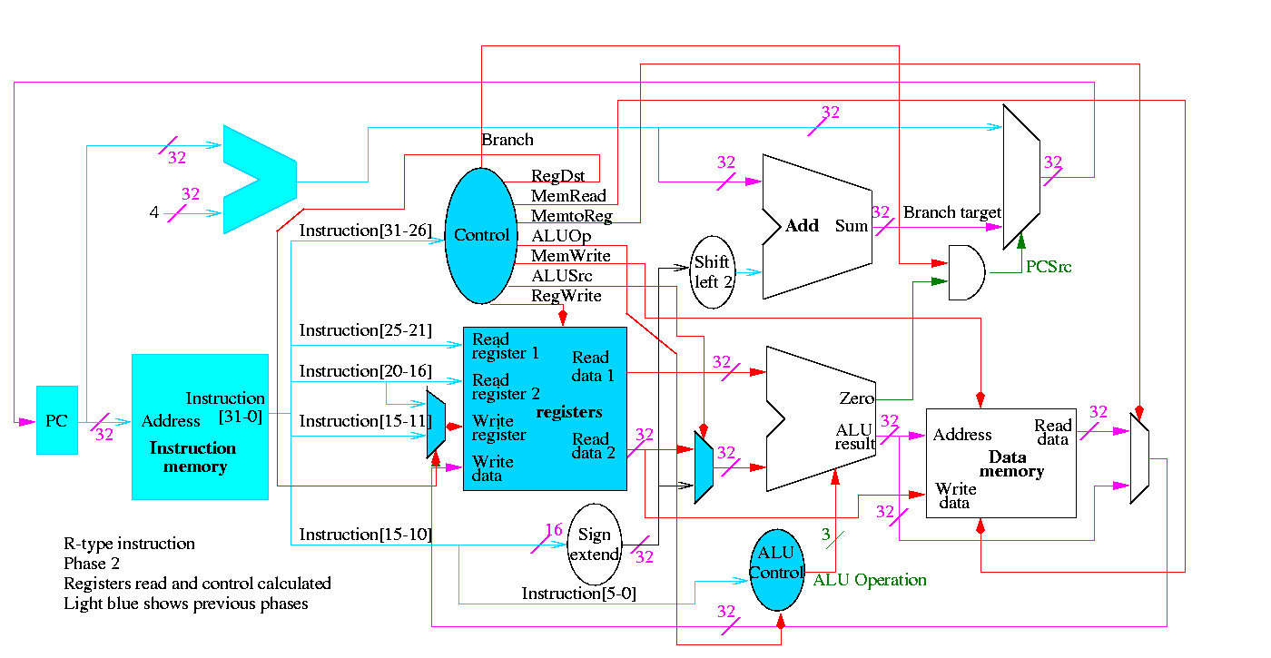

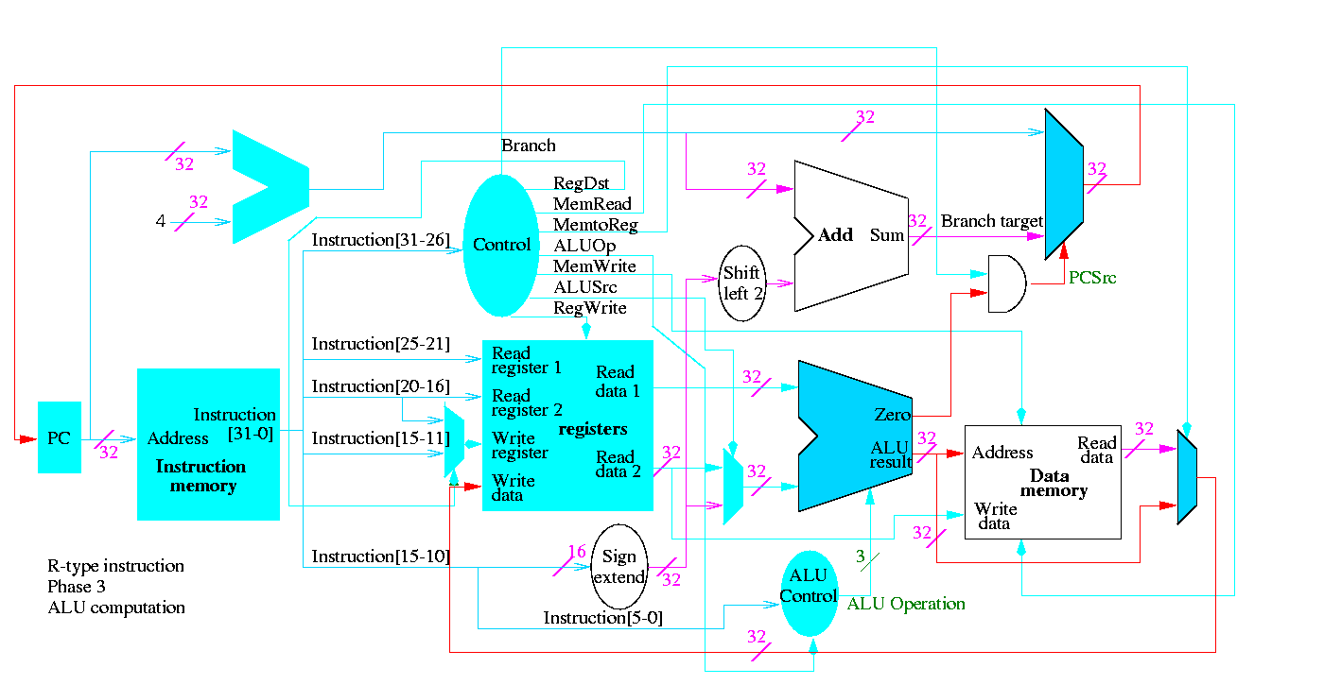

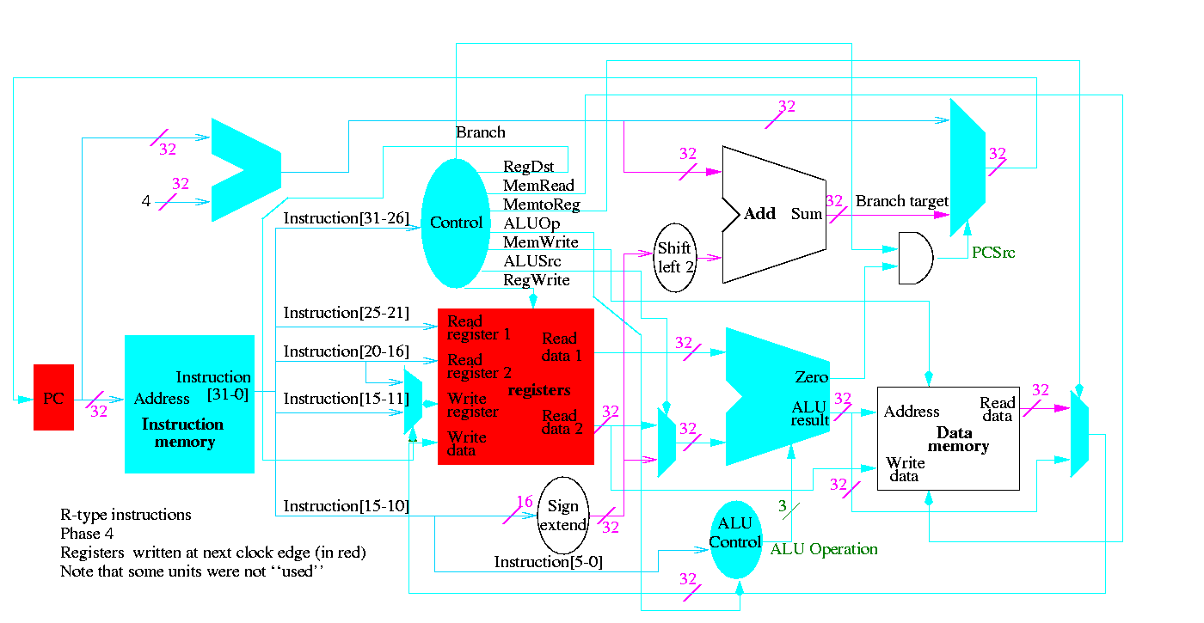

Next we show lw

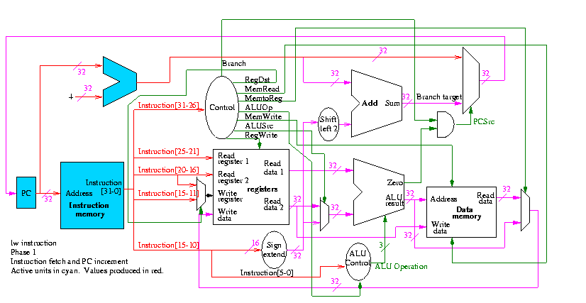

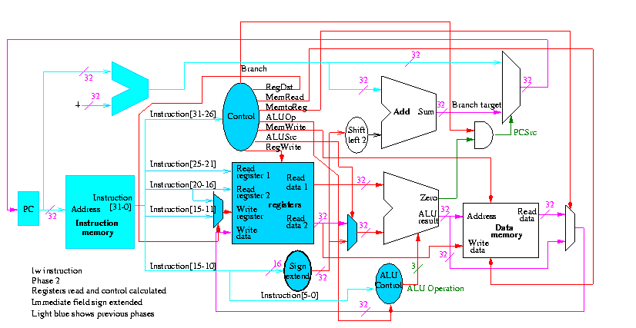

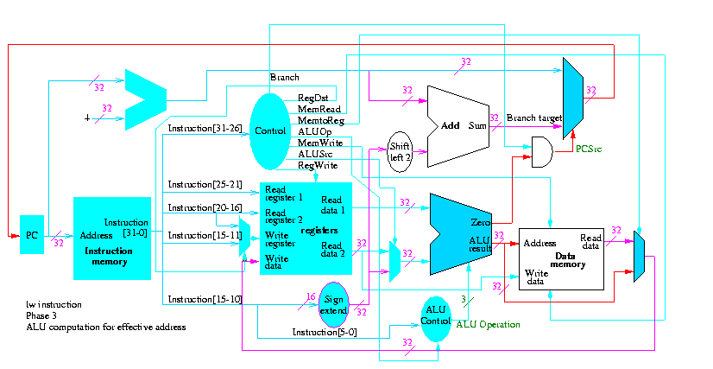

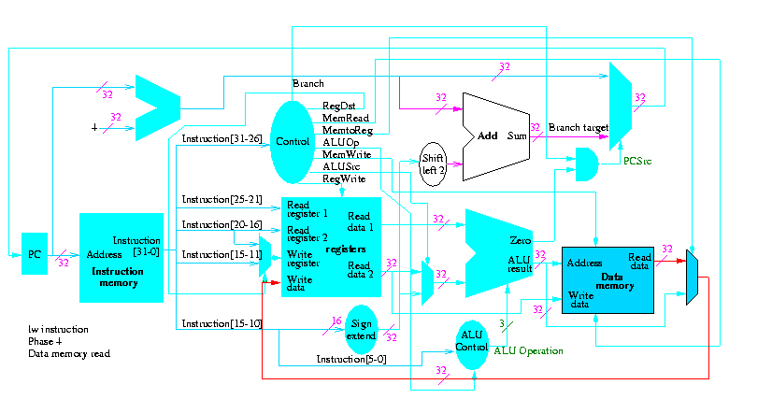

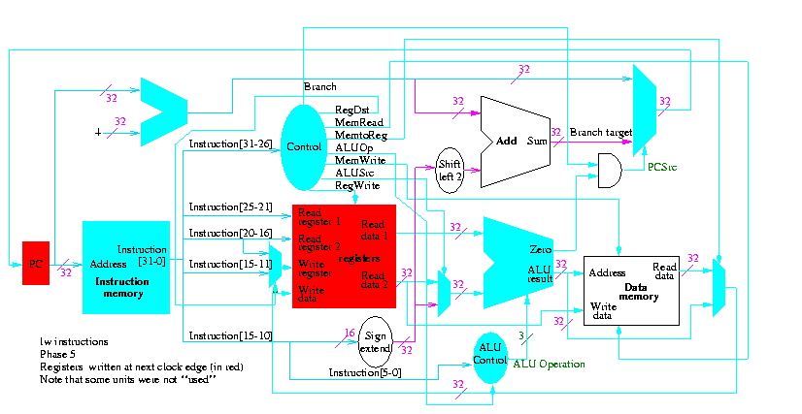

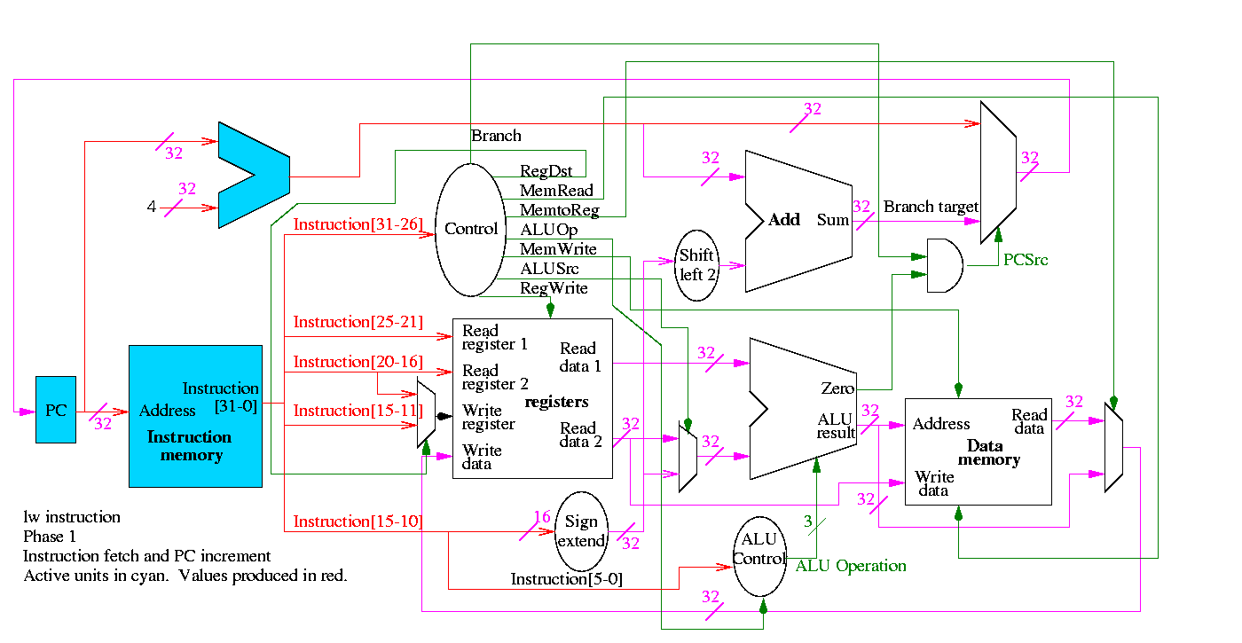

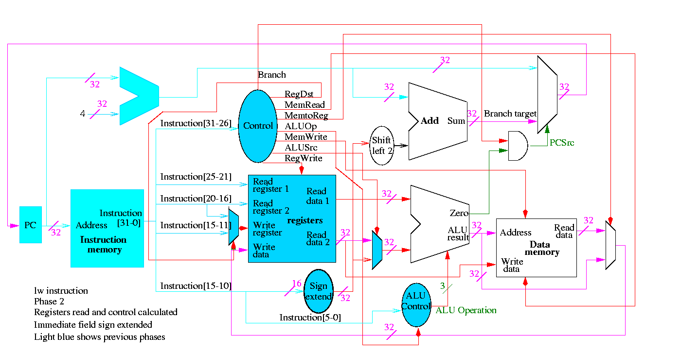

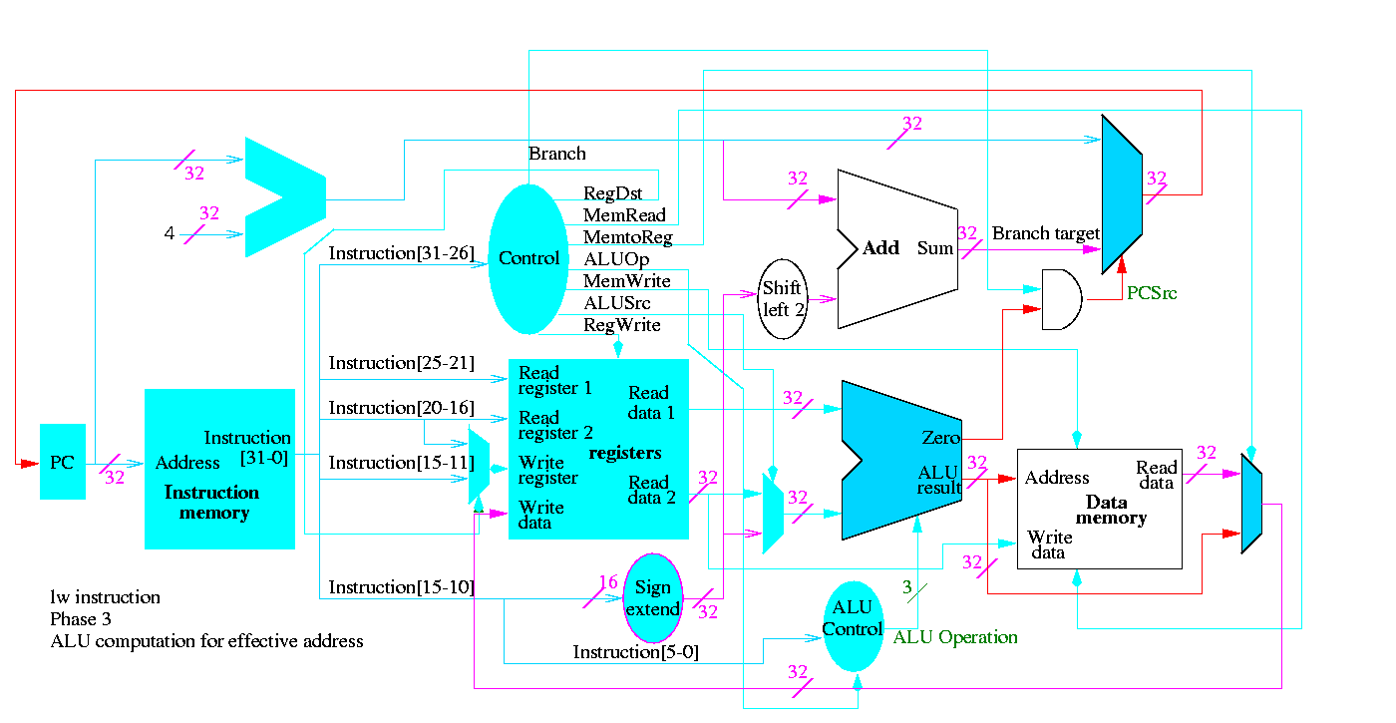

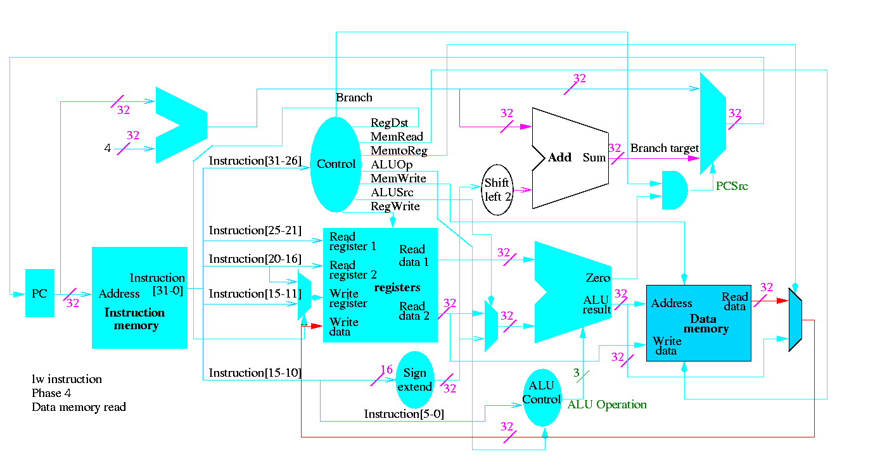

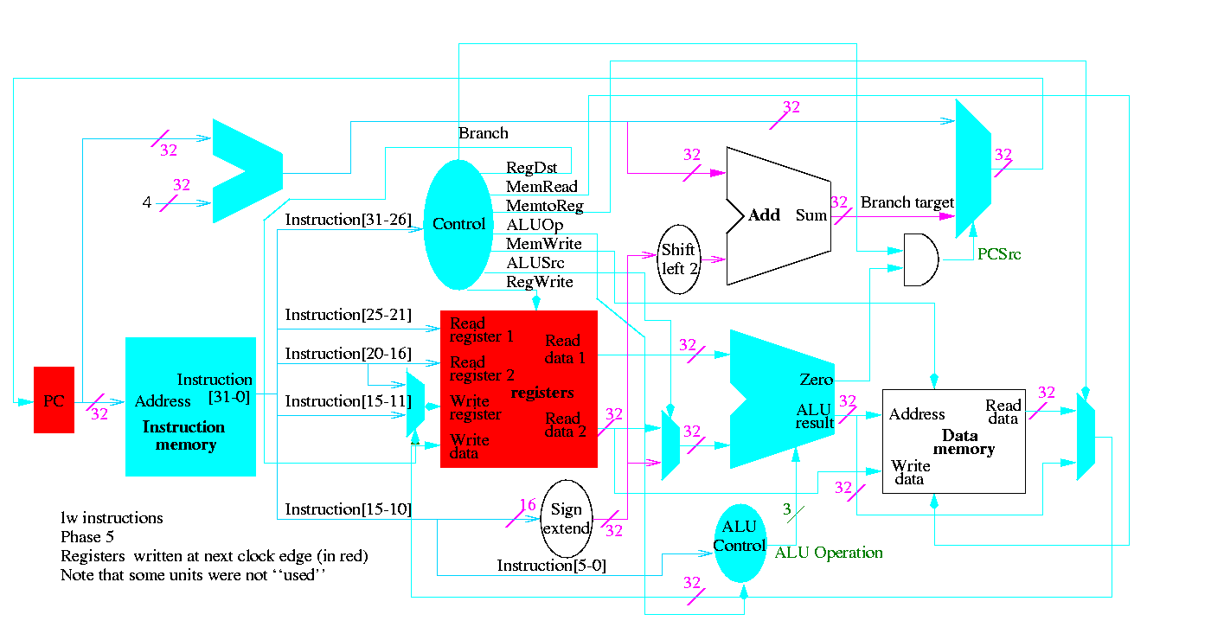

The following truth table shows the settings for the control lines for each opcode. This is drawn differently since the labels of what should be the columns are long (e.g. RegWrite) and it is easier to have long labels for rows.

|  |  |  |  |  |
| --- | --- | --- | --- | --- |
| **Signal** | **R-type** | **lw** | **sw** | **beq** |
| Op5 | 0 | 1 | 1 | 0 |
| Op4 | 0 | 0 | 0 | 0 |
| Op3 | 0 | 0 | 1 | 0 |
| Op2 | 0 | 0 | 0 | 1 |
| Op1 | 0 | 1 | 1 | 0 |
| Op0 | 0 | 1 | 1 | 0 |
|  |  |  |  |  |
|  |  |  |  |  |
|  |  |  |  |  |
|  |  |  |  |  |
|  |  |  |  |  |
| RegDst | 1 | 0 | X | X |
| ALUSrc | 0 | 1 | 1 | 0 |
| MemtoReg | 0 | 1 | X | X |
| RegWrite | 1 | 1 | 0 | 0 |
| MemRead | 0 | 1 | 0 | 0 |
| MemWrite | 0 | 0 | 1 | 0 |
| Branch | 0 | 0 | 0 | 1 |
| ALUOp1 | 1 | 0 | 0 | 0 |
| ALUOp | 0 | 0 | 0 | 1 |

Now it is straightforward but tedious to get the logic equations

When drawn in pla style the circuit is

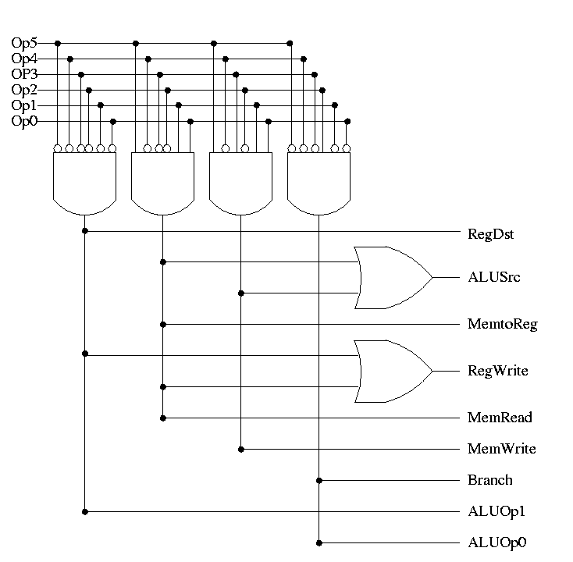

**Homework:** 5.5 and 5.11 control, 5.1, 5.2, 5.10 (just the single-cycle datapath) 5.11

**Implementing a J-type instruction, unconditional jump**

opcode addr

31-26 25-0

Addr is word address; bottom 2 bits of PC are always 0

Top 4 bits of PC stay as they were (AFTER incr by 4)

Easy to add.

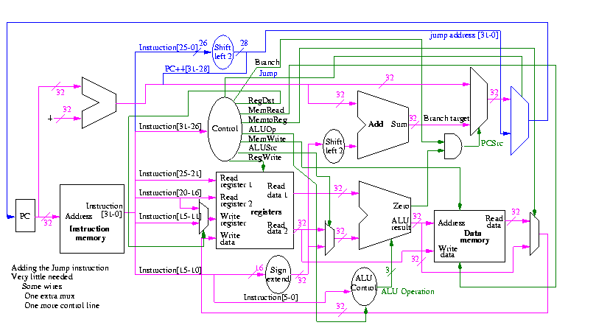

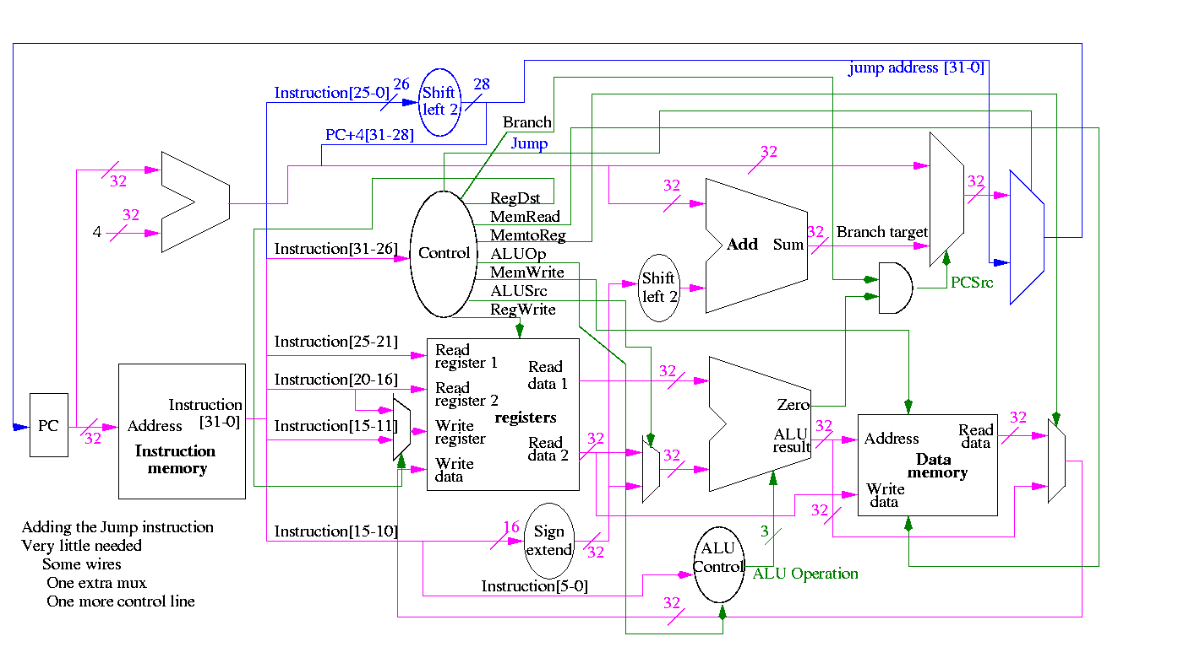

Smells like a good final exam type question.

**What's Wrong**

Some instructions are likely slower than others and we must set the clock cycle time long enough for the slowest. The disparity between the cycle times needed for different instructions is quite significant when one considers implementing more difficult instructions, like divide and floating point ops.

Possible solutions

* 1. Variable length cycle
  2. Asynchronous logic
     + ``Self-timed'' logic
     + No clock. Instead each signal (or group of signals) is coupled with another signal that changes only when the first signal (or group) is stable.
     + Hard to debug
  3. Multicycle instructions
     + More complicated instructions have more cycles
     + Since only one instruction being done at a time, can reuse a single ALU and other resourses during different cycles
     + It is in the book right at this point but we are not covering it.

**======== START LECTURE #19 ========**

Even Faster

* 1. Pipeline the cycles
     + Since at one time we will have several instructions active, each at a different cycle, the resourses can't be reused (e.g., more than one instruction might need to do a register read/write at one time)
     + Pipelining is more complicated than the single cycle implementation we did.
     + This was the basic RISC technology on the 1980s
     + It is covered in chapter 6.
  2. Multiple datapaths (superscalar)
     + Issue several instructions each cycle and the *hardware* figures out dependencies and only executes instructions when the dependencies are satisfied.
     + Much more logic required, but conceptually not too difficult providing the system executes instructions *in order*
     + Pretty hairy if *out of order* (OOO) exectuion is permitted.
     + Current high end processors
  3. VLIW (Very Long Instruction Word)
     + User (i.e., the compiler) packs several instructions into one ``superinstruction'' called a very long instruction.
     + User guarentees that there are no dependencies within a superinstruction.
     + Hardware still needs multiple datapaths (indeed the datapaths are not so different as superscalar.
     + Was proposed and tried in 80s, but was dominated by superscalar.
     + A comeback (?) with Intel's EPIC (Explicitly Parallel Instruction Computer ?).
       - Called IA-64 (Intel Architecture 64-bits); the first implementation was called Merced and now has a funny name (Itanium?). It should be available next year
       - It has other features as well (e.g. predication).
       - The x86, Pentium, etc are called IA-32.

**Chapter 2 Performance analysis**

**Homework:** Read Chapter 2

**Throughput** measures the number of jobs per day that can be accomplished. **Response time** measures how long an individual job takes.

* 1. So a faster machine improves both (increasing throughput and decreasing response time).
  2. Normally anything that improves response time improves throughput.
  3. Adding a processor likely to increase throughput more than it decreases response time.
  4. We will mostly be concerned with response time

Performance = 1 / Execution time

So machine X is n times faster than Y means that

* 1. Performance-X = n * Performance-Y
  2. Execution-time-X = (1/n) * Execution-time-Y

How should we measure execution-time?

* 1. CPU time
     + Includes time waiting for memory
     + Does not include time waiting for I/O as this process is not not running
  2. Elapsed time on empty system
  3. Elapsed time on ``normally loaded'' system
  4. Elapsed time on ``heavily loaded'' system

We mostly use CPU time, but this does *not* mean the other metrics are worse.

Cycle time vs. Clock rate

* 1. Recall that the cycle time is the length of a cycle.
  2. It is a unit of *time*.
  3. For modern computers it is expressed in *nanoseconds*, abbreviated ns.
  4. One nano-second is one billionth of a second = 10^(-9) seconds.
  5. The clock rate tells how many cycles fit into a given time unit (normally in one second).
  6. So the natural unit is *cycles per second*. This was abbreviated CPS.
  7. However, the world has changed and the new name (for the same thing) is *Hertz*, abbreviated Hz. One Hertz is one cycle per second.
  8. For modern computers the rate is expressed in *megahertz*, abbreviated MHz.
  9. One megahertz is one million hertz = 10^6 hertz.
  10. What is the cycle time for a 333MHz computer?
      + 333 million cycles = 1 second
      + 3.33*10^8 cycles = 1 second
      + 1 cycle = 1/(3.33*10^8) seconds = 10/3.33 * 10^(-9) seconds ~= 3ns
      + Electricity travels about 1 foot in 1ns

So the execution time for a given job on a given computer is

(CPU) execution time = (#CPU clock cycles required) * (cycle time)

= (#CPU clock cycles required) / (Clock rate)

So a machine with a 10ns cycle time runs at a rate of  
1 cycle per 10 ns = 100,000,000 cycles per second = 100 MHz

The number of CPU clock cycles required equals the number of instructions executed times the number of cycles in each instruction.

* 1. In our single cycle implementation, the number of cycles required is just the number of instructions executed.
  2. If every instruction took 5 cycles, the number of cycles required would be five times the number of instructions executed.

But systems are more complicated than that!

* 1. Some instructions take more cycles than others.
  2. With pipelining, several instructions are in progress at different stages of their execution.
  3. With super scalar (or VLIW) many instructions are issued at once and many can be at the same stage of execution.
  4. Since modern superscalars (and VLIWs) are also pipelined we have many many instructions in execution at once

Through a great many measurement, one calculates for a given machine the *average* CPI (cycles per instruction).

#instructions for a given program depends on the instruction set. For example we saw in chapter 3 that 1 vax instruction is often accomplishes more than 1 MIPS instruction.

Complicated instructions take longer; either more cycles or longer cycle time

Older machines with complicated instructions (e.g. VAX in 80s) had CPI>>1

With pipelining can have many cycles for each instruction but still have CPI nearly 1.

Modern superscalar machines have CPI < 1

* 1. They issue many instructions each cycle
  2. They are pipelined so the instructions don't finish for several cycles
  3. If have 4-issue and all instructions 5 pipeline stages, there are up to 20=5*4 instructions in progress (often called in flight) at one time.

Putting this together, we see that

Time (in seconds) = #Instructions * CPI * Cycle_time (in seconds)

Time (in ns) = #Instructions * CPI * Cycle_time (in ns)

**Homework:** Carefully go through and understand the example on page 59

**Homework:** 2.1-2.5 2.7-2.10

**Homework:** Make sure you can easily do all the problems with a rating of [5] and can do all with a rating of [10]

What about MIPS?

* 1. Millions of Instructions Per Second
  2. *Not* the same as the MIPS computer (but *not* a coincidence).
  3. For a given machine language program, the seconds required is  
     the number of instructions executed / MIPS  
     **BUT**
     + The same program in C might need different number of instructions on different computers (e.g. one VAX instruction might take 2 instructions on a power-PC)
     + Different programs generate different MIPS ratings on same arch.
       - Some programs execute more long instructions than do other programs.
       - Some programs have more cache misses and hence cause more waiting for memory.
       - Some programs inhibit full pipelining (e.g. mispredicted branches)
       - Some programs inhibit full superscalar behavior (data dependencies)
     + One can oftern raise the MIPS rating by adding NOPs despite increasing exec time

**Homework:** Carefully go through and understand the example on pages 61-3

Why not use MFLOPS

* 1. Millions of FLoating point Operations Per Second
  2. Similiar problems to MIPS (not quite as bad since can't add no-ops)

Benchmarks

* 1. This is better, but still has difficulties
  2. Hard to find benchmarks that represent *your future* usage.

**Homework:** Carefully go through and understand 2.7 ``fallacies and pitfalls''

**======== START LECTURE #20 ========**

**Chapter 7 Memory**

**Homework:** Read Chapter 7

Ideal memory is

* 1. Fast
  2. Big (in capacity; not physical size)
  3. Cheap
  4. Imposible

We observe empirically

* 1. *Temporal Locality*: The word referenced now is likely to be referenced again soon. Hence it is wise to keep the currently accessed word handy for a while.
  2. *Spacial Locality*: Words near the currently referenced word are likely to be referenced soon. Hence it is wise to prefetch words near the currently referenced word and keep them handy for a while.

So use a memory *hierarchy*

* 1. Registers
  2. Cache (really L1 L2 maybe L3)
  3. Memory
  4. Disk
  5. Archive

There is a gap between each pair of adjacent levels. We study the cache <---> memory gap

* 1. In modern systems there are many levels of caches.
  2. Similar considerations apply to the other gaps (e.g., memory<--->disk, where virtual memory techniques are applied)
  3. But terminology is often different, e.g. cache line vs page.
  4. In fall 97 my OS class was studying ``the same thing'' at this exact point (memory management). Not true this year since the OS text changed and memory management is earlier.

A **cache** is a small fast memory between the processor and the main memory. It contains a subset of the contents of the main memory.

A Cache is organized in units of **blocks**. Common block sizes are 16, 32, and 64 bytes.

* 1. We also view memory as organized in blocks as well. If the block size is 16, then bytes 0-15 of memory are in block 0, bytes 16-31 are in block 1, etc.
  2. Transfers from memory to cache and back are one block.
  3. Big blocks make good use of spacial locality
  4. (OS think of pages and page frames)

A **hit** occurs when a memory reference is found in the upper level of memory hierarchy.

* 1. We will be interested in cache hits (OS in page hits), when the reference is found in the cache (OS: when found in main memory)
  2. A **miss** is a non-hit.
  3. **The hit rate** is the fraction of memory references that are hits.
  4. **The miss rate** is 1 - hit rate, which is the fraction of references that are misses.
  5. **The hit time** is the time required for a hit.
  6. **The miss time** is the time required for a miss.
  7. **The miss penalty** is Miss time - Hit time.

We start with a very simple cache organization.

* 1. Assume all referencess are for one word (not too bad).
  2. Assume cache blocks are one word.
     + This does not take advantage of spacial locality so is not done in real machines.
     + We will drop this assumption soon.
  3. Assume each memory block can only go in one specific cache block
     + Called **Direct Mapped**.
     + The location of the memory block in the cache (i.e. the block number in the cache) is the memory block number modulo the number of blocks in the cache.
     + For example, if the cache contains 100 blocks, then memory block 34452 is stored in cache block 52.
     + In real systems the number of blocks in the cache is a power of 2 so taking modulo is just extracting low order bits.
  4. Example: if the cache has 16 blocks, the location of a block in the cache is the low order 4 bits of block number.
  5. A pictorial example for a cache with only 4 blocks and a memory with only 16 blocks.

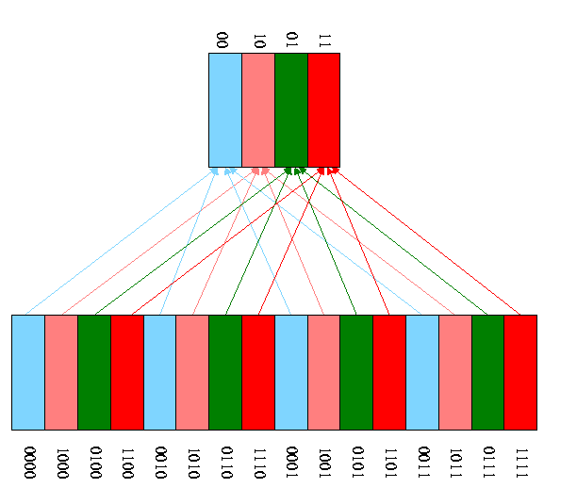

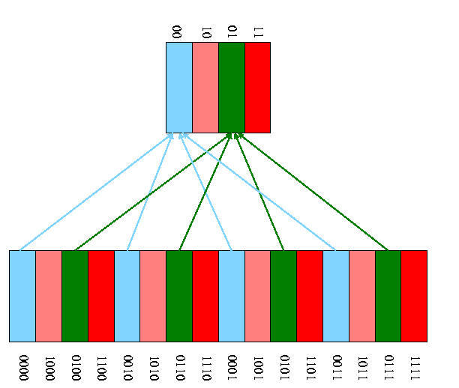

* 1. How can we tell if a memory block is in the cache?
     + We know where it will be *if* it is there at all (memory block number mod number of blocks in the cache).
     + But many memory blocks are assigned to that same cache block.
     + So we need the ``rest'' of the address (i.e., the part lost when we reduced the block number modulo the size of the cache) to see if the block in the cache is the memory block of interest,
     + Store the rest of the address, called the *tag.*
     + Also store a *valid* bit per cache block so that we can tell if there is a memory block stored in this cache block.  
       For example when the system is powered on, all the cache blocks are invalid.

Example on pp. 547-8.

* 1. Tiny 8 word direct mapped cache with block size one word and all references are for a word.
  2. In the table to follow all the addresses are word addresses. For example the reference to 3 means the reference to word 3 (which includes bytes 12, 13, 14, and 15).
  3. If reference experience a miss and the cache block is valid, the current reference is discarded (in this example only) and the new reference takes its place.
  4. Do this example on the board showing the address store in the cache at all times

|  |  |  |  |
| --- | --- | --- | --- |
| **Address(10)** | **Address(2)** | **hit/miss** | **block#** |
| 22 | 10110 | miss | 110 |
| 26 | 11010 | miss | 010 |
| 22 | 10110 | hit | 110 |
| 26 | 11010 | hit | 010 |
| 16 | 10000 | mis | 000 |
| 3 | 00011 | miss | 011 |
| 16 | 10000 | hit | 000 |
| 18 | 10010 | miss | 010 |

The basic circuitry for this simple cache to determine hit or miss and to return the data is quite easy.

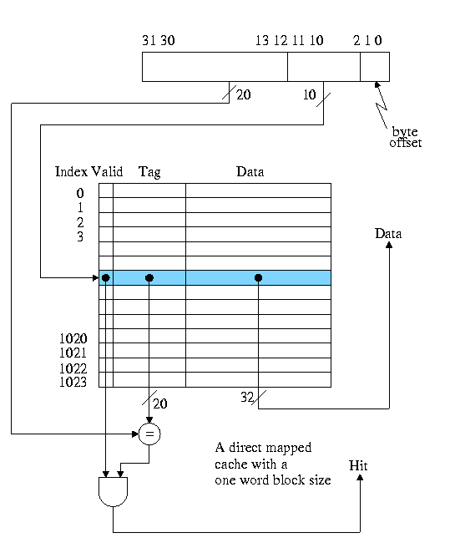

Calculate on the board the total number of bits in this cache.

**Homework:** 7.1 7.2 7.3

Processing a read for this simple cache

* 1. Hit is trivial (return the data found).
  2. Miss: Evict and replace
     + Why? I.e., why keep new data instead of old?  
       Ans: Temporal Locality
     + This is called **write-allocate**.
     + The alternative is called **write-no-allocate**.

Skip section ``handling cache misses'' as it discusses the multicycle and pipelined implementations of chapter 6, which we skipped.

For our single cycle processor implementation we just need to note a few points

* 1. The instruction and data memory are replaced with caches.
  2. On cache misses one needs to fetch or store the desired data or instruction in central memory.
  3. This is very slow and hence our cycle time must be very long.
  4. Yet another reason why the single cycle implementation is not used in practice.

Processing a write for this simple cache

* 1. Hit: **Write through** vs **write back**.
     + Write through writes the data to memory as well as to the cache.
     + **Write back**: Don't write to memory now, do it later when this cache block is evicted.
  2. Miss: write-allocate vs write-no-allocate
  3. The simplist is write-through, write-allocate
     + Still assuming blksize=refsize = 1 word and direct mapped
     + For any write (Hit or miss) do the following:
       - Index the cache using the correct LOBs (i.e., not the very lowest order bits as these give the byte offset.
       - Write the data and the tag
         * For a hit, we are overwriting the tag with itself.
         * For a miss, we are performing a write allocate and since the cache is write-throught we can simply overwrite the current entry
       - Set Valid to true
       - Send request to main memory
     + Poor performance
       - GCC benchmark has 11% of operations stores
       - If we assume an infinite speed memory, CPI is 1.2 for some reasonable estimate of instruction speeds
       - Assume a 10 cycle store penalty (reasonable) since we have to write main memory (recall we are using a write-through cache).
       - CPI becomes 1.2 + 10 * 11% = 2.5, which is **half speed**.

**======== START LECTURE #21 ========**

**Homework:** 7.2 7.3 (should have been give above with 7.1. I changed the notes so this is fix for ``next time'')

**Improvement: Use a write buffer**

* 1. Hold a few (four is common) writes at the processor while they are being processed at memory.
  2. As soon as the word is written into the write buffer, the instruction is considered complete and the next instruction can begin.
  3. Hence the write penalty is eliminated as long as the word can be written into the write buffer.
  4. Must stall (i.e., incur a write penalty) if the write buffer is full. This occurs if a bunch of writes occur in a short period.
  5. If the rate of writes is greater than the rate at which memory can handle writes, you must stall eventually. The purpose of a write-buffer (indeed of buffers in general) is to handle short bursts.
  6. The Decstation 3100 had a 4-word write buffer.

**Unified vs split I and D (instruction and data)**

* 1. Given a fixed total size of caches, is it better to have two caches, one for instructions and one for data; or is it better to have a single ``unified'' cache?
  2. Unified is better because better ``load balancing''. If the current program needs more data references than instruction references, the cache will accomodate. Similarly if more instruction references are needed.
  3. Split is better because it can do two references at once (one instruction reference and one data reference).
  4. The winner is ...  
     split I and D.
  5. But unified has the better (i.e. higher) hit ratio.
  6. So hit ratio is *not* the ultimate measure of good cache performance.

**Improvement: Blocksize > Wordsize**

* 1. The current setup does not take any advantage of spacial locality. The idea of larger blocksizes is to bring in words near the referenced word since, by spacial locality, they are likely to be referenced in the near future.
  2. The figure below shows a direct mapped cache with 4-word blocks.

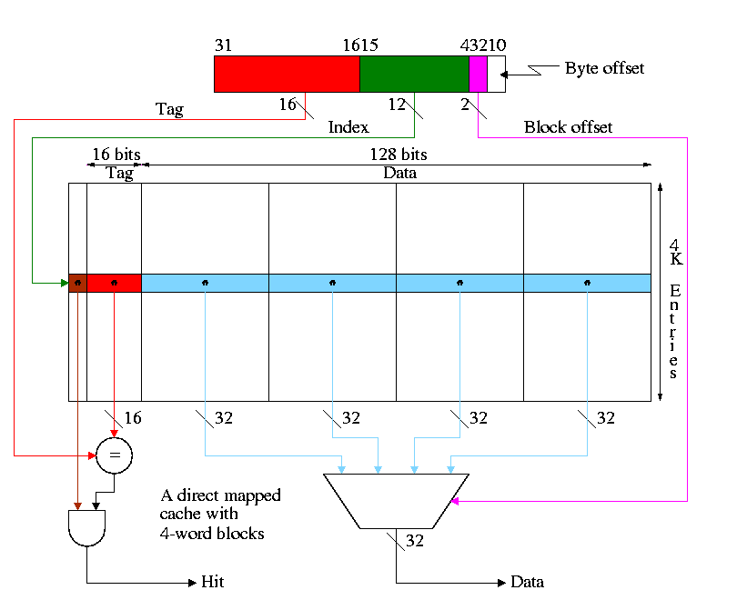

* 1. What addresses in memory are in the block and where in the cache do they go?
     + The **memory** block number =  
       the word address / number of words per block =   
       the byte address / number of bytes per block
     + The **cache** block number =  
       the memory block number modulo the number of blocks in the cache
     + The block offset =   
       the word address modulo the number of words per block
     + The tag =   
       the word addres / the number of words in the cache =  
       the byte address / the number of bytes in the cache
     + Show from the diagram how this gives the red portion for the tag and the green portion for the index or cache block number.
  2. Consider the cache shown in the diagram above and a reference to **word** 17001.
     + 17001 / 4 gives 4250 with a remainder of 1
     + So the memory block number is 4250 and the block offset is 1
     + 4K=4096 and 4250 / 4096 gives 0 with a remainder of 154.
     + So the cache block number is 154.
     + Putting this together a reference to word 17001 is a reference to the first word of the cache block with index 154
     + The tag is 17001 / (4K * 4) = 1
  3. Cachesize = Blocksize * #Entries. For the diagram above this is 64KB.
  4. Calculate the total number of bits in this cache and in one with one word blocks but still 64KB of data
  5. If the references are strictly sequential the pictured cache has 75% hits; the simplier cache with one word blocks has **no** hits.

**Homework:** 7.7 7.8 7.9

Why not make blocksize enormous? Cache one huge block.

* 1. NOT all access are sequential
  2. With too few blocks misses go up again

**Memory support for wider blocks**

* 1. Should memory be wide?
  2. Should the bus be wide?

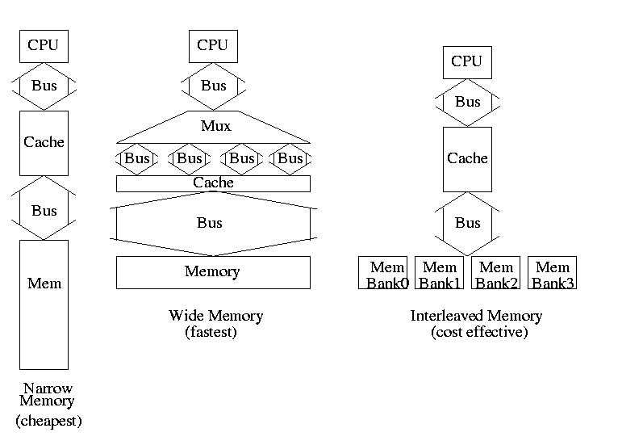

* 1. Assume
     + 1 clock to send the address only one address for all designs
     + 15 clocks for each memory access (independent of width)
     + 1 Clock/busload of data
  2. Narrow design (a) takes 65 clocks for a read miss since must make 4 memory requests (do it on the board)
  3. Wide design (b) takes 17
  4. Interleaved (c) takes 20
  5. Interleaving works great because in this case we are *guaranteed* to have sequential accesses
  6. Imagine design between (a) and (b) with 2-word wide datapath Takes 33 cycles and more expensive to build than (c)

**Homework:** 7.11

**======== START LECTURE #22 ========**

Performance example to do on the board (dandy exam question).

* 1. Assume
     + 5% I-cache miss
     + 10% D-cache miss
     + 1/3 of the instructions access data
     + CPI = 4 if miss penalty is 0 (A 0 miss penalty is not realistic of course)
  2. What is CPI with miss penalty 12 (do it)?
  3. What is CPI if double speed cpu+cache, single speed mem (24 clock miss penalty) (do it)?
  4. How much faster is the ``double speed'' machine? It would be double speed if miss penalty 0 or 0% miss rate

**Homework:** 7.15, 7.16

A lower base (i.e. miss-free) CPI makes stalls appear more expensive since waiting a fixed amount of time for the memory corresponds to losing more instructions if the CPI is lower.

Faster CPU (i.e., a faster clock) makes stalls appear more expensive since waiting a fixed amount of time for the memory corresponds to more cycles if the clock is faster (and hence more instructions since the base CPI is the same).

Another performance example

* 1. Assume
     + I-cache miss rate 3%
     + D-cache miss rate 5%
     + 40% of instructions reference data
     + miss penalty of 50 cycles
     + Base CPI of 2
  2. What is the CPI including the misses?
  3. How much slower is the machine when misses are taken into account?
  4. Redo the above if the I-miss penalty is reduced to 10 (D-miss still 50)
  5. With I-miss penalty back to 50, what is performance if CPU (and the caches) are 100 times faster

**Remark: Larger caches have *longer* hit times.**

**Improvement: Associative Caches**

Consider the following sad story. Jane had a cache that held 1000 blocks and had a program that only references 4 (memory) blocks, namely 23, 1023, 123023, and 7023. In fact the reference occur in order: 23, 1023, 123023, 7023, 23, 1023, 123023, 7023, 23, 1023, 123023, 7023, 23, 1023, 123023, 7023, etc. Referencing only 4 blocks and having room for 1000 in her cache, Jane expected an extremely high hit rate for her program. In fact, the hit rate was zero. She was so sad, she gave up her job as webmistriss, went to medical school, and is now a brain surgeon at the mayo clinic in rochester MN.

* 1. So far We have studied*only direct mapped* caches, i.e. those for which the location in the cache is determined by the address. Since there is only one possible location in the cache for any block, to check for a hit we compare *one* tag with the HOBs of the addr.
  2. The other extreme is *fully associative*.
     + A memory block can be placed in any cache block
     + Since any memory block can be in any cache block, the cache index where the memory block is store tells us nothing about which cache block is here. Hence the tag must be entire address and we must check all cache blocks to see if we have a hit.
     + The larger tag is a minor problem.
     + The search is a disaster.
       - It could be done sequentially (one cache block at a time), but this is much too slow.
       - We could have a comparator with *each* tag and mux all the blocks to select the one that matches.
         * This is too big due to both the many comparators and the humongous mux.
         * However, it is exactly what is done when implementing translation lookaside buffers (TLBs), which are used with demand paging
     + An alternative is to have a table with one entry per MEMORY block giving the cache block number. This is too big and too slow for caches but is used for virtual memory (demand paging).
  3. Most common for caches is an intermediate configuration called *set associative* or n-way associative (e.g. 4-way associative) or n-way set associative.
     + n is typically 2, 4, or 8.
     + If the cache has B blocks, we group them into B/n **sets** each of size n. Memory block number K is then stored in set K mod (B/n).
     + Figure 7.15 has a bug. It indicates that the tag for memory block 12 is itself 12. The figure below corrects this

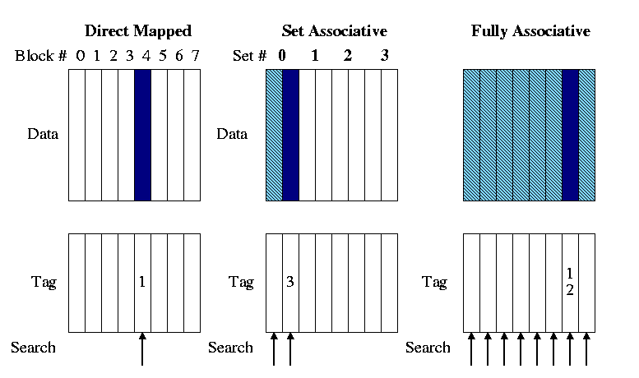

* 1. The picture did 2-way set set associative. Do on the board 4-way set associative.
  2. The Set# = (memory) block# mod #sets
  3. The Tag = (memory) block# / #sets
  4. What is 8-way set associative in a cache with 8 blocks (i.e., the cache in the picture)?
  5. What is 1-way set associative?
  6. Why is set associativity good? For example, why is 2-way set associativity better than direct mapped?
     + Consider referencing two modest arrays (<< cache size) that start at location 1MB and 2MB.
     + Both will contend for the same cache locations in a direct mapped cache but will fit together in a cache with >=2 sets.

**======== START LECTURE #23 ========**

* 1. How does the cache find a memory block?

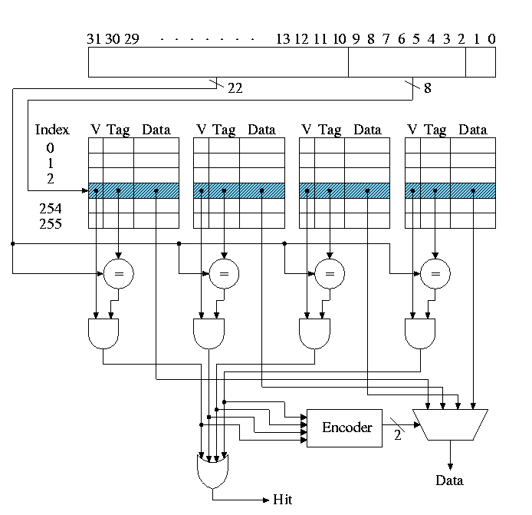

* 1. Why is set associativity bad?  
     It is a little slower due to the mux and AND gate.
  2. Which block (in the set) should be replaced?
     + Random is sometimes used
     + LRU is better but not so easy to do quickly.
       - If the cache is 2-way set associative, each set is of size two and it is easy to find the lru block quickly. How?  
         For each set keep a bit indicating which block in the set was just referenced and the lru block is the other one.
       - If the cache is 4-way set associative, each set is of size 4. Consider these 4 blocks as two groups of 2. Use the trick above to find the group most recently used and pick the other group. Also use the trick within each group and chose the block in the group not used last.
       - Sound great. We can do lru fast. Wrong! The above is not LRU it is just an approximation. Show this on the board.

**Tag size and division of the address bits**

We continue to assume a byte addressed machines, but all references are to a 4-byte word (lw and sw).

The 2 LOBs are not used (they specify the byte within the word but all our references are for a complete word). We show these two bits in dark blue. We continue to assume 32 bit addresses so there are 2**30 words in the address space.

Let's review various possible cache organizations and determine for each how large is the tag and how the various address bits are used. We will always use a 16KB cache. That is the size of the **data**portion of the cache is 16KB = 4 kilowords = 2**12 words.

* 1. 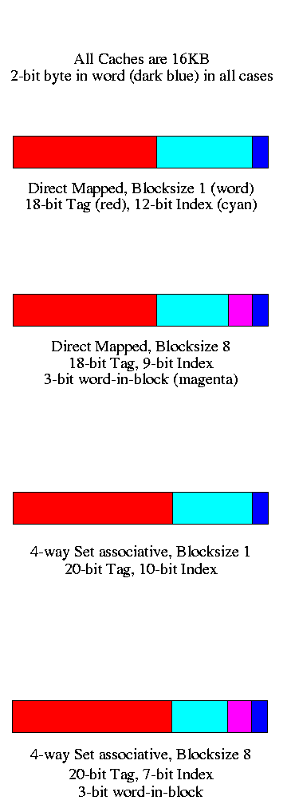Direct mapped, blocksize 1 (word).
     + Since the blocksize is one word, there are 2**30 memory blocks and all the address bits (except the 2 LOBs that specify the byte within the word) are used for the memory block number. Specifically 30 bits are so used.
     + The cache has 2**12 words, which is 2**12 blocks.
     + So the low order 12 bits of the memory block number give the index in the cache (the cache block number), shown in cyan.
     + The remaining 18 (30-12) bits are the tag, shown in red.
  2. Direct mapped, blocksize 8
     + Three bits of the address give the word within the 8-word block. These are drawn in magenta.
     + The remaining 27 HOBs of the memory address give the memory block number.
     + The cache has 2**12 words, which is 2**9 blocks.
     + So the low order 9 bits of the memory block number gives the index in the cache.
     + The remaining 18 bits are the tag
  3. 4-way set associative, blocksize 1
     + Blocksize is 1 so there are 2**30 memory blocks and 30 bits are used for the memory block number.
     + The cache has 2**12 blocks, which is 2**10 sets (each set has 4=2**2 blocks).
     + So the low order 10 bits of the memory block number gives the index in the cache.
     + The remaining 20 bits are the tag. As the associativity grows the tag gets bigger. Why?  
       Growing associativity reduces the number of sets into which a block can be placed. This increases the number of memory blocks that be placed in a given set. Hence more bits are needed to see if the desired block is there.
  4. 4-way set associative, blocksize 8
     + Three bits of the address give the word within the block.
     + The remaining 27 HOBs of the memory address give the memory block number.
     + The cache has 2**12 words = 2**9 blocks = 2**7 sets.
     + So the low order 7 bits of the memory block number gives the index in the cache.

**Homework:** 7.39, 7.40 (not assigned 1999-2000)

**Improvement: Multilevel caches**

Modern high end PCs and workstations all have at least two levels of caches: A very fast, and hence not too big, first level (L1) cache together with a larger but slower L2 cache.

When a miss occurs in L1, L2 is examined and only if a miss occurs there is main memory referenced.

So the average miss penalty for an L1 miss is

(L2 hit rate)*(L2 time) + (L2 miss rate)*(L2 time + memory time)

We are assuming L2 time is the same for an L2 hit or L2 miss. We are also assuming that the access doesn't begin to go to memory until the L2 miss has occurred.

Do an example

* 1. Assume
     + L1 I-cache miss rate 4%
     + L2 D-cache miss rate 5%
     + 40% of instructions reference data
     + L2 miss rate 6%
     + L2 time of 15ns
     + Memory access time 100ns
     + Base CPI of 2
     + Clock rate 400MHz
  2. How many instructions per second does this machine execute
  3. How many instructions per second would this machine execute if the L2 cache were eliminated.
  4. How many instructions per second would this machine execute if both caches were eliminated.
  5. How many instructions per second would this machine execute if the L2 cache had a 0% miss rate (L1 as originally specified).
  6. How many instructions per second would this machine execute if both L1 caches had a 0% miss rate

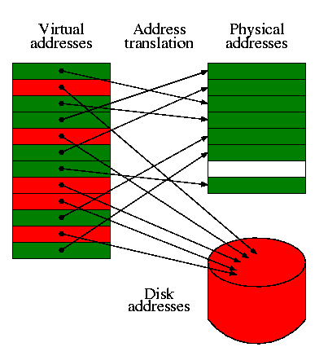**7.4: Virtual Memory**

I realize this material was covered in operating systems class (V22.0202). I am just reviewing it here. The goal is to show the similarity to caching, which we just studied. Indeed, (the demand part of) demand paging *is* caching: In demand paging the memory serves as a cache for the disk, just as in caching the cache serves as a cache for the memory.

The names used are different and there are other differences as well.

|  |  |
| --- | --- |
| **Cache concept** | **Demand paging analogue** |
| Memory block | Page |
| Cache block | Page Frame (frame) |
| Blocksize | Pagesize |
| Tag | None (table lookup) |
| Word in block | Page offset |
| Valid bit | Valid bit |

|  |  |
| --- | --- |
| **Cache concept** | **Demand paging analogue** |
| Associativity | None (fully associative) |
| Miss | Page fault |
| Hit | Not a page fault |
| Miss rate | Page fault rate |
| Hit rate | 1 - Page fault rate |
| Placement question | Placement question |
| Replacement question | Replacement question |

**======== START LECTURE #24 ========**

**Homework:** 7.39, 7.40 (should have been asked earlier)

* 1. 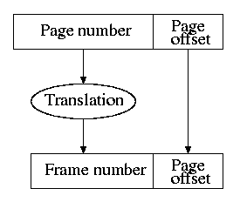For both caching and demand paging, the **placement** question is trivial since the items are fixed size (no first-fit, best-fit, buddy, etc).
  2. The **replacement** question is not trivial. (H&P list this under the placement question, which I believe is in error). Approximations to LRU are popular for both caching and demand paging.
  3. The cost of a page fault vastly exceeds the cost of a cache miss so it is worth while in paging to slow down hit processing to lower the miss rate. Hence demand paging is fully associative and uses a table to locate the frame in which the page is located.
  4. The figures to the right are for demand paging. But they can be interpreted for caching as well.   
     + 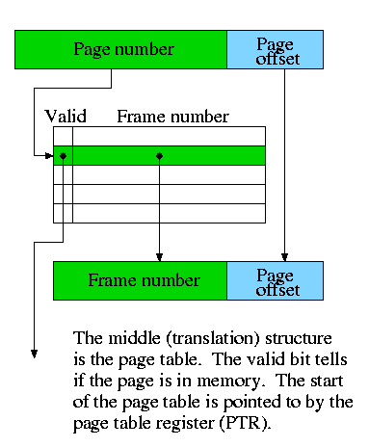The (virtual) page number is the memory block number
     + The Page offset is the word-in-block
     + The frame (physical page) number is the cache block number (which is the index into the cache).
     + Since demand paging uses full associativity, the tag is the entire memory block number. Instead of checking every cache block to see if the tags match, a (page) table is used.
  5. There are of courses differences as well.
     + When the valid bit is off for a cache entry, the entry is junk.
     + When the valid bit is off for a page table entry, then entry still contains important data, specifically the location on the disk where the page can be found.

**Homework:** 7.32 

**Write through vs. write back**

Question: On a write hit should we write the new value through to (memory/disk) or just keep it in the (cache/memory) and write it back to (memory/disk) when the (cache-line/page) is replaced.

* 1. Write through is simpler since write back requires two operations at a single event.
  2. But write-back has fewer writes to (memory/disk) since multiple writes to the (cache-line/page) may occur before the (cache-line/page) is evicted.
  3. For caching the cost of writing through to memory is probably less than 100 cycles so with a write buffer the cost of write through is bearable and it does simplify the situation.
  4. For paging the cost of writing through to disk is on the order of 1,000,000 cycles. Since write-back has fewer writes to disk, it is used.

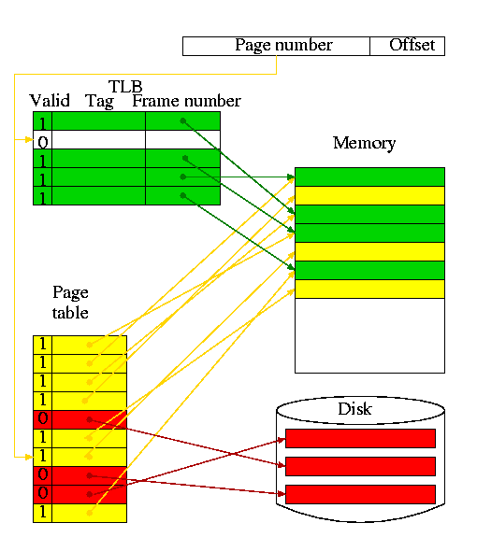**Translation Lookaside Buffer (TLB)**

A TLB is a cache of the page table

* 1. Needed because otherwise every memory reference in the program would require two memory references, one to read the page table and one to read the requested memory word.
  2. Typical TLB parameter values
     + Size: hundreds of entries
     + Block size: 1 entry
     + Hit time: 1 cycle
     + Miss time: tens of cycles
     + Miss rate: Low (<= 2%)
  3. In the diagram on the right
     + The green path is the fastest (TLB hit)
     + The red is the slowest (page fault)
     + The yellow is in the middle (TLB miss, no page fault)

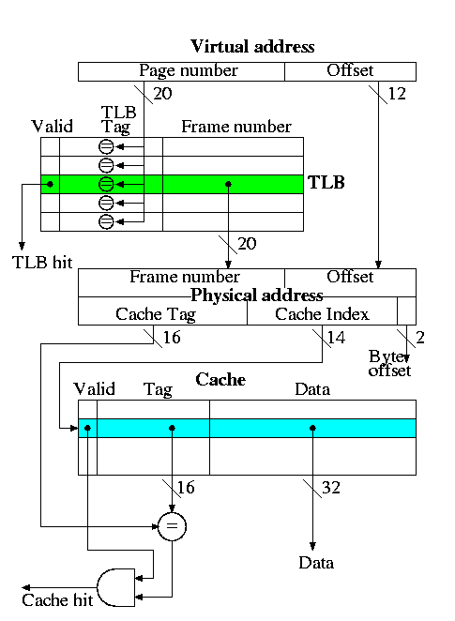**Putting it together: TLB + Cache**

This is the decstation 3100

* 1. Virtual address = 32 bits
  2. Physical address = 32 bits
  3. Fully associative TLB (naturally)
  4. Direct mapped cache
  5. Cache blocksize = one word
  6. Pagesize = 4KB = 2^12 bytes
  7. Cache size = 16K entries = 64KB

Actions taken

* 1. The page number is searched in the fully associative TLB
  2. If a TLB hit occurs, the frame number from the TLB together with the page offset gives the physical address. A TLB miss causes an exception to reload the TLB, which we do not discuss.
  3. The physical address is broken into a cache tag and cache index (plus a two bit byte offset that is not used for word references).
  4. If the reference is a write, just do it without checking for a cache hit (this is possible because the cache is so simple as we discussed [previously](NULL#3100-write-action)).
  5. For a read, if the tag located in the cache entry specified by the index matches the tag in the physical address, the referenced word has been found in the cache; i.e., we had a read hit.
  6. For a read miss, the cache entry specified by the index is fetched from memory and the data returned to satisfy the request.

**Hit/Miss possibilities**

|  |  |  |  |
| --- | --- | --- | --- |
| **TLB** | **Page** | **Cache** | **Remarks** |
| hit | hit | hit | Possible, but page table not checked on TLB hit, data from cache |
| hit | hit | miss | Possible, but page table not checked, cache entry loaded from memory |
| hit | miss | hit | Impossible, TLB references in-memory pages |
| hit | miss | miss | Impossible, TLB references in-memory pages |
| miss | hit | hit | Possible, TLB entry loaded from page table, data from cache |
| miss | hit | miss | Possible, TLB entry loaded from page table, cache entry loaded from memory |
| miss | miss | hit | Impossible, cache is a subset of memory |
| miss | miss | miss | Possible, page fault brings in page, TLB entry loaded, cache loaded |

**Homework:** 7.31, 7.33

**7.5: A Common Framework for Memory Hierarchies**

**Question 1: Where can the block be placed?**

This could be called the *placement* question. There is another placement question in OS memory memory management. When dealing with varying size pieces (segmentation or whole program swapping), the available space becomes broken into varying size available blocks and varying size allocated blocks (called holes). We do not discussing the above placement question in this course (but presumably it was in 204 when you took it and for sure it will be in 204 next semester--when I teach it).

The placement question we do study is the associativity of the structure.

Assume a cache with N blocks

* 1. For a direct mapped caches a block can only be placed in one slot. That is, there is one block per set and hence the number of sets equals N, the number of blocks.
  2. For fully associative caches the block can be placed in any of the N slos. That is, there are N blocks per set and hence one set.
  3. For k-way associative caches the block can be placed in any of k slots. That is, there are k blocks per set and hence N/k sets
  4. 1-way assosciativity is direct mapped.
  5. For a cache with n blocks, n-way associativity is the same as fully associative.

**Typical Values**

|  |  |  |  |
| --- | --- | --- | --- |
| Feature | Typical values for caches | Typical values for paged memory | Typical values for TLBs |
| Size | 8KB-8MB | 16MB-2GB | 256B-32KB |
| Block size | 16B-256B | 4KB-64KB | 4B-32B |
| Miss penalty in clocks | 10-100 | 1M-10M | 10-100 |
| Miss rate | .1%-10% | .000001-.0001% | .01%-2% |  |

**Question 2: How is a block found?**

|  |  |  |
| --- | --- | --- |
| **Associativity** | **Location method** | **Comparisons Required** |
| Direct mapped | Index | 1 |
| Set Associative | Index the set, search among elements | Degree of associativity |
| Full | Search all cache entries | Number of cache blocks |
| Separate lookup table | 0 |

The difference in sizes and costs for demand paging vs. caching, leads to a different choice implementation of finding the block. Demand paging always uses the bottom row with a separate table (page table) but caching never uses such a table.

* 1. With page faults so expensive, misses must be reduced as much as possible. Hence full associativity is used.
  2. With page faults so expensive, a software implementation can be used so no extra hardware is needed to index the table.
  3. The large block size (called page size) means that the extra table is a small fraction of the space.

**Question 3: Which block should be replaced?**

This is called the *replacement* question and is much studied in demand paging (remember back to 202).

* 1. For demand paging with miss costs so high and associativity so high (fully associative), the replacement policy is important and some approximation to LRU is used.
  2. For paging, the hit time must be small so simple schemes are used. For 2-way associativity, LRU is trivial. For higher associativity (but associativity is never very high) crude approximations may be used and sometimes random. replacement is used.

**Question 4: What happens on a write?**

* 1. Write-through
     + Data written to both the cache and main memory (in general to both levels of the hierarchy).
     + Sometimes used for caching, never used for demand paging
     + Advantages
       - Misses are simpler and cheaper (no copy back)
       - Easier to implement, especially for block size 1, which we did in class.
       - For blocksize > 1, a write miss is more complicated since the rest of the block now is invalid. Fetch the rest of the block from memory (or mark those parts invalid by extra valid bits--not covered in this course).

**Homework:** 7.41

* 1. Write-back
     + Data only written to the cache. The memory has stale data, but becomes up to date when the cache block is subsequently replaced in the cache.
     + Only real choice for demand paging since writing to the lower level of the memory hierarch (in this case disk) is so slow.
     + Advantages
       - Words can be written at cache speed not memory speed
       - When blocksize > 1, writes to multiple words in the cache block are only written once to memory (when the block is replaced).
       - Multiple writes to the same word in a short period are written to memory only once.
       - When blocksize > 1, the replacement can utilize a high bandwidth transfer. That is, writing one 64-byte block is faster than 16 writes of 4-bytes each.

**======== START LECTURE #25 ========**

* + - Write miss policy (advanced)
      * For demand paging, the case is pretty clear. Every implementation I know of allocates a frame for the page miss and fetches the page from disk. That is it does both an *allocate* and a *fetch*.
      * For caching this is not always the case. Since there are two optional actions there are four possibilities.
        + Don't allocate and don't fetch: This is sometimes called write around. It is done when the data is not expected to be read and is large.
        + Don't allocate but do fetch: Impossible, where would you put the fetched block?
        + Do allocate, but don't fetch: Sometimes called no-fetch-on-write. Also called SANF (store-allocate-no-fetch). Requires multiple valid bits per block since the just-written word is valid but the others are not (since we updated the tag to correspond to the just-written word).
        + Do allocate and do fetch: The normal case we have been using.

**Chapter 8: Interfacing Processors and Peripherals.**

With processor speed increasing 50% / year, I/O must improved or essentially all jobs will be I/O bound.

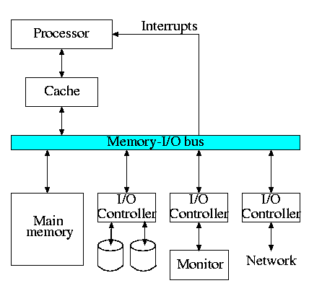The diagram on the right is quite oversimplified for modern PCs but serves the purpose of this course.

**8.2: I/O Devices**

Devices are quite varied and their datarates vary enormously.

* 1. Some devices like keyboards and mice have tiny datarates.
  2. Printers, etc have moderate datarates.
  3. Disks and fast networks have high rates.
  4. A good graphics card and monitor has huge datarate

Show a real disk opened up and illustrate the components

* 1. Platter
  2. Surface
  3. Head
  4. Track
  5. Sector
  6. Cylinder
  7. Seek time
  8. Rotational latency
  9. Transfer time

**8.4: Buses**

A bus is a shared communication link, using one set of wires to connect many subsystems.

* 1. Sounds simple (once you have tri-state drivers) ...
  2. ... but it's not.
  3. Very serious electrical considerations (e.g. signals reflecting from the end of the bus. We have ignored (and will continue to ignore) all electrical issues.
  4. Getting high speed buses is state-of-the-art engineering.
  5. **Tri-state drivers**:
     + A output device that can either
       - Drive the line to 1
       - Drive the line to 0
       - Not drive the line at all (be in a high impedance state)
     + Can have many of these devices devices connected to the same wire providing careful to be sure that all but one are in the high-impedance mode.
     + This is why a single bus can have many output devices attached (but only one actually performing output at a given time).
  6. Buses support bidirectional transfer, sometimes using separate wires for each direction, sometimes not.
  7. Normally the memory bus is kept separate from the I/O bus. It is a fast **synchronous** bus and I/O devices can't keep up.
  8. Indeed the memory bus is normally custom designed (i.e., companies design their own).
  9. The graphics bus is also kept separate in modern designs for bandwidth reasons, but is an industry standard (the so called AGP bus).
  10. Many I/O buses are industry standards (ISA, EISA, SCSI, PCI) and support **open architectures**, where components can be purchased from a variety of vendors.

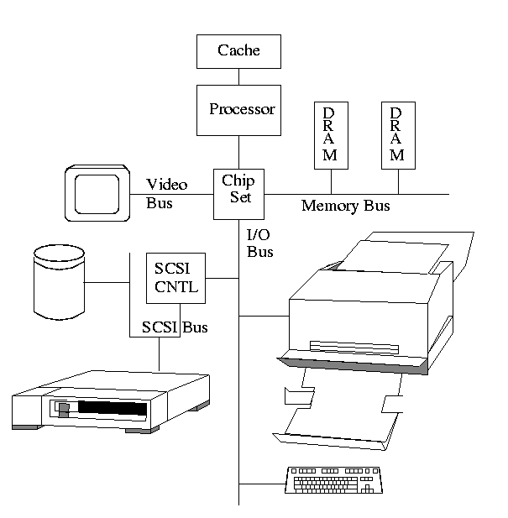

* 1. 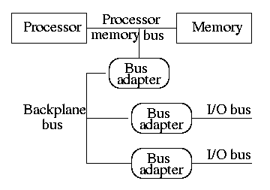This figure above is similar to H&P's figure 8.9(c), which is shown on the right. The primary difference is that they have the processor directly connected to the memory with a processor memory bus.
  2. The processor memory bus has the highest bandwidth, the backplane bus less and the I/O buses the least. Clearly the (sustained) bandwidth of each I/O bus is limited by the backplane bus. Why?  
     Because all the data passing on an I/O bus must also pass on the backplane bus. Similarly the backplane bus clearly has at least the bandwidth of an I/O bus.
  3. Bus adaptors are used as interfaces between buses. They perform speed matching and may also perform buffering, data width matching, converting between **synchronous** and **asynchronous** buses.
  4. For a realistic example draw, on the board the diagram from *Microprocessor Reports* on the new Intel chip set. I am not sure of copyright questions so will not put it in the notes.
  5. Bus adaptors have a variety of names, e.g. host adapters, hubs, bridges.
  6. Bus lines (i.e. wires) include those for data (data lines), function codes, device addresses. Data and address are considered data and the function codes are considered control (remember our datapath for MIPS).
  7. Address and data may be multiplexed on the same lines (i.e., first send one then the other) or may be given separate lines. One is cheaper (good) and the other has higher performance (also good). Which is which?  
     Ans: the multiplexed version is cheaper.

**Synchronous vs. Asynchronous Buses**

A **synchronous** bus is **clocked**.

* 1. One of the lines in the bus is a clock that serves as the clock for all the devices on the bus.
  2. All the bus actions are done on fixed clock cycles. For example, 4 cycles after receiving a request, the memory delivers the first word.
  3. This can be handled by a simple finite state machine (FSM). Basically, once the request is seen everything works one clock at a time. There are no decisions like the ones we will see for an asynchronous bus.
  4. Because the protocol is so simple it requires few gates and is very fast. So far so good.
  5. Two problems with synchronous buses.
     + All the devices must run at the same speed.
     + The bus must be short due to *clock skew*
  6. Processor to memory buses are now normally synchronous.
     + The number of devices on the bus are small
     + The bus is small
     + The devices (i.e. processor and memory) are prepared to run at the same speed
     + High speed is needed

An **asynchronous** bus is **not** clocked.

* 1. Since the bus is not clocked a variety of devices can be on the same bus.
  2. There is no problem with clock skew (since there is no clock).
  3. But the bus must now contain control lines to coordinate transmission.
  4. Common is a handshaking protocol.
  5. We now show a protocol in words and FSM for a device to obtain data from memory.
  6. 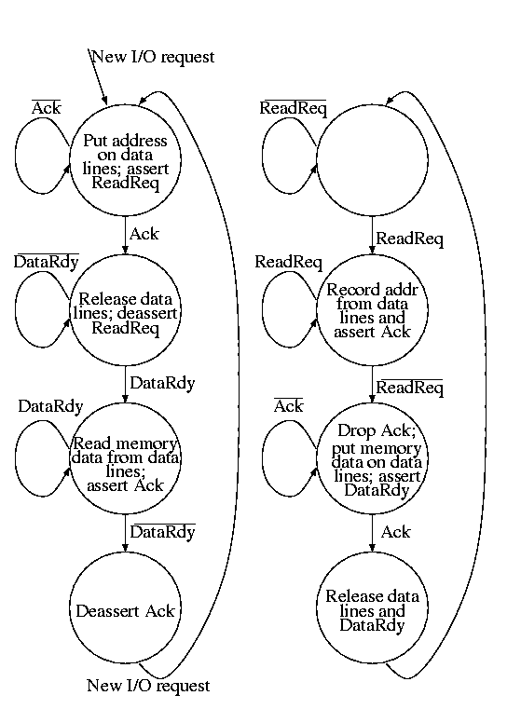The device makes a request (asserts ReadReq and puts the desired address on the data lines).
  7. Memory, which has been waiting, sees ReadReq, records the address and asserts Ack.
  8. The device waits for the Ack; once seen, it drops the data lines and deasserts ReadReq.
  9. The memory waits for the request line to drop. Then it can drop Ack (which it knows the device has now seen). The memory now at its leasure puts the data on the data lines (which it knows the device is not driving) and then asserts DataRdy. (DataRdy has been deasserted until now).
  10. The device has been waiting for DataRdy. It detects DataRdy and records the data. It then asserts Ack indicating that the data has been read.
  11. The memory sees Ack and then deasserts DataRdy and releases the data lines.
  12. The device seeing DataRdy low deasserts Ack ending the show.

**======== START LECTURE #26 ========**

**Improving Bus Performance**

These improvements mostly come at the cost of increased expense and/or complexity.

* 1. Hierarchy of buses.
  2. Synchronous instead of asynchronous protocols.
     + Synchronous is actually simplier, but it essentially implies a hierarchy of protocols since not all devices can operate at the same speed.
  3. Wider data path: Use more wires, send more at once.
  4. Separate address and data lines: Same as above.
  5. Block transfers: Permit a single transaction to transfer more than one busload of data. Saves the time to release and acquire the bus, but the protocol is more complex.
  6. 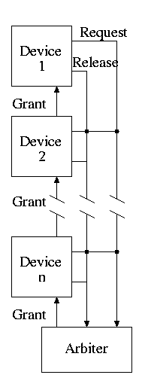Obtaining bus access:
     + The simplest scheme is to permit only one bus **master**.
       - That is on each bus only one device is permited to initiate a bus transaction.
       - The other devices are **slaves** that only respond to requests.
       - With a single master, there is no issue of arbitrating among multiple requests.
     + One can have multiple masters with **daisy chaining** of the **grant line**.
       - Any device can raise the request line.
       - The device with the request raises the release line when done.
       - The arbiter monitors the request and request lines and raises the grant line.
       - The grant signal is passed from one to the other so the devices near the arbiter have priority and can starve the ones further away.
       - Passing the grant from device to device takes time.
       - Simple but not fair or high performance
     + Centralized parallel arbiter: Separate request lines from each device and separate grant lines. The arbiter decides which device should be granted the bus.
     + Distributed arbitration by self-selection: Requesting processes identify themselves on the bus and decide individually (and consistently) which one gets the grant.
     + Distributed arbitration by collision detection: Each device transmits whenever it wants, but detects collisions and retries. Ethernet uses this scheme (but not new switched ethernets).

|  |  |  |
| --- | --- | --- |
| **Option** | **High performance** | **Low cost** |
| bus width | separate address and data lines | multiplex address and data lines |
| data width | wide | narrow |
| transfer size | multiple bus loads | single bus loads |
| bus masters | multiple | single |
| clocking | synchronous | asynchronous |

**======== START LECTURE #27 ========**

Do on the board the example on pages 665-666

* 1. Memory and bus support two widths of data transfer: 4 words and 16 words
  2. 64-bit synchronous bus; 200MHz; 1 clock for addr; 1 for data.
  3. Two clocks of ``rest'' between bus accesses
  4. Memory access times: 4 words in 200ns; additional 4 word blocks in 20ns per block.
  5. Can overlap transferring data with reading next data.
  6. Find
     + Sustained bandwidth and latency for reading 256 words using both size transfers
     + How many bus transactions per sec for each (addr+data)
  7. Four word blocks
     + 1 clock to send addr
     + 40 clocks read mem
     + 2 clocks to send data
     + 2 idle clocks
     + 45 total clocks
     + 256/4=64 transactions needed so latency is 64*45*5ns=14.4us
     + 64 trans per 14.4us = 64/14.4 trans per 1us = 4.44M trans per sec
     + Bandwidth = 1024 bytes per 14.4us = 1024/14.4 B/us = 71.11MB/sec
  8. Sixteen word blocks
     + 1 clock for addr
     + 40 clocks for reading first 4 words
     + 2 clocks to send
     + 2 clocks idle
     + 4 clocks to read next 4 words. But this is free! Why?  
       Because it is done during the send and idle of previous block.
     + So we only pay for the long initial read
     + Total = 1 + 40 + 4*(2+2) = 57 clocks.
     + 16 transactions neeed; latency = 57*16*5ns=4.56ms, which is **much better** than with 4 word blocks.
     + 16 transactions per 4.56us = 3.51M transactions/sec
     + Bandwidth = 1024B per 4.56ms = 224.56MB/sec

**8.5: Interfacing I/O Devices**

**Giving commands to I/O Devices**

This is really an OS issue. Must write/read to/from device registers, i.e. must communicate commands to the controller.

* 1. The controler has a few registers which can be read and/or written by the processor, similar to how the processor reads and writes memory.
  2. Nearly every controler contains
     + A data register, which is readable for an input device (e.g., a simple keyboard), writable for an output device (e.g., a simple printer), and both readable and writable for input/output devices (e.g., disks).
     + A control register for giving commands to the device.
     + A readable status register for reporting errors and announcing when the device is ready for the next action (e.g., for a keyboard telling when the data register is valid, and for a printer telling when the character to be printed has be successfully retrieved from the data register). Remember the communication protocol we studied where ack was used.
  3. Many controllers have more registers

**Communicating with the Processor**

Should we check periodically or be told when there is something to do? Better yet can we get someone else to do it since we are not needed for the job?

* 1. We get mail at home once a day.
  2. At some business offices mail arrives a few times per day.
  3. No problem checking once an hour for mail.
  4. If email wasn't buffered, you would have to check several times per minute (second?, milisecond?).
  5. Checking email this often is too much of a burden and most of the time when you check you find there is none so the check was wasted

**Polling**

Processor continually checks the device status to see if action is required.

* 1. Like the mail example above.
  2. For a general purpose OS, one needs a timer to tell the processor it is time to check (OS issue).
  3. For an embedded system (microwave) make the checking part of the main control loop, which is guaranteed to be executed at a minimum frequency.
  4. For a keyboard or mouse with very low data rates, can afford to have the main CPU check. Do an example where you must sample 60 times a second and a modern (say 600MHz) processor takes a few hundred clocks to do a poll.
  5. It is a little better for slave-like output devices such as a simple printer. Then the processor only has to poll after a request has been made until the request has been satisfied.

Do on the board the example on pages 676-677

* 1. Cost of a poll is 400 clocks
  2. CPU is 500MHz
  3. How much of the CPU is needed to poll
     + A mouse that requires 30 polls per sec.
     + A floppy that sends 2-byte at a time and achieves 50KB/sec.
     + A hard disk that sends 16-bytes at a time and achieves 4MB/sec.
  4. For mouse 12,000 cycles/sec
  5. For floppy need 25K polls/sec
  6. For disk need 250K polls/sec
  7. Would not do polls for floppy and disk until make a request but then must keep polling until request statisfied.

**Interrupt driven I/O**

Processor is told by the device when to look. The processor is *interrupted* by the device.

* 1. Dedicated lines (i.e. wires) on the bus are assigned for interrupts.
  2. When a device wants to send an interrupt it asserts the corresponding line.
  3. The processor checks for interrupts after each instruction.
  4. If an interrupt is pending (i.e. if the line is asserted) the processor
     + Saves the PC and perhaps some registers.
     + Switches to kernel (i.e. privileged) mode.
     + Jumps to a location specified in the hardware (the *interrupt handler*.
     + OS takes over.
  5. What if we have several different devices and want to do different things depending on what caused the interrupt?
  6. Use **vectored** interrupts.
     + Instead of jumping to a single fixed location have a set of locations.
     + Could have several interrupt lines if line 1 is asserted, jump to location 100, if line 2 isserted jump to location 200, etc.
     + Could have just one line and have the device send the address to jump to.
  7. There are other issues with interrupts that are (hopefully) taught in OS. For example, what happens if an interrupt occurs while an interrupt is being processed. For another example, what if one interrupt is more important than another.
  8. The time for processing an interrupt is typically longer than the type for a poll. But interrupts are *not* generated when the device is idle, a big advantage.

Do on the board the example on pages 681-682

* 1. Same hard disk and processor as above.
  2. Cost of servicing an interrrupt is 500 cycles
  3. Disk is active only 5% of the time
  4. What percent of the processor would be used to service the interrupts?
  5. Cycles/sec needed for processing interrupt is 125 million
  6. 25% of processor is needed.
  7. 1.25% since only active 5%.

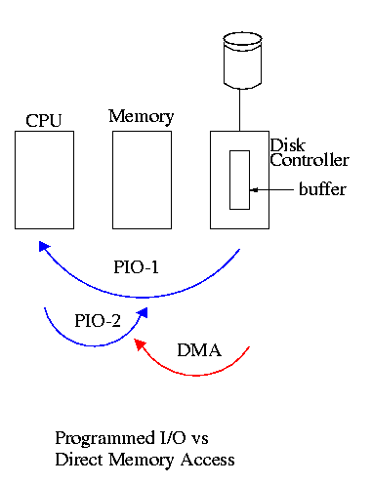**Direct Memory Access (DMA)**

The processor initiates the I/O operation then ``something else'' takes care of it and notifies the processor when it is done (or if an error occurs).

* 1. Have a DMA engine (a small processor) on the controller.
  2. The processor initiates the DMA by writing the command into data registers on the controller (e.g., read sector 5, head 4, cylinder 123 into memory location 34500)
  3. For commands that are longer than the size of the data register(s), a protocol must be used to transmit the information.
  4. (I/O done by the processor as in the previous methods is called programmed I/O, PIO).
  5. The controller collects data from the device and then sends it on the bus to the memory without bothering the CPU.
     + So we have a multimaster bus and need some sort of arbitration.
     + Normally the I/O devices are given higher priority than the CPU.
     + Freeing the CPU from this task is good but isn't as wonderful as it seems since the memory is busy (but cache hits can be processed).
     + A big gain is that only one bus transaction is needed per bus load. With PIO, two transactions are needed: controller to processor and then processor to memory.
     + This was for an input operation (the device writes to memory). A similar situation occurs for output where the device reads from the memory). Once again one bus transaction per bus load.
  6. When the controller detects that the I/O is complete or if an error occurs, it sets the status register accordingly and sends an interrupt to the processor to notify the latter that the I/O is complete.

**More Sophisticated Controllers**

* 1. Sometimes (often?) called ``intelligent'' device controlers, but I prefer not to anthropomorphisize (sp?).
  2. Some devices, for example a modem on a serial line, deliver data without being requested to. So a controller may need to be prepared for unrequested data.
  3. Some devices, for example an ethernet, have a complicated protocol so it is desirable for the controller to process some of that protocol. In particular, the collision detection and retry with exponential backoff caharacteristic of (non-switched) ethernet requires a real program.
  4. Hence some controllers have full microprocessors on board. These controllers handle much more than block transfers.
  5. In the old days there were I/O channels, which could execute entire programs. However, channel programs were written dynamically by the main processor. For the modern controllers the programs are fixed and loaded in ROM or PROM.

**Subtlties involving the memory system**

* 1. Just writing to memory doesn't update the cache.
  2. Reading from memory gets old values with a write-back cache.
  3. The memory area to be read or written is specified by the program using virtual addresses. But the I/O must actually go to physical addresses. Need help from the MMU.

**8.6: Designing an I/O system**

Do on the board the example page 681

* 1. Assume a system with
     + CPU executes 300 million instructions/sec
     + 50K instructions for each I/O (OS instructions)
     + Backplane bus on which all I/O travels supports 100MB/sec
     + Disk controllers (scsi-2) supporting 20MB/sec and accommodating up to 7 disks.
     + Disks with bandwidth 5MB/sec and seek plus rotational latency of 10ms
  2. Assume a workload of 64-KB reads and 100K instructions between reads.
  3. Find
     + Max I/O rate achievable
     + How many controllers are needed for this rate.
     + How many disks are needed
  4. I/O takes 150,000 instructions
  5. So CPU limits us to 2000 I/O per sec
  6. Backplane bus limits us to 100 million / 64,000 = 1562 I/Os per sec
  7. So max is 1562 / sec
  8. Time for each I/O (at the disk) is 22.8ms
  9. Each disk can achieve 43.9 I/Os per sec
  10. So need 36 disks
  11. Each disk uses avg 2.74 MB/sec of bus bandwidth (64KB/22.8ms)
  12. Since the scsi bus supports 20 MB/sec it will not be limiting and we can load it to the max (i.e. 7 disks).
  13. So need 6 controllers (not all will have 7 disks).

**Remark:** The above analysis was very simplistic. It assumed everything overlapped just right and the I/Os were not bursty and that the I/Os conveniently spread themselves accross the disks.

**======== START LECTURE #28 ========**

Review for final.

* 1. Do example at beginning of last time (which was skipped).
  2. Between 30%-40% of exam will be on material from first half (i.e. lectures 1-13, includes H&P App B, Ch 3, Ch 4).
  3. Between 60%-70% of exam will be on material from second half (i.e. lectures 15-27, includes H&P Ch 5, Ch 2, Ch 7, Ch 8)
  4. A fair question would be to hand out the datapath and ask you to modify it to support an additional instruction.
  5. An unfair question would be to ask you to draw the datapath (i.e., I don't assume you have it memorized).
  6. Questions on how much faster a system gets if cache misses decreases or how much faster if cpu+cache is faster but memory isn't
  7. Direct mapped vs associative caches.
  8. Block sizes
  9. MHz vs ns
  10. I/O configurations